淡江時報 第 987 期
TKU’s Innovative Imagination Futuristic Classroom
學校要聞
【Xin-yu Wang, Tamsui Campus Report】In order to create a friendly, effective and future-oriented learning environment, Tamkang University created the first “Innovative Imagination Futuristic Classroom” in the Ching-sheng building room 1201. On Dec. 12 the Graduate Institute of Future Studies held a ceremony, unveiling the new room while giving a demonstration of its capabilities. The modern classroom allows interactive learning through the support of cloud and media player technology to give a glimpse of current and projected global trends. By utilizing the technical and digital tools to understand and analyze the possibilities of future development, TKU students will be able to get a head start in their careers.

There were 50 participants in attendance at the ceremony including President Flora Chia-I Chang, Director of the Graduate Institute of Future Studies, Kuo-hua Chen, first and second level administrators along with teachers and students of various departments. “Future-oriented development is one of the main objectives of the university.” President Chang pointed out in her address. She continued, “It is my desire to see a completely futuristic interactive curriculum for students and teachers to enhance learning capabilities.”

Kuo-hua Chen explained that the new room is called the “IF Room.” The “I” represents both imagination and innovation and the “F” represents the future. He then detailed the room consisted of 5 modern projectors, interactive whiteboards and movable desks that make student interaction is both convenient and efficient. He stated, “Tamkang University has spent a lot of time and effort in the promotion of future and information-oriented education.” He then thanked the audience while encouraging students to continue to embrace the university’s spirit of excellence.
2015/12/25

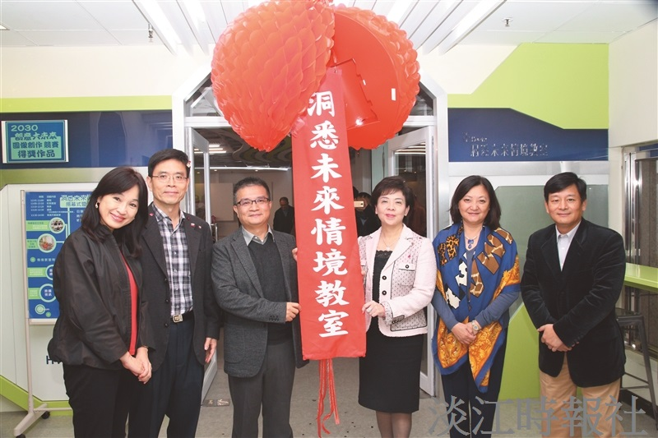
本校在I201設立為「洞悉未來情境教室」，於16日舉行開幕儀式，由校長張家宜（右3）、未來學所所長陳國華（左3）等人，一同拉下彩球為儀式開幕。現場還進行時光機遊戲，讓與會者感受洞悉未來情境教室互動功能。（攝影／閩家瑋）

