淡江時報 第 978 期
Malaysian TKU Alumni Honored for Success
學校要聞
On Aug. 15 the Federation of Alumni Association of Taiwan Universities, Malaysia (FAATUM) held their 41st Anniversary that was themed, “Passing Along the Torch - Creating New Heights of Innovation Together.” President Flora Chia-I Chang and Vice President of Administration, Yi-jen Hu, attended the ceremonial banquet. During the event, President of FAATUM and Alumni of the Department of Accounting, Ser-chong Lee, was presented with the Second Hua Guang Professional Achievement Award. Ser-chong Lee, showed his appreciation to Taiwan and for the opportunity to have an education of the spirit of excellence. (Article written by Kai-jun Lin)
2015/10/23

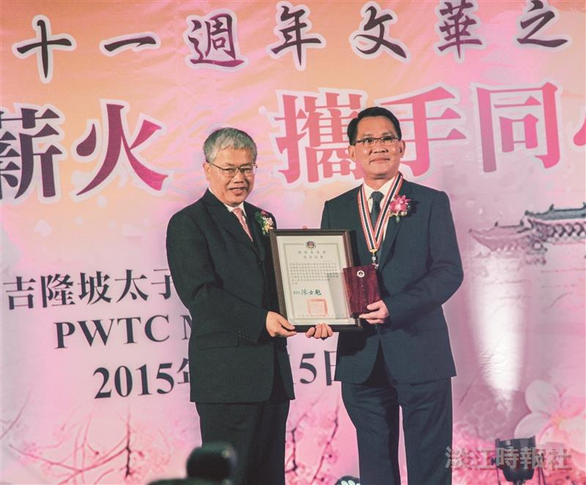
馬來西亞留臺校友會聯合總會於8月15日舉辦41週年文華之夜中，中華民國僑務委員會頒發二等華光專業獎章給聯合總會會長拿督、本校會計系校友李子松，表揚其長期熱心服務華社，以及對於臺馬雙邊教育卓越貢獻。（圖／校服暨資發處提供）

