淡江時報 第 976 期
TKU Drum Team is Invited to the Sunshine State
學校要聞
【Lin-kai Jun, Tamsui Campus Report】On Sept. 27 The Tamkang University Alumni Association of Northern California (TKUAANC) held the “San Francisco Grand Confucius Celebration “ in the Culture Center of Taipei Economic and Culture Office In San Francisco. The TKU Drum Team was invited and the stage performance ignited the celebration. Director of the TKUAANC, Ling-biao Jiang, expressed, “The TKU Drum Team was invited on this very important festival, which will spread the reputation and honor of the university. It’s great to be able to share the treasures of TKU as well as the spirit of the TKU Drum Team.” (Article/ Lin-kai Jun)
2015/10/12

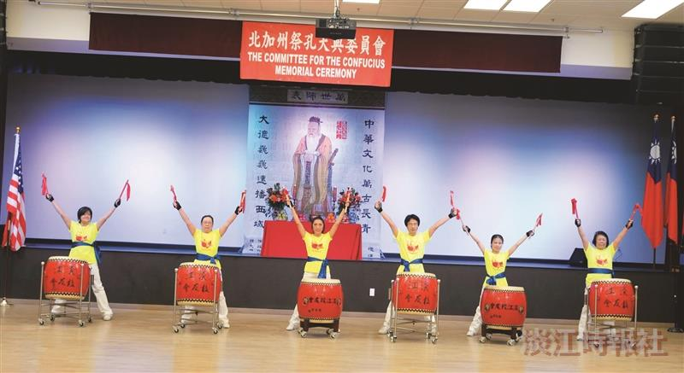
北加州淡江大學校友會於上月27日上午10時出席在美國舊金山灣區南灣華僑文教服務中心舉行「舊金山祭孔大典」活動，淡江大鼓隊受邀表演開場擊鼓。（圖／校友服務暨資源發展處提供）

