淡江時報 第 883 期
【Resume行銷自己】第一次撰寫英文履歷就上手
書香聊天室
文／林佳彣、楊宜君採訪整理報導

在地球村及國際化的現況下，如何用英文寫自傳和工作履歷？一篇好的自傳第一眼就能夠引起他人興趣，因而高度引起雇者閱讀的動機，進而願意認識你這個人。其內容包括：家庭背景、教育背景、工作經歷、人際關係、社會層面上的成長、人生哲學觀、未來目標以及reasons why you should hire me.

本校英文系副教授郭岱宗，日前在講座課程中建議英文履歷自傳中的各段可書寫如下：

首段：

Growing up in a very humble family, I have cherished every minute at school and at work. I graduated from Tamkang University eight years ago and have worked ever since, except for my military service.

第二段：若有工作經驗

As for my work experience, I first worked at Siemens Telecommunication System Limited for a year and half as an engineer in the technical support department, and then I worked in a local computer company as a technical engineer. After that I moved to Canada to start my own business. Those three years in Canada have been extremely helpful to me---I was running a telecom, Internet and computer company. My work covered from A to Z, including purchasing, repairing , market expansion, problem solving, customer services, selling, and I also gave computer lessons to students.

第二段：若無工作經驗，可以直接介紹自己的長才和其他的經驗即可，而經驗和興趣要和公司的需求相符：

I would like to take this opportunity to introduce myself. I graduated from the department of XXX at Tamkang University in 2013, and my goal has always been to XXX ！ I've always had a great passion for XXX （行業）. Ever since I was a teenager, I've wanted to work as a XXX in xxx. To reach this goal, I have been a member of XXX（社團）at my university, where I served as XXX and worked as a teacher's assistant. These experiences have given me abundant knowledge and a greater interest in XXX（行業）. It would be a dream come true if I could have the honor of working for you.

第三段：若因個人家庭因素而另求他職，可如下撰寫：

My customers came from different countries in the world, making me quite aware of their customs, conceptions, and lifestyles, we had a very difficult start, but my business started to take off in one year.

Unfortunately, my father got sick and missed us a lot, so my wife and I decided that we should come back immediately. I very luckily sold my company at a good price and came back in this July.

第三段：若非個人家庭因素而造成另求他職，也可如此寫：

I liked my previous job at XXX company very much. We had a very happy and effective team. Unfortunately the workplace was too far from my home and the commute consumed at least two hours a day, which is why I eventually decided to find employment elsewhere. Fortunately, I have found a great opportunity at your company and truly feel that my skills will make me an asset at XXX.

第四段：感性地推銷自己：

I would also like to share my appreciation for one of my professors, Dr. XXX. I was very shy and introverted until I met her. Dr. XXX taught me to discover and appreciate the true beauty and value of life, making me see that everyone is unique and full of potential. Today I am calm, confident, and dynamic, and I must give all the credit to Dr. XXX.

第四段：若已婚，也可以感性地另行介紹：

Speaking of my growth, I cannot ignore my wife. I was a very shy boy until I met her. She taught me to discover and appreciate the true beauty of life, making me see that everyone is full of potential, and the sky is the only limit.（資料來源／英文系副教授郭岱宗）

專家指南

◎英文系副教授郭岱宗

一篇優良履歷，文字內容需精簡，且一開始就高度引起他人的閱讀動機。方法要脫離千篇一律，展現個人特色。履歷並非洋洋灑灑道盡人生經歷，而是用最精簡細膩的文字，傳達你的目的，並且仍須兼具理性與感性，理性之處是讓主考官欣賞我們的邏輯思維；感性之處則讓主考官認知我們的生命。

臺灣的工作面試，常會要求以中、英2種語言進行。建議可以準備好2種語言的自我介紹，而且要準備地十分流暢，能輕描淡寫似地說出。工作面試之所以重要，是因為從談吐、聲音中可以得知一個人是否應對得體，以及有良好的氣質談吐。謙遜的自信、愉悅的心情、溫暖的表情，可以讓他人得知我們未來的工作態度，以及良好的人際關係。倘若自信不足、略顯緊張，則會讓面試官的觀感不佳。面試過程中，三不五時的淺淺微笑、適時的眼神交流，更是會讓人印象深刻。

◎英文所博士生王有慧，具上海高級口筆譯證書

我曾幫他人看自傳和履歷，最大問題是錯誤百出的文法，再來是內容排序。新鮮人的履歷，通常學歷寫在最前頭，再來是經歷。整體視覺上以簡潔為主，內容順序應為：學歷、經歷、證照、得獎記錄、社團經歷及曾參與的活動，使自我優點更加凸顯，專長和興趣亦可附上。內容陳述時必須緊扣所申請職位的主要要求，或強調自身附加價值；而社會人士則應先寫經歷再寫學歷，其中經歷包含：公司名稱、擔任職務、時間、以及敘述公司名稱、職務等等；自傳會有邏輯和文法的問題，必要的話可尋求母語人士或其它專業協助。

另外，因英文面試是測試英文能力，在表達上，最重要的是流暢度，而非內容。準備上，可以就自身優點寫一篇講稿，並保持一定的熟悉和流暢度。

實務分享

◎【求職】運管系校友魯郁寧，現為長榮航空空服員

我當初準備時，曾參考他人推甄自傳及考取空服員分享內容。建議寫完之後，可以給英文能力佳的友人閱讀，看看是否有錯誤，總比寫錯好。由於自傳有字數限制，所以如何言簡意賅是最困擾之事。在求職履歷上，論及自身事蹟、打工及實習經驗，從高中時期寫起即可，毋須從小學時期開始撰寫。此外，依面試的工作性質、公司文化，以及熟知公司需要的人才，適時表達個人專長及優勢，並多加描述。要在眾人中脫穎而出，關鍵點莫過於履歷、自傳要有特色，才能捕捉面試官的目光，並進而想見你一面。在英文面試方面，無需過度緊張，只要態度大方、簡單回答即可，倘若長篇大論，面試官也會不耐煩。面試時，通常提問的內容不會太多，更遑論專業的部分。比如我所從事的服務業，主要是看此人是否合適這份工作，並非以其過去的豐功偉業評定錄取與否。

◎【求學】航太系校友蔡耀釧，現就讀史丹福大學航空與航太工程學系碩士班

大學重視全人發展，而研究所重視學術研究。故研究所的自傳含括：讀書計畫（Statement of Purpose）、個人經歷（Personal Statement）。其中，以讀書計畫較為重要，其最高原則為：文章言簡意賅、請他人校稿、撰寫內容應與教授充分討論。

起筆時，可參考網路版本、購買相關書籍，再寫出架構、雛形，不斷反覆修正。履歷的篇幅長短最好1頁、至多2頁，1頁半最為忌諱；而自傳最忌長篇大論，2頁或1000字以內的長度為佳。初寫自傳的盲點，是無法準確表達自身就學動機，造成文章過於冗長。內容的重點不在長，而是如何用最簡短的篇幅，呈現最佳的一面。所謂「重質不重量」便是如此，要懂得去蕪存菁。讀書計畫首段寫就讀動機，依序為修課狀況、在學成績、得獎紀錄、以及社團、研究、工作經驗，最後總結。頭尾兩段，以及各段落第一句，要寫的強而有力，同時也是文章的重點；首段是第一印象，須具有強烈的吸引力。由於自身書寫會有盲點，給第三者校稿更是重要。第三者包括朋友、教授、母語人士等。其中，教授熟知你的求學狀況；母語人士可看出語言上的盲點，往往是以英文為第二語言的人難以發現的。
2013/01/07

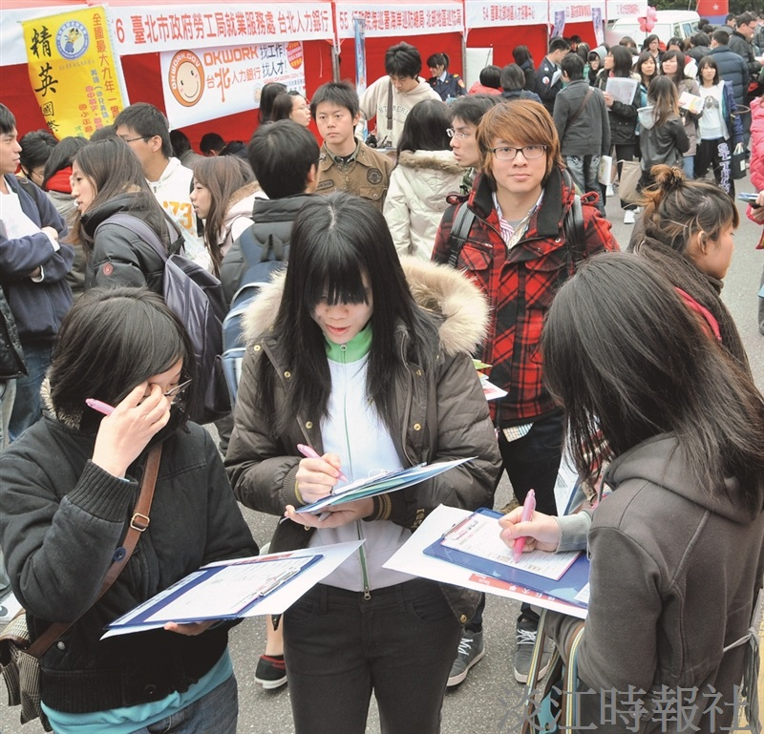
本校就業博覽會活動實況（本報資料照片）

