淡江時報 第 881 期
Kwei Lun Mei Crowned Queen of Asian Pacific Films
學校要聞
TKU Department of French alumna and well-known Taiwanese actress Kwei Lun-Mei recently received the Best Actress award at the 2012 Asia Pacific Film Festival. She won the award for her widely acclaimed performance in the movie “Girlfriend, Boyfriend”, in which she played “Lin Mei-bao”, a fictitious character who finds herself in a love triangle that evolves over two decades.

Kwei Lun-mei, who is currently shooting a new film in Harbin, China, explained that “I feel like acting is a process of learning that never ends. However, receiving this award at this particular point in time means so much to me and is such an encouragement.”
2013/01/04

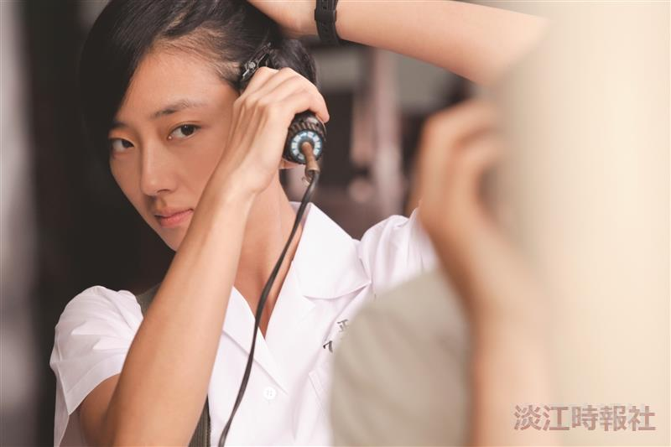
圖為法文系校友桂綸鎂在「女朋友。男朋友」電影中，因表演需要真實操刀剃髮。她演出的「林美寶」一角個性鮮明、演技生動，獲得好評。（圖／原子映象有限公司提供）

