淡江時報 第 756 期
蘭陽之歌--Proud of You
特刊
Love in your eyes

Sitting silent by my side

Going on holding hand

Walking through the nights

Hold me up Hold me tight

Lift me up to touch the sky

Teaching me to love with heart

Helping me open my mind

I can fly

I'm proud that I can fly

To give the best of mine

Till the end of the time

Believe me I can fly

I'm proud that I can fly

To give the best of mine

The heaven in the sky ......
2010/09/27

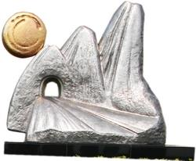
雪山隧道雕塑

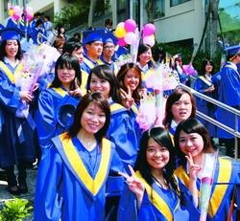
(攝影�馮文星）

