Tamkang Times No.1221
Tamkang Forms Strategic Alliance with Makati Hope Christian School, Opening a New Chapter of Cooperation in the Philippines

On the morning of July 9 at 9:00 a.m., Dr. Marivic L. Daguio, Principal of Makati Hope Christian School in the Philippines, along with Academic Affairs Director Ms. Kristin M. Basco and Administrative Officer Mr. Dino Paolo Cortes, visited Tamkang University. The delegation was welcomed by the Office of International and Cross-Strait Affairs and attended a signing ceremony at Hsu Shou-Chlien International Conference Center, where President Huan-Chao Keh and Dr. Daguio represented the two institutions in signing a strategic alliance agreement. The ceremony was also attended by Vice President for International Affairs Prof. Hsiao-Chuan Chen, Dean of the College of Business and Management Prof. Li-Ren Yang, Dean of International Affairs Prof. Chien-Mu Yeh, and the Office Secretary and Exchange Section Chief Ms. Hsinyin AC Chu. The visit concluded with a guided tour of the University History Gallery and the Chueh Sheng Memorial Library, where guests learned about Tamkang’s institutional development and library resources.

In his remarks, President Keh extended a warm welcome to the three guests on behalf of the University, emphasizing that the signing of the agreement marks “the starting point of a friendship and a solid foundation for future collaboration.” He introduced Tamkang’s robust academic environment, including its network of 284 sister universities, 45 dual-degree programs jointly offered with 29 partner institutions, and 12 bachelor’s and master’s programs taught entirely in English. He further highlighted Tamkang’s strong performance in various global university rankings and domestic evaluations, as well as its commitment to providing a highly internationalized and student-friendly learning environment. He encouraged Makati Hope Christian School to recommend more students to pursue their studies at Tamkang.

Dr. Daguio shared the origins of the partnership, noting that in March, Tamkang’s delegation — led by Prof. Hsiao-Chuan Chen, accompanied by Prof. Li-Ren Yang and Ms. Hsinyin AC Chu — visited their school, where they introduced students to Tamkang’s programs and teaching resources, and hosted a special lecture session. She noted that the students expressed a strong interest in the University. She also praised Tamkang’s visionary initiatives of “AI+SDGs=∞” and “ESG+AI=∞”, which left a strong impression on her. Looking ahead, she expressed hope for developing vertically integrated curriculum models to align high school courses with university-level expectations, and suggested organizing parent information sessions at their school to encourage parents to support their children in choosing Tamkang University for higher education.

Makati Hope Christian School, founded in 1985, is the first strategic partner high school of Tamkang University in the Philippines. Located in Makati City, MHCS is a Christian Chinese school offering Chinese language education from kindergarten through high school, cultivating bilingual proficiency while integrating Christian values into all subject areas to foster students’ spiritual, character, and academic development. The school also provides a wide array of extracurricular activities to help students explore their talents and interests. MHCS holds Level 3 accreditation from the ACSCU-ACI, the organization responsible for evaluating Christian schools in the Philippines. This Level 3 designation recognizes the school as a high-quality educational institution with substantial academic autonomy.
2025/09/03

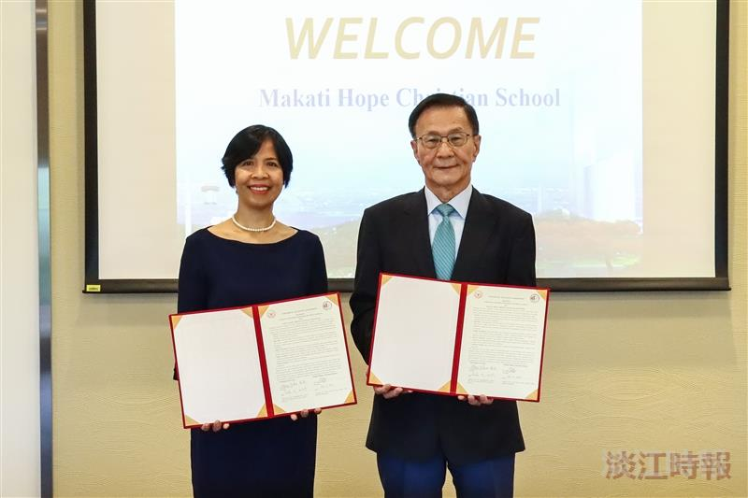
Tamkang University signed a strategic alliance agreement with Makati Hope Christian School in the Philippines, represented by President Huan-Chao Keh (right) and Dr. Marivic L. Daguio (left).

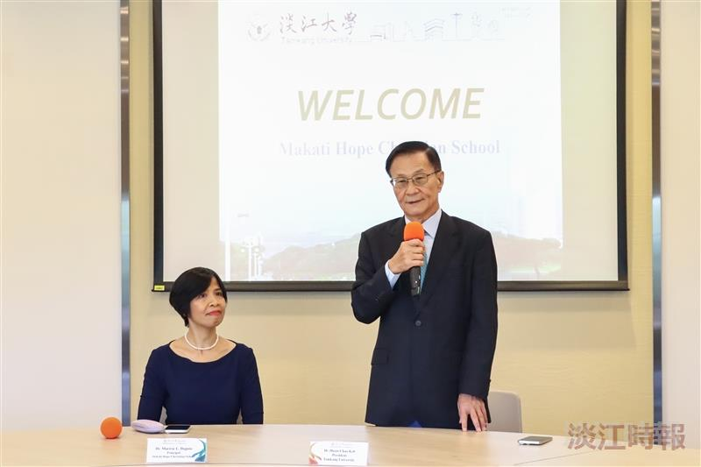
President Huan-Chao Keh delivers a speech.

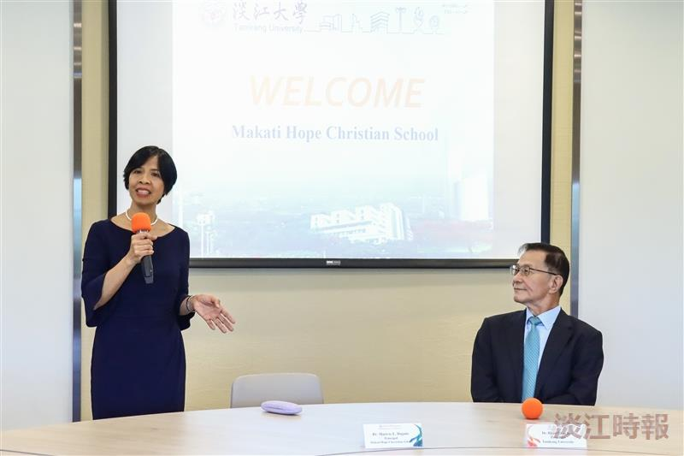
Dr. Marivic L. Daguio (left), Principal of Makati Hope Christian School, delivers a speech.

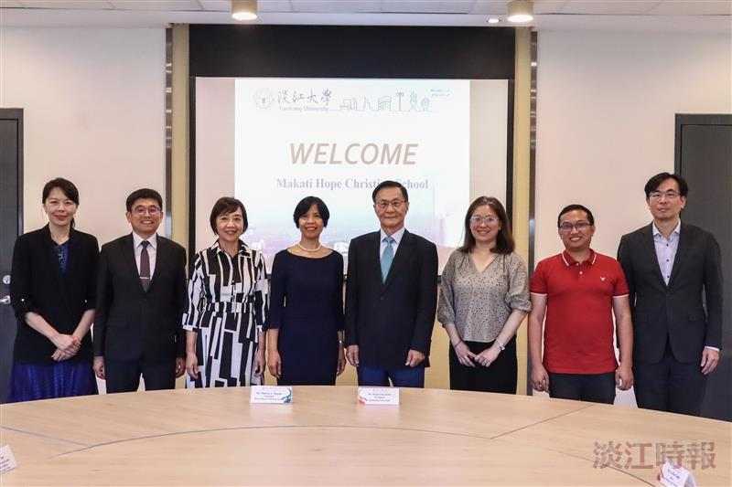
Tamkang University signs a strategic alliance with Makati Hope Christian School in the Philippines.

