Tamkang Times No.1221
Leadership Camp for International Student Club Officers: Training AI-Driven Leaders

The International Student Guidance Section of the Office of International and Cross-Strait Affairs hosted the “2025 Tamkang University International Student Leadership Camp” on June 19 and 20, held at both the Hsu Shou-Chlien International Conference Center and the Fullon Hotel Tamsui. Themed “AI Thinking × Leadership: Shaping the Leaders of Tomorrow,” the camp combined intensive courses with hands-on training to strengthen students’ planning, decision-making, and teamwork skills, laying a solid foundation for future student organization management. This year, 39 officers from 6 international student associations participated, including the Japanese Student Association, Indonesian Student Association, Malaysian Student Association, Lion Dance Club, International Student Friendship Club, and the International Ambassador Team.

At the opening ceremony, Vice President for International Affairs, Prof. Hsiao-Chuan Chen, encouraged students to confidently express themselves and embrace teamwork throughout the camp: “I hope that during these two days, you will share your strengths and perspectives, actively engage in the program, and explore the unique character of Tamkang together — most importantly, I hope you will develop the skills to grow into future leaders.”

Building upon the camp’s tradition of practical training and teamwork, this year’s program placed greater emphasis on the integration of AI tools and applied leadership training. The curriculum was designed around 3 core themes: leadership, recruitment strategies, and sustainability practices. Through high-paced, interactive sessions, student officers gained hands-on experience using AI to develop action plans, learning how to incorporate technology into real-world student organization management to enhance both strategic planning and execution capabilities.+

In the project planning workshops, students worked in groups to apply AI tools across the entire planning process — from brainstorming activities and drafting proposals to designing presentations. Projects focused on showcasing the cultural diversity of countries such as China, Japan, Malaysia, and Indonesia, as well as participants’ experiences and expectations of studying in Taiwan. These activities helped students enhance their creativity, strategic planning, and communication skills, while deepening their understanding of practical AI applications.

Beyond classroom sessions, the camp also featured scenario-based simulations and team-building challenges. On the second day, students took part in an outdoor mission at Tamsui Fisherman’s Wharf, where each team was tasked with locating and photographing assigned landmarks. The activity encouraged students to practice strategic planning, collaboration, and quick decision-making, fostering stronger teamwork and group cohesion.

The closing ceremony, led by Dean of International Affairs, Prof. Chien-Mu Yeh, featured the presentation of the Best Team Award. Prof. Yeh encouraged students with the message, “Join the club like joining a family”, urging them to manage their organizations with dedication and passion: “You have learned valuable skills here. I believe that as the new semester begins, you will confidently apply what you’ve gained during these two days to lead your organizations effectively.”

Participants expressed highly positive feedback after the camp, highlighting the practicality of the courses and the opportunities to connect with peers from different cultural backgrounds. Gracelyn Salim Wong, a sophomore in the Department of Business Administration and officer of the Indonesian Student Association, reflected: “I’ve gained valuable experience in teamwork and problem-solving that I’ll bring back to my organization. Teamwork makes the dream work — only by working together can we turn challenges into our best memories!”
2025/09/12

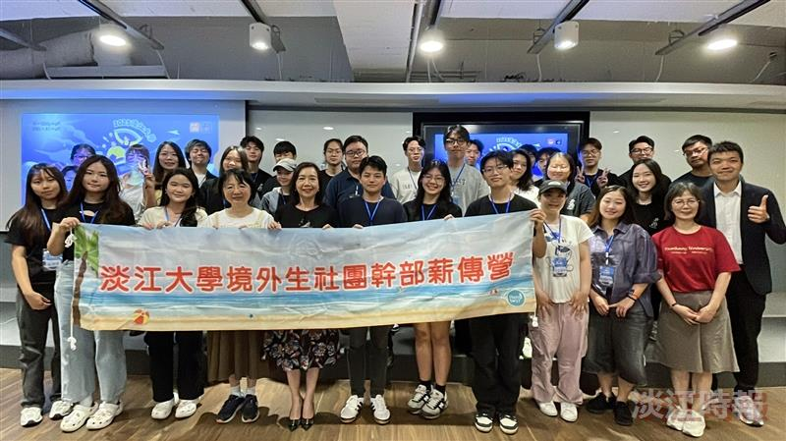
International Student Guidance Section of the International and Cross-Strait Affairs Office organized the 2025 Tamkang University Leadership Camp for International Student Club Officers, aimed at cultivating AI-driven thinking and leadership skills to strengthen their ability to manage student organizations in the future.

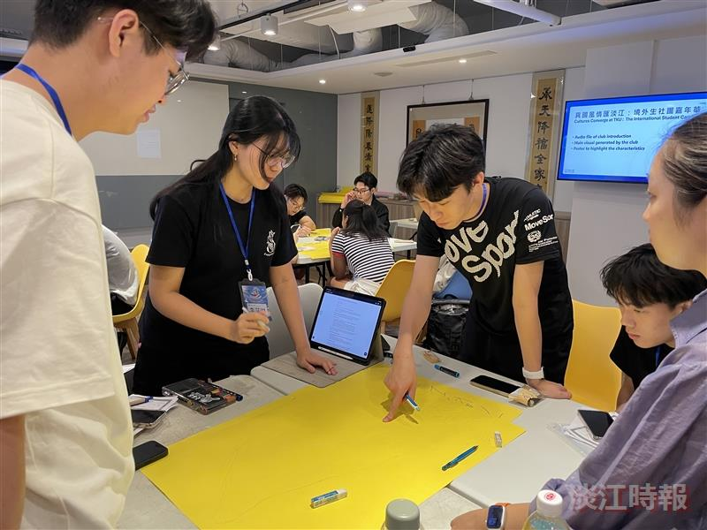
Students worked in groups to carry out project planning exercises.

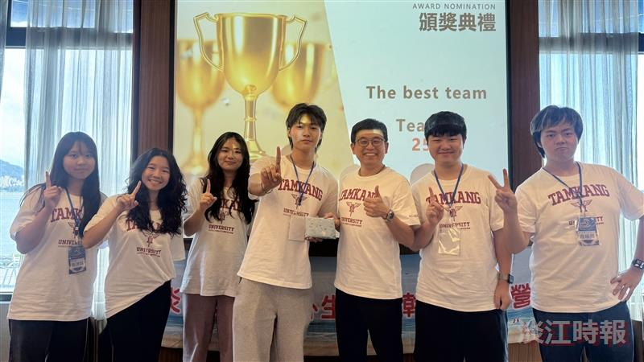
Dean of International Affairs Chien-Mu Yeh presented the prize for the Best Team Award.

