Tamkang Times No.1219
Tamkang x Foxconn x Cardinal Tien x FriendaiotProperty Join Forces to Promote Smart Healthcare: Nation’s First to Offer Free Annual Health Checkups for Students

Tamkang University has partnered with Foxconn Technology Group, Cardinal Tien Healthcare System, and FriendaiotProperty Medical Equipment Property Management Consulting Company to officially launch an annual free health check-up program for all students. Announcing this national first, President Huan-Chao Keh declared, “This donation and collaboration ceremony marks a significant moment where education, healthcare, and industry join hands to promote student health and well-being.” Tamkang University students will be entitled to one free health checkup each year, further advancing the comprehensive digitization of healthcare services.

The signing ceremony took place on June 16 at 10:30 a.m. in the 4th-floor atrium of the Chueh-Sheng International Conference Hall on Tamkang’s Tamsui Campus. The agreement was signed by President Huan-Chao Keh, Chih-Hsiung Chiang (General Manager of Business Group B at Foxconn), Jih-Chyun Chou (President of Cardinal Tien Hospital Xindian), and Kuang-Tsung Lin (General Manager of FriendaiotProperty). FriendaiotProperty donated the CoDoctor Pro “Smart Medical Multifunctional Diagnostic Device – Professional Edition,” along with software updates and technical support. The event was attended by senior executives from all four institutions and university leadership.

This partnership serves as a model for collaboration between higher education and the healthcare system, deepening industry-academic cooperation and driving medical innovation. It represents a key step toward advancing Taiwan’s technology and education sectors. President Keh emphasized that Tamkang prioritizes holistic student development, including health care, and that this health checkup program aligns closely with the university’s strategic development goal: “AI+SDGs=∞.” With AI and smart technology leading the way in the future, the implementation of the SDGs will be accelerated by integrating the research strengths of the College of Engineering, the Artificial Innovative Intelligence College, and the College of Precision Healthcare. “This will help create a healthier, safer, and more compassionate learning environment.”

Chih-Hsiung Chiang described the collaboration as the “digital health movement.” As an alumnus of Tamkang, he was deeply moved that Kuang-Tsung Lin selected medical Level 2 products certified by the Taiwan Food and Drug Administration (TFDA) and donated them for priority use at Tamkang University. From a preventive medicine perspective, he stressed the importance of detecting physiological signals early. With Cardinal Tien’s support, cloud-based and real-time health monitoring can provide complete care. “This is a perfect integration of cloud and on-premise services,” he added.

Jih-Chyun Chou discussed the initiative from a preventive medicine viewpoint, highlighting the “four major plagues” of the 21st century: cancer, dementia, cardiovascular disease, and mental illness. He emphasized that early detection and correction of unhealthy behaviors are essential. “The integration of smart, precision, and green medicine into intelligent hospitals is the direction the medical field eagerly awaits,” he said, adding that partnering with Tamkang gives him great hope.

Kuang-Tsung Lin, who earned his master's degree from Tamkang’s Department of Civil Engineering 27 years ago, recalled the university’s open and liberal academic atmosphere. “Today marks the beginning of preventive healthcare,” he said, noting that basic steps are the most important. Modern dietary habits have led to many health problems. While digital monitoring alone won’t improve health, it can raise awareness. He praised Dean Tzung-Hang Lee of the Colleges of Engineering, Artificial Innovative Intelligence, and Precision Healthcare for his foresight in integrating AI into health care. He also hailed this four-way collaboration as a national leader in health care research and a first step toward better public health. “Let’s begin health management with the younger generation. One day, digital monitoring will become a national habit—and a source of pride.”

Dean Lee further explained that the College of Engineering has already partnered with Foxconn and Harmony in Medical and Technology (HiMEDt). “FriendaiotProperty’s donated equipment will be officially donated to the College of Engineering and permanently installed on campus, offering students free annual health check-ups to enhance the health awareness and preventive medicine concepts among all faculty and students.” If checkup results indicate health concerns, Cardinal Tien Hospital will provide follow-up referrals and professional consultations, establishing a complete health support system from prevention to treatment.
2025/07/29

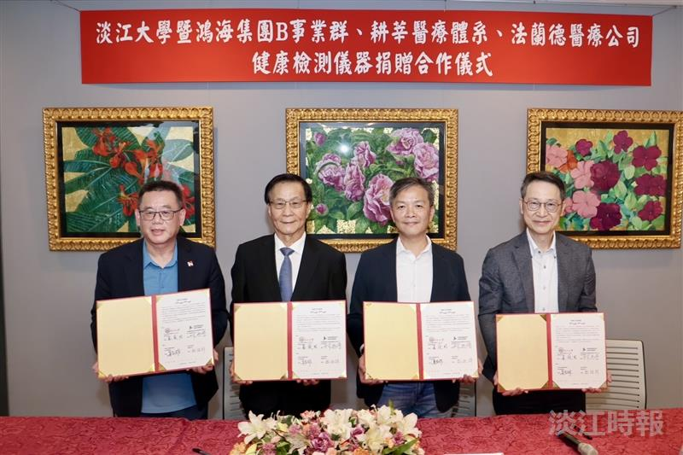
(From left) Chih-Hsiung Chiang, head of Foxconn’s Business Group B; Tamkang University President Huan-Chao Keh; Kuang-Tsung Lin of FriendaiotProterty; and Jih-Chyun Chou, President of Cardinal Tien Hospital Xindian, signed the agreement.

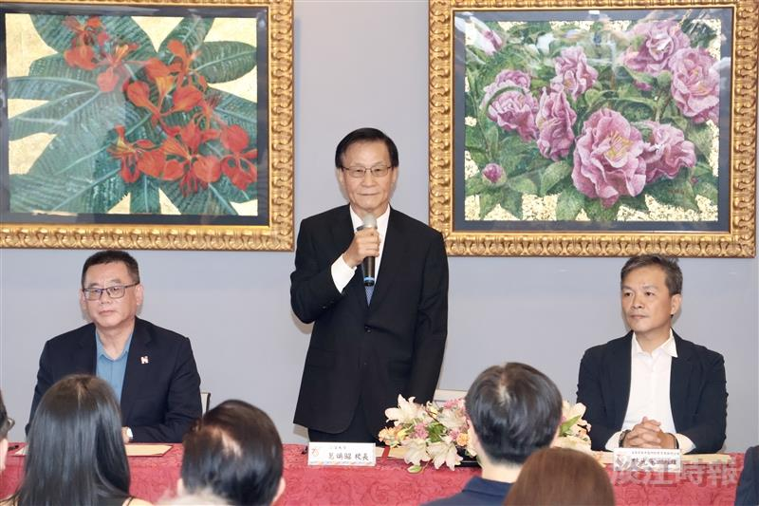
President Huan-Chao Keh declared this national first, stating: “This donation and collaboration ceremony marks a significant moment where education, healthcare, and industry join forces to promote the health and well-being of students.”

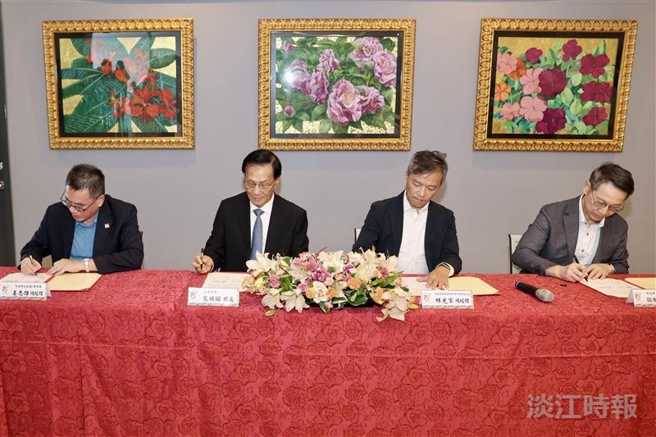
(From left) Chih-Hsiung Chiang, General Manager of Business Group B at Foxconn; Tamkang University President Huan-Chao Keh; Kuang-Tsung Lin of FriendaiotProperty; and Jih-Chyun Chou, President of Cardinal Tien Hospital Xindian, signed the agreement.

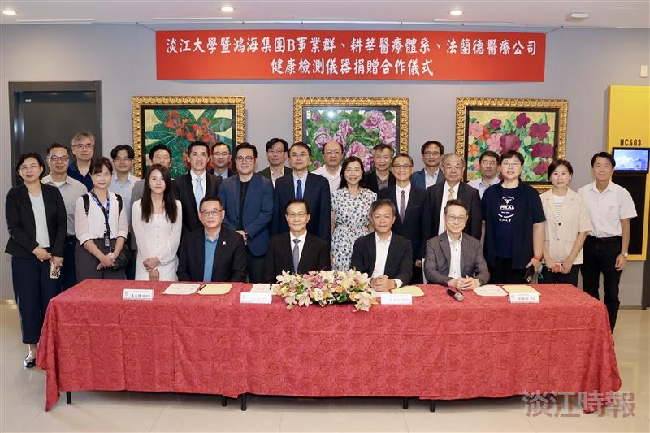
Group photo taken after the signing ceremony.

