Tamkang Times No.1217
[Tamkang Clement and Carrie Chair] Prof. Jussi Parikka: Developing Digital Culture Must Also Consider Environmental Sustainability

Invited by the Department of Information and Communication at Tamkang University, Prof. Jussi Parikka, a renowned scholar in digital aesthetics and media theory from Aarhus University, Denmark, delivered a Tamkang Clement and Carrie Chair Lecture on May 29 at 1:00 p.m. in the Hsu Shou-Chlien International Conference Center's Chang Yeo Lan International Conference Hall. His speech, “Environments of Digital Culture: the Humanities in the Anthropocene”, explored the environmental dimensions of digital culture and the evolving role of the humanities in an era shaped by ecological challenges. Prof. Parikka opened his talk by discussing the construction of a TikTok data center in rural Finland, illustrating how digital technologies are reshaping the global landscape. He emphasized that the humanities must reconsider their role in response to these developments.

Vice President for Academic Affairs Hui-Huang Hsu introduced Prof. Parikka, highlighting the deep interconnection between digital technologies and culture, and welcomed him to address a topic that is both timely and crucial to global sustainability. Inviting faculty member, Assistant Professor Hui-Lan Chang from the Department of Information and Communication, stated that Prof. Jussi Parikka has introduced a forward-looking perspective on media theory to the field of communication. In his book A Geology of Media, he presents the concept of media materiality, exploring the relationship between AI development and environmental sustainability in the digital age. In particular, as Taiwan is a global hub for technology manufacturing, it is essential to examine the potential impacts of technological development on land and society from the perspective of environmental humanities.

In his lecture, Prof. Parikka shared the example of his Finnish hometown—a former paper production center—that transformed into a digital infrastructure hub in just a decade. While the local river, once polluted by industry, has become clean again, new challenges arise from the energy demands of data centers. He stressed that this transformation is not unique to Finland but reflects the global digitalization process. Drawing from his teaching and research across six countries, Prof. Parikka called for rethinking the digital future through an environmental humanities perspective.

For the past decade, Prof. Parikka has advocated bridging media studies with geoscience, arguing that devices like smartphones and tablets depend heavily on rare metals. “What once seemed radical a decade ago has now become common sense. To understand digital culture, we must also understand its mineral foundations and energy dependencies,” he stated. He warned that electronic waste from digital devices forms a new geological layer on the Earth's surface. He called on media scholars to expand disciplinary boundaries and engage in cross-disciplinary collaboration, highlighting the renewed mission of the humanities.

Addressing how university faculty and students should approach digital tools, Prof. Parikka proposed rethinking the role of “media systems.” He cited the solar energy cooperative at Aarhus University as an example of how academic buildings can be transformed into renewable energy production hubs to support the growing demands of computational infrastructure. As the humanities increasingly rely on computational methods and large databases, he urged a reckoning with the material cost of knowledge production: “We must create sustainable knowledge environments and account for the environmental costs of digital humanities research.”

Guan-Hao Liao, a senior student from the Department of Information and Communication, reflected on Prof. Parikka's point that media are extensions of scientific perception, but the material components of media, such as the metals required for their production, are scarce. “As technology advances, we must be more conscious of environmental issues and consider the true cost of using AI. Most importantly, we must cherish and protect the Earth’s resources,” he said.

Prof. Jussi Parikka is a prolific author, and Tamkang University Library holds 23 of his major works, making it the most comprehensive collection of publications among universities in Taiwan. Notable titles include Digital Contagions, Insect Media, and A Geology of Media. From May 21 to 28, the library hosted a book signing and media ecology exhibition, with Prof. Parikka presenting his books' themes at the signing event on May 28, emphasizing the ecological responsibility tied to digital development.

As an artist and curator visiting Taiwan for the first time, Prof. Parikka was accompanied by faculty members from the Department of Information and Communication to visit the Museum of Contemporary Art Taipei and Taipei Digital Center, where he screened a co-directed short film followed by a discussion. He also visited a renowned tea plantation to observe how digital tools are used for business management and operations.

Earlier on May 29, Prof. Parikka paid separate visits to President Huan-Chao Keh and Chairperson Flora Chia-I Chang, accompanied by Dean Huei-Chun Chi of the College of Liberal Arts, Department Chairs Hui-Ju Lai (Information and Communication), Chi-Lin Lee (History), Wen-Yau Cathy Lin (Information and Library Science), Ming-Yu Yang (Mass Communication), and Assistant Professor Chih-Ming Yang (Information and Communication).

President Keh expressed a warm welcome and noted the significance of inviting Prof. Parikka as Tamkang’s first guest scholar from Northern Europe. He also expressed hope for potential academic partnerships with Danish institutions, as Tamkang has no sister schools in Denmark. Chairperson Chang shared the origin of the Tamkang Clement and Carrie Chair series with Prof. Parikka. Visiting Taiwan for the first time, Prof. Parikka praised the beauty of Tamkang’s campus and appreciated the restful stay in the Panda Suite at the Hwei-Wen Hall.

As a prolific author, he thanked the library for organizing the book signing event, expressing his heartfelt appreciation for Tamkang’s complete collection of his publications—the most extensive among Taiwan’s university libraries. President Keh introduced the university’s recent efforts in integrating AI into teaching and also presented the “Smart e-Pen” system, a collaborative project between the Carrie Chang Fine Arts Center and the College of Engineering, spearheaded by Director Ben-Hang Chang. Chairperson Chang discussed the relationship between media culture and sustainability and the humanities' critical role in the digital media age. To commemorate the visit, President Keh and Chairperson Chang presented Prof. Parikka with the Panda trophy and a specially crafted Tamkang vase featuring calligraphy by masters Chi-Mao Lee and Ben-Hang Chang, along with imagery of the university and its anthem lyrics.
2025/06/16

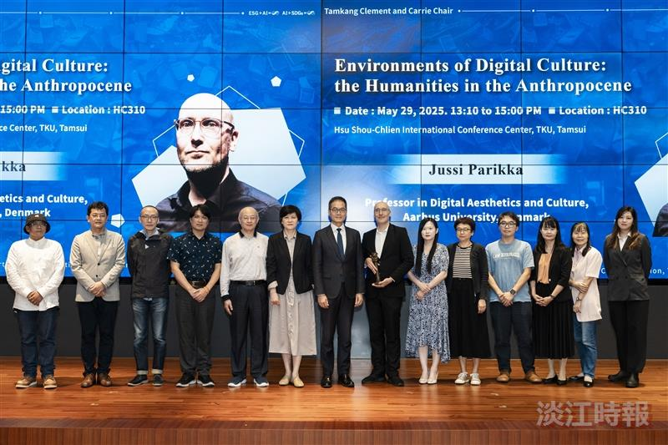
Professor Jussi Parikka (7th from the right), Vice President for Academic Affairs Prof. Hui-Huang Hsu (8th from the right), along with the Dean of the College of Liberal Arts, department chairs, and faculty members from the Department of Information and Communication, pose for a group photo.

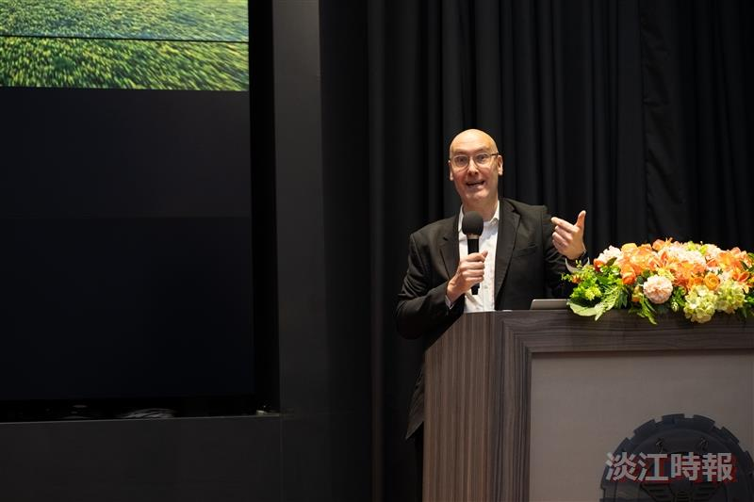
Professor Jussi Parikka from the Department of Digital Aesthetics and Culture at Aarhus University, Denmark, visited Tamkang University to deliver a lecture.

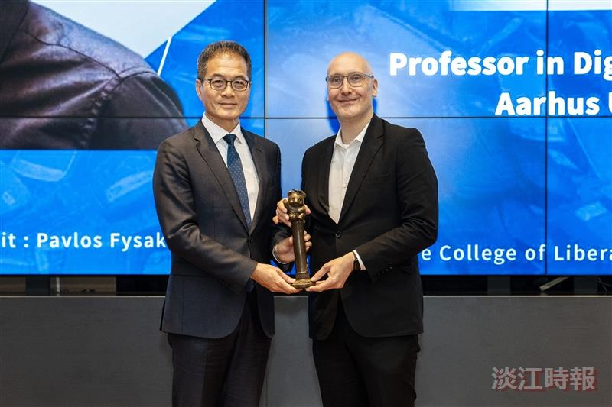
Vice President for Academic Affairs Prof. Hui-Huang Hsu (left) presented the Panda trophy.

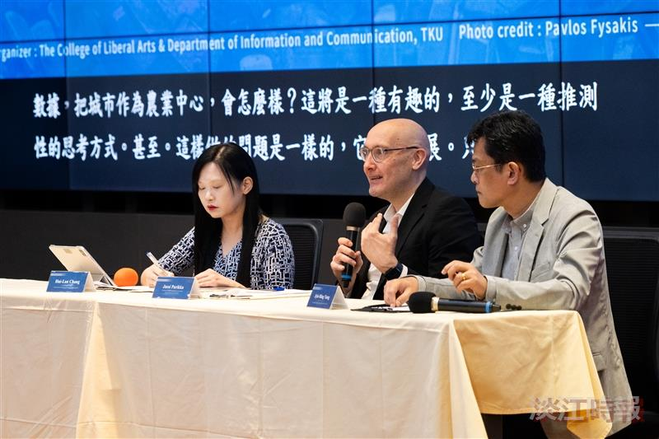
Following the lecture, a discussion session was held where Prof. Jussi Parikka (center) warmly responded to students' questions, flanked by Assistant Professors Jyh-Ming Yang (right) and Hui-Lan Chang from the Department of Information and Communication.

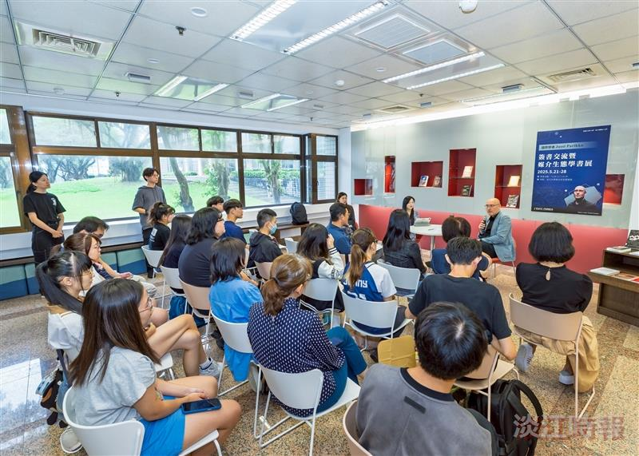
From May 21 to 28, the university library hosted a book signing and Media Ecology Book Exhibition with Tamkang Clement and Carrie Chair, Prof. Jussi Parikka.

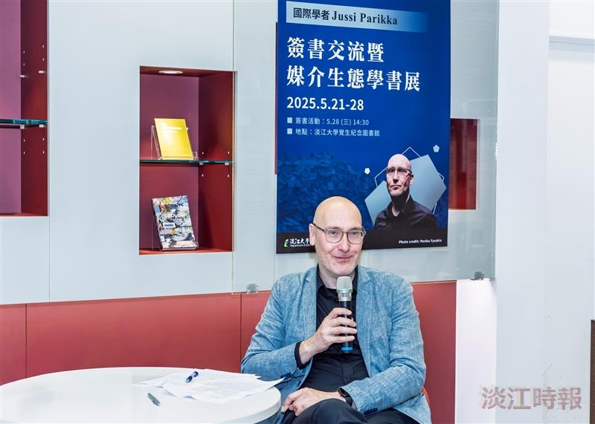
Prof. Jussi Parikka shared insights about his works during the book signing event.

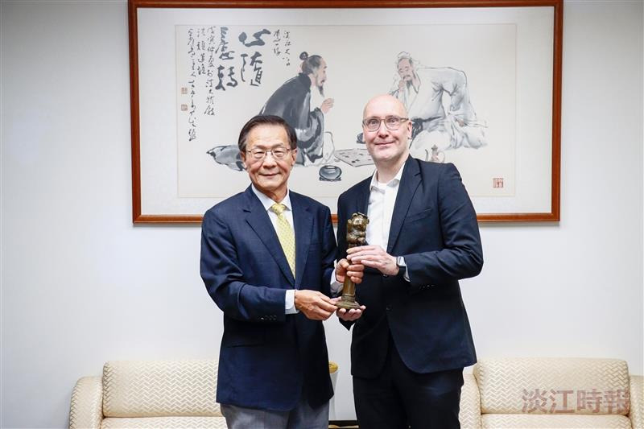
President Huan-Chao Keh (left) personally presented the Panda trophy to Prof. Jussi Parikka, the Tamkang Clement and Carrie Chair speaker, invited by the Department of Information and Communication.

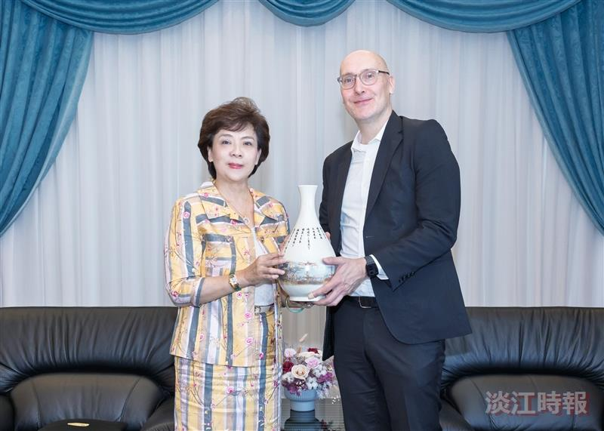
Chairperson Flora Chia-I Chang (left) personally presented a signature Tamkang vase to Prof. Jussi Parikka, the Tamkang Clement and Carrie Chair speaker, invited by the Department of Information and Communication.

