Tamkang Times No.1215
Chinese Reading and Speech Contest: International Students Showcase Learning Achievements with Fluent Mandarin

The Office of International and Cross-Strait Affairs hosted the 2024~2025 Academic Year Chinese Reading and Speech Contest for International Students on the evening of May 8 at the Ching-Sheng International Conference Hall. The event provided a platform for international students to demonstrate their language learning achievements and express themselves through reading articles, lyrics, and sharing personal experiences and cultural observations. In the end, Aksarapat Khuttiya, a first-year International Business student, won the reading category championship. In contrast, Juan Rojas Merino, a first-year Spanish exchange student, stood out in the speech category and claimed first place.

In the reading category, 16 international student groups recited short texts, poems, and song lyrics, showcasing their sensitivity to rhythm and emotion despite Chinese not being their native language. In the speech category, 17 students presented perspectives on cultural topics such as the differences between northern and southern zongzi, experiences in the Hanxi village indigenous community, and reflections on pursuing dreams. The contest became not just a language competition but a space for cross-cultural listening and exchange.

Judges praised the students for their fluency, pronunciation, natural emotional expression, and content-rich presentations. “Many of them only started learning Chinese after arriving in Taiwan. It’s truly moving to see such impressive progress quickly,” one judge remarked. Judge Hsiu-Ling Tung particularly appreciated the originality of topics, such as cultural comparisons and firsthand experiences in indigenous villages, expressing excitement for next year’s competition.

Indonesian student Aksarapat Khuttiya won first place in the reading category with her interpretation of the fable Freedom in Heaven (〈天堂裡_的自由〉), offering the insight: “True freedom is not about where you are, but whether your heart is happy and whether you have the right to choose.” She described the competition as a meaningful and unforgettable experience, having devoted significant time to practicing pronunciation and rhythm, seeking guidance from teachers and peers, and improving based on their feedback. She was very grateful for the opportunity to share a story that deeply moved her with everyone.

In the speech category, Spanish student Juan Rojas Merino won first prize with his humorous account of cultural misunderstandings in Taiwan, such as mistaking a QR code on a drink bottle for a prize notification or confusing the garbage truck music for an ice cream truck. He noted these moments helped him reflect on cultural differences. In his fourth year of Chinese study, he said, “This competition is not just a stage—it’s a reminder that I’m making progress.”

Among other standout participants, Vietnamese student Nguyen Thi Minh Anh from the International Foundation Program wore traditional Vietnamese attire and read Vietnam’s Declaration of Independence with a steady tone and evident emotion, earning fourth place in the reading category. Japanese student Haruto OKatsu from the Department of Diplomacy and International Affairs received a special award in the speech category for his heartfelt talk titled, Taiwan, A Happy Rainbow Nation, where he shared his experiences of acceptance as an LGBTQ+ individual in Taiwan. He expressed his gratitude for the ability to tell his story in Chinese, receiving warm applause from the audience.

Winners List

Reading Category: 1st, Aksarapat Khuttiya, year 1 in International Business; 2nd, Ono Mifu, year 1 in Chinese Literature; 3rd, Rio Miki, year 1 in Public Administration; 4th, Nguyen Thi Minh, year 1 in Information & Communication; 5th, Yuri Takata, year 1 in International Business; Special Awards, Nguyen Quynh Phuong, year 2 in the English-taught master’s program in Banking and Finance; Nguyen Thanh Binh, year 1 in the master's program in Information & Communication. Speech Category: 1st, Juan Rojas Merino, year 1 exchange student in Spanish; 2nd, John Charles, year 4 in Business Administration; 3rd, Hellena, year 1 in Business Administration; 4th, Tran Giang Tuan Thanh, year 1 in Civil Engineering; 5th, Akari Sawa, year 1 in International Business; Best Stage Presence, Yuri Ishitomi, year 1 exchange student in Chinese Literature; Jessica Angel Viola, Chemical and Materials Engineering; Special Awards, Haruto OKatsu, year 2 in Diplomacy and International Relations; Miki Mashiro, year 1 exchange student in Japanese.
2025/06/03

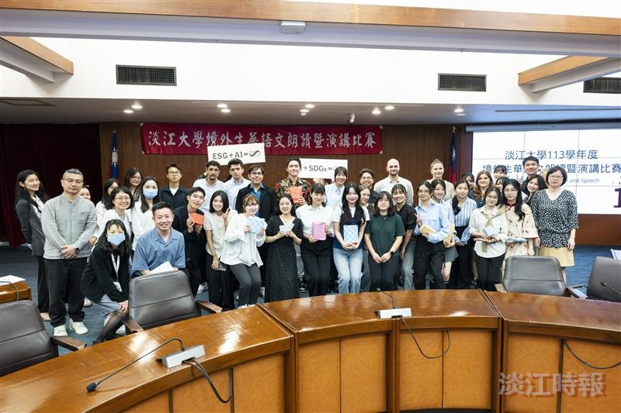
The Office of International and Cross-Strait Affairs held a Chinese Reading and Speech Contest for international students on May 8; participants posed for a group photo after the competition.

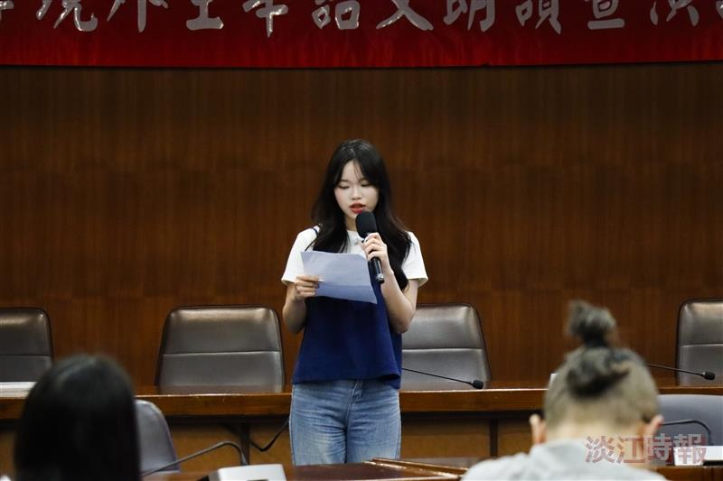
Aksarapat Khuttiya, a first-year student in International Business, won first place in the reading category with her recitation of Freedom in Heaven (〈天堂裡_的自由〉).

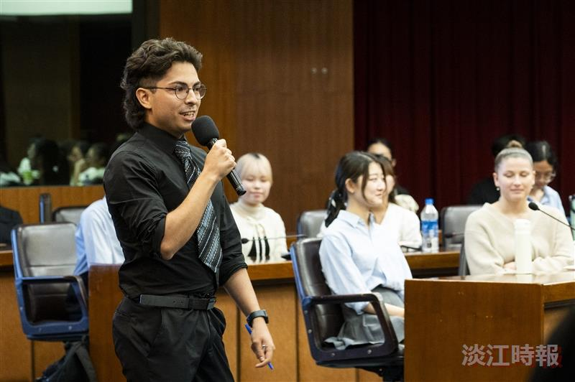
Juan Rojas Merino, a first-year exchange student in Spanish, humorously shared on “Cultural Differences Between Taiwan and Spain” and won first place in the speech category.

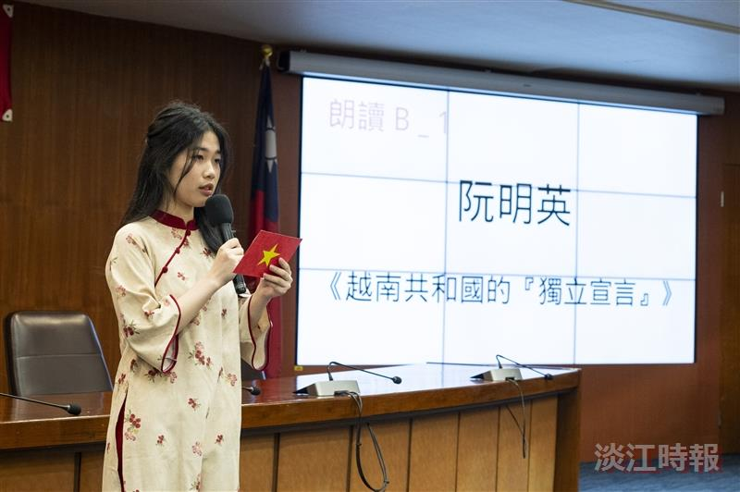
Nguyen Thi Minh Anh, a first-year Information and Communication student from the International Foundation Program, wore traditional Vietnamese attire and held the Vietnamese national flag while reading the "Declaration of Independence of the Republic of Vietnam."

