Tamkang Times No.1215
Physics Exchange Student Kristofer R. Sano Realizes His Dream of Becoming a Scientist at Tamkang

Kristofer R. Sano, an exchange student from Mapúa University in Manila, Philippines, fulfilled his dream of becoming a scientist at Tamkang University’s Department of Physics this semester. Since kindergarten, he had aspired to be a scientist, and that dream came true when he arrived at Tamkang. Under the guidance of the Department Chair, Professor Cheng-Hao Chuang, Kristofer came to Taiwan to explore advanced instruments and radiation detection research. In the Energy Materials Laboratory, he learned essential knowledge about personal safety, proper handling of detection equipment, and the management of chemicals. Before returning home, he created a video and an impressive report to preserve these invaluable memories.

He shared, “People at Tamkang are very friendly. Although I don’t understand Chinese and communication can be difficult, I have constantly met amazing individuals on the bus, in the library, and at school events. I made many good friends here.” Initially, he felt nervous handling equipment worth millions of NT dollars in the lab. He often worked day and night until 2 a.m., completing sample measurements and packaging. Yet as an aspiring scientist, he found great fulfillment in satisfying his thirst for knowledge.

Kristofer’s research experience extended beyond Tamkang. He also spent three intensive days—operating 24 hours a day—at the National Synchrotron Radiation Research Center in Hsinchu. There, he realized the vast scope of scientific work. The facility is a large-scale physics lab and a multidisciplinary hub for engineers, biologists, pharmaceutical scientists, and materials researchers. Now well-versed in conducting experiments in a synchrotron and performing qualitative analyses through observation and computation, Kristofer expressed profound gratitude to the Department of Physics for offering this exchange opportunity, which made his incredible journey possible. He hopes more students will be inspired to explore the world of science.

Professor Chuang, who served as his advisor, highly praised Kristofer’s outstanding performance during the exchange period. He noted that Kristofer independently handled all stages of the research, from material synthesis and testing to mass spectrometry analysis. In just two months, he experienced the equivalent workload of a master's program. Chuang emphasized that by opening the lab to international collaboration, overseas students can witness the strengths of Tamkang's physics research and the potential of future materials applications. He hoped that more students would be drawn to participate, further raising Tamkang’s academic profile in physics.
2025/06/03

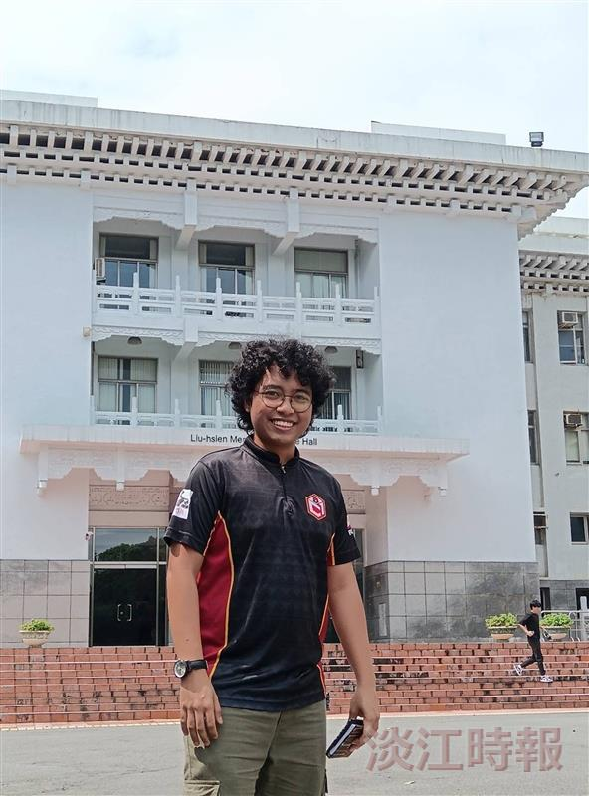
Kristofer R. Sano from the Philippines is delighted to join the Department of Physics at Tamkang University as an exchange student and to explore new scientific knowledge.

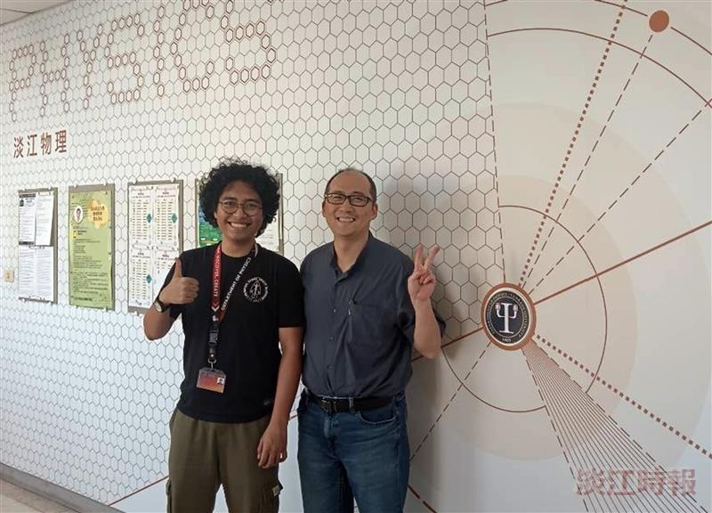
Kristofer R. Sano from the Philippines (left) is thrilled to join the Department of Physics at Tamkang University and learn scientific knowledge under the guidance of Department Chair Cheng-Hao Chuang.

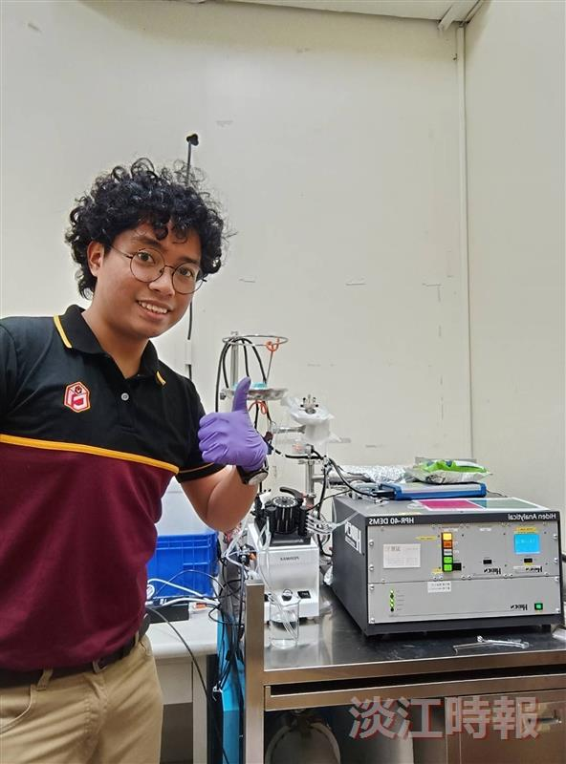
Kristofer R. Sano from the Philippines praised the Department of Physics for its advanced and well-equipped laboratories.

