Tamkang Times No.1215
【Department Spotlight】Distinguished Chair Professor Way-Faung Pong 's Paper Published in Leading U.S. Journal JACS, Advancing Clean Energy Research

Distinguished Chair Professor Way-Faung Pong from the Department of Physics, in collaboration with research teams from National Taiwan University (NTU) and the National Synchrotron Radiation Research Center (NSRRC), co-authored a paper titled “In Situ Identification of Spin Magnetic Effect on Oxygen Evolution Reaction Unveiled by X-ray Emission Spectroscopy”, which was published in April in the prestigious international journal, Journal of the American Chemical Society (JACS). The journal, published by the American Chemical Society, has an impact factor of 14.4 and a history spanning 150 years, making it one of the most authoritative Q1 journals in physics and chemistry.

Prof. Pong noted that this study is the first to utilize synchrotron-based X-ray Emission Spectroscopy (XES) and X-ray Absorption Spectroscopy (XAS) under applied magnetic field conditions to observe the spin state evolution of iron and cobalt atoms in the magnetic spinel catalyst CoFe₂O₄ during the Oxygen Evolution Reaction (OER). The results demonstrate a significant correlation between magnetic properties and catalytic activity, representing a green energy materials research breakthrough. This discovery opens promising applications in hydrogen energy, a key component in global net-zero transformation strategies.

The paper was co-authored by Professor Pong and Distinguished Professor Chun-Wei Chen from the Department of Materials Science and Engineering at NTU, along with scientists from the NSRRC. Professors Pong and Chen served as corresponding authors. The third and fourth authors are Tamkang University Ph.D. students Wei-Xuan Lin (3rd-year) and Kuan-Hung Chen (5th-year), both of the Physics Department’s Absorption Spectroscopy Laboratory. Other co-authors include three researchers from NSRRC, Dr. Chih-Wen Pao, Dr. Jyh-Chyuan Jan, and Dr. Yu-Cheng Shao, as well as Professor Jau-Wern Chiou, Chair of the Department of Applied Physics at National University of Kaohsiung. All are Tamkang’s Physics Department alumni and former doctoral students under Professor Pong’s guidance.

Pong emphasized that, with the support of Taiwan Photon Source (TPS) beamline 44 at NSRRC and the domestically developed BL12XU beamline at Japan’s SPring-8 synchrotron facility, the team overcame prior technical limitations to reinterpret magnetic field-driven catalysis from an electron spin perspective. This breakthrough holds significant scientific value and application potential for developing high-efficiency water-splitting hydrogen production and low-carbon energy materials. “This research highlights the strong capabilities of Tamkang University’s Department of Physics in synchrotron radiation techniques and energy materials science,” Pong remarked. “It also injects new momentum into advancing clean energy technologies.”
2025/06/03

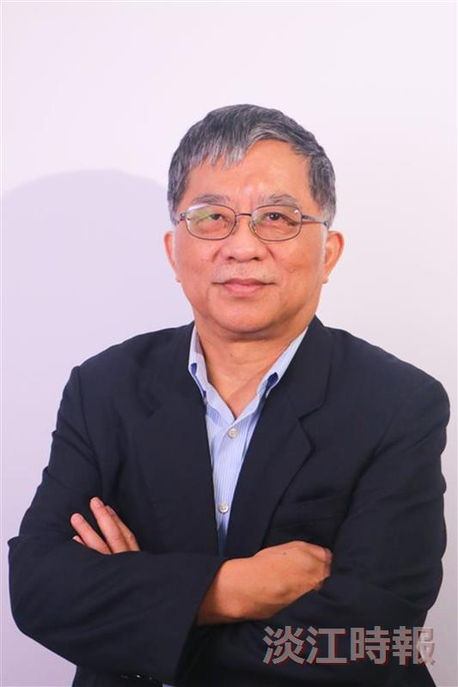
Distinguished Chair Professor Way-Faung Pong from the Department of Physics, in collaboration with teams from National Taiwan University and the National Synchrotron Radiation Research Center, published a research paper in April in the prestigious international journal, Journal of the American Chemical Society (JACS), which has an impact factor of 14.4.

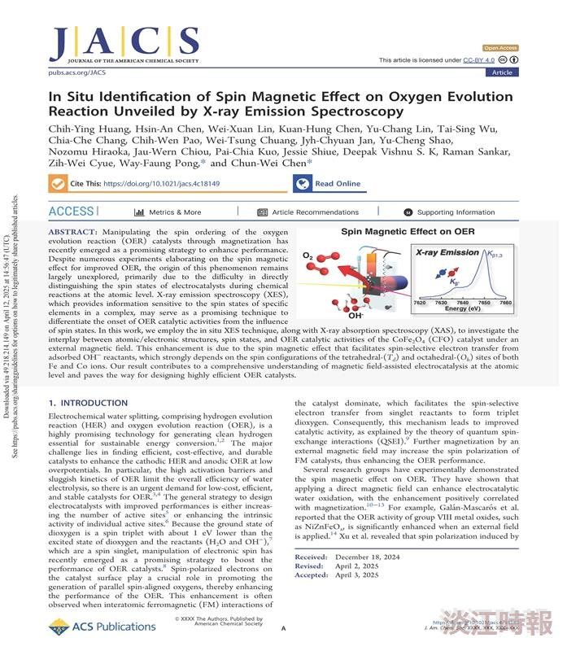
Distinguished Chair Professor Way-Faung Pong from the Department of Physics, in collaboration with teams from National Taiwan University and the National Synchrotron Radiation Research Center, published a research paper in April in the prestigious international journal, Journal of the American Chemical Society (JACS), which has an impact factor of 14.4.

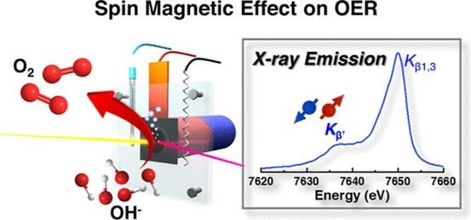
Distinguished Chair Professor Way-Faung Pong from the Department of Physics, in collaboration with teams from National Taiwan University and the National Synchrotron Radiation Research Center, published a research paper in April in the prestigious international journal, Journal of the American Chemical Society (JACS), which has an impact factor of 14.4.

