Tamkang Times No.1213
VP Hui-Huang Hsu Calls for Digitalization and Open Access to Boost Journal Impact at Tamkang

On the afternoon of April 21, the Publishing Center of Tamkang University’s Office of Research and Development hosted a forum on “Open Access and Journal Management” in HC303. Assistant Professor Tzu-Lan Tseng from the Department of Management Sciences shared insights on “The Development and Digital Transformation of Academic Journals: Strategies and Experiences to Enhance Impact.” Vice President for Academic Affairs Hui-Huang Hsu emphasized the importance of digitalization and Open Access (OA), stating, “By making research freely accessible online, academic outcomes can break geographical barriers and gain global visibility, while reducing paper usage also supports environmental sustainability.”

Dean of Research and Development, Prof. Hung-Chung Hsueh, noted that fewer private universities continue publishing academic journals. As a leading private university in academic development, Tamkang University maintains high standards and competes on par with national universities. He hoped that Tamkang would continue to achieve quantitative and qualitative breakthroughs. Publishing Center Director Prof. Wen-Yau Cathy Lin added that the development of Open Access has already been included in the university’s current development plan. The university aims to strengthen collaborations with domestic and international third-party archiving platforms to ensure the long-term preservation and dissemination of academic output.

Asst. Prof. Tseng, who oversees Tamkang’s university-run journal The International Journal of Information and Management Sciences (IJIMS), shared her experience transitioning the journal’s workflow. Previously, submissions were made via email, requiring the editorial team to respond, assign tracking numbers, and manage the review process manually. Since 2022, IJIMS has undergone a complete digital transformation, migrating all submissions and peer reviews to the iPress platform. The team also retroactively archived past issues, digitized print files, and organized journal volumes and review records. Additionally, IJIMS has launched dual applications for inclusion in ESCI and TSSCI indexes. The team has been closely reviewing key evaluation indicators such as rejection rates, publication timelines, formatting consistency, citation standards, and the quality of reviewer feedback. With a clearly defined work schedule, the journal has systematically improved in all these areas and met the required benchmarks.

To further enhance journal quality, Prof. Hsu suggested that having internal university units take charge of initial structural checks could help maintain consistent quality. Prof. Lin explained that to ensure a stable digital archiving mechanism, in addition to each journal maintaining its archives, joining the TOAJ platform, supported by the National Science and Technology Council, is recommended. This would help ensure long-term preservation of journal content and enhance the university’s academic visibility and research value.
2025/05/20

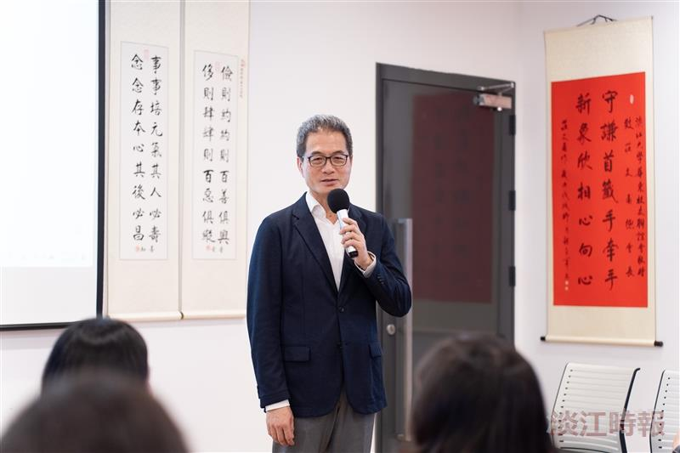
The Publishing Center of the Office of Research and Development held a forum on open access and academic journal management. Vice President for Academic Affairs Hui-Huang Hsu emphasized the importance of digitalization and open access (OA).

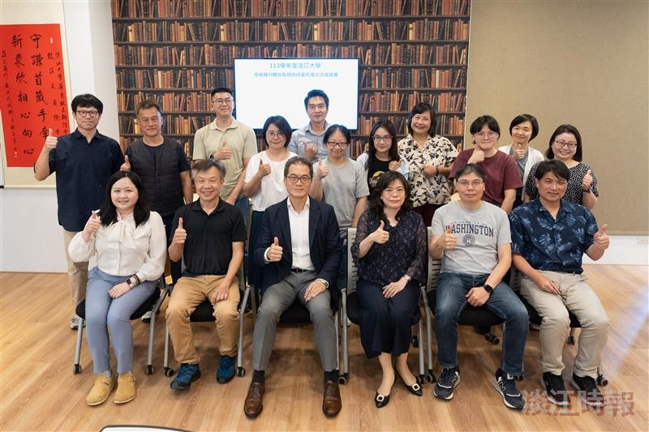
The Publishing Center hosted a forum on open access and academic journal management.

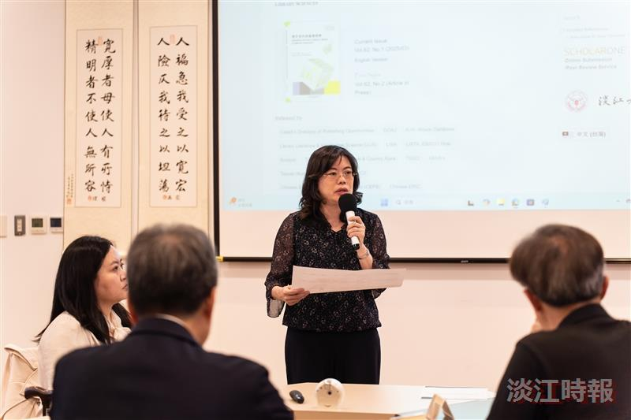
Director of the Publishing Center, Prof. Wen-Yau Cathy Lin, explained that Open Access has been included in the center’s development plan to ensure the long-term preservation and dissemination of academic research.

