Tamkang Times No.1211
Assoc. Prof. Li-Mei Liu’s Scholarly Monograph Revives Rare 18th-Century Spanish Missionaries’ Mandarin Research Archives

Associate Professor Li-Mei Liu from the Department of Spanish has published her new scholarly monograph The Grammar of Mandarin Chinese (《中國官話語法》, Arte de lengua chinica, que vulgarmente se llama mandarina) in March this year, through Tamkang University Press. This work results from her National Science and Technology Council (NSTC) overseas research project conducted between 2022 and 2023. By uncovering this previously unstudied text, Liu aims to explore 18th-century Spanish missionaries' research on Mandarin Chinese grammar and contribute to contemporary scholarship’s reexamination of early Western linguistic thought and its intersection with Chinese grammar. The monograph also provides valuable material for studies on linguistic views and cross-cultural grammatical traditions during the Ming and Qing dynasties.

Li-Mei Liu specializes in Chinese–Spanish translation studies. The Grammar of Mandarin Chinese bears witness to the efforts of two authors - 18th-century Spanish missionaries from the Order of Saint Augustine—Juan Rodríguez (1724–1785) and José de Villanueva (1734–1794)—who conducted grammatical research on Chinese in the Philippines, showcasing the Western world’s early understanding and interpretation of Chinese grammatical structures. The book faithfully reproduces the original grammar manuscripts of these two authors, conducts comparative analysis, and systematically organizes their observations on the Chinese language and grammar, encompassing both historical research and Chinese translation.

The content documented reflects the historical process through which Western missionaries, starting in the 16th century, explored and understood the Chinese language system after arriving in Asia. Through firsthand contact, linguistic observation, and extensive fieldwork, they collected rich data and, applying Latin grammatical frameworks, attempted to construct a descriptive model of Chinese aligned with Western grammatical logic.

From the 16th to the 18th century, this process involved the compilation of language manuscripts, lecture notes, and dictionaries by early missionaries, leading to the later construction and systematization of Chinese grammatical knowledge. Liu noted that this body of work not only played a crucial role in shaping Europeans' understanding of Chinese grammar at the time but also exerted a lasting and profound influence on linguistic and Sinological research during the 18th and 19th centuries.

The book focuses primarily on presenting the original manuscripts, showcasing historical documents, and conducting comparative analyses between different versions. It includes the Latin and Spanish manuscripts written by the first author and the expanded and revised versions produced by the second author.

Liu plans to continue exploring the diachronic development of this grammar work in her next monograph.

"It is highly meaningful that Liu received NSTC funding and chose our university press for the publication," said Prof. Wen-Yao Cathy Lin, Director of Tamkang University Press. She emphasized that encouraging academic research and publishing scholarly monographs using the university's academic resources has been a key focus of the press in recent years.
2025/05/06

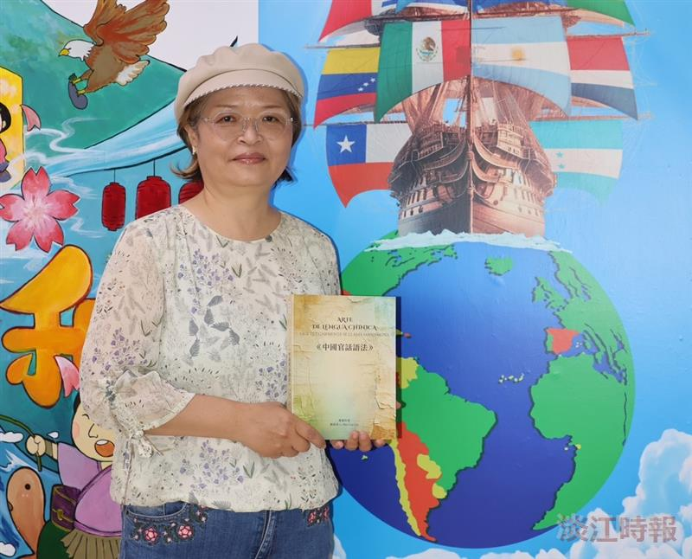
Associate Professor Li-Mei Liu poses with her new book, The Grammar of Mandarin Chinese (《中國官話語法》, Arte de lengua chinica, que vulgarmente se llama mandarina）

