Tamkang Times No.1211
【Department Spotlight】4 Architecture Alumni Admitted to Columbia University’s Graduate School of Architecture Through Perseverance

Tamkang University's Department of Architecture graduates are advancing straight into Ivy League schools! In 2025, 4 alumni, including Chi-Tung Wu, were admitted to the Master of Science degree in Advanced Architectural Design of the Graduate School of Architecture, Planning, and Preservation, Columbia University's (Columbia GSAPP, M.S.AAD). The news, shared on the Department of Architecture’s Facebook page, greatly excites faculty and students. Among them, Chi-Tung Wu was awarded the Dean’s Scholarship from Columbia University, worth an impressive USD 45,000, highlighting his outstanding performance and potential.

Among the four alumni, the youngest is Yen-Ting Cha, who graduated in 2024. Kuan-Yi Hsiao, Nien Li, and Chi-Tung Wu graduated in 2016, 2020, and 2023, respectively. All four set their sights on Columbia and were successfully admitted, demonstrating Tamkang University’s strong competitiveness in international architectural education. "Such achievements are backed by years of preparation and perseverance," said Professor Tzen-Ying Ling, a Columbia GSAPP alumna who served as their recommender, expressing her pride.

The four alumni have built impressive portfolios. Chi-Tung Wu, who received the scholarship, had previously been awarded a fully funded visiting student position at the University of California, Berkeley in 2023. In addition to his Columbia admission this year, he was accepted into UC Berkeley and the University of Pennsylvania (U Penn) for their architecture graduate programs.

Wu’s recent accolades are remarkable, including an Honorable Mention at the Taipei Architects Association’s Graduation Design Awards, selection as a finalist and honorable mention for the Asian Contest of Architectural Rookie’s Awards (ACARA), and a total of eight major prizes.

Department Chair Chun-Jung Ko commented, "The department is committed to providing international resources and support mechanisms. We even offer courses including overseas international workshops during the summer, allowing students from their junior year onward to receive critiques from international experts, broadening their horizons and boosting their confidence and global competitiveness in design." These courses provide students with extensive growth opportunities, and the Office of International and Cross-Strait Affairs and the College of Engineering offer additional support. "Dean Tzung-Hang Lee of the College of Engineering has also specially increased the annual scholarship funding to support these efforts," Ko added.

Professor Ling explained that students aiming to study abroad often set their goals during their junior or senior years, working closely with faculty to develop individualized application plans. From preparing portfolios, studying for language exams, and assembling application documents, to practicing mock interviews, every step requires enormous time and effort.

She noted that some students enter architecture firms after graduation, "juggling practical work during the day while continuing to revise portfolios and prepare for exams at night; others balance heavy graduation projects with language and academic preparations, gradually finding their rhythm and direction under intense pressure and time constraints." She praised them, saying, "It wasn't me pushing them forward; their determination and effort drove them."

Ling emphasized that applying to top international graduate programs requires tremendous perseverance and patience, and the hardships behind these achievements are often unseen. "Their success is no accident; it is the inevitable result of years of preparation," she said. Lin also encouraged future students who aspire to challenge prestigious schools: "The most important things are confidence and persistence. If you believe in yourself and are willing to work step by step, you can reach the stage where your dreams come true."
2025/05/06

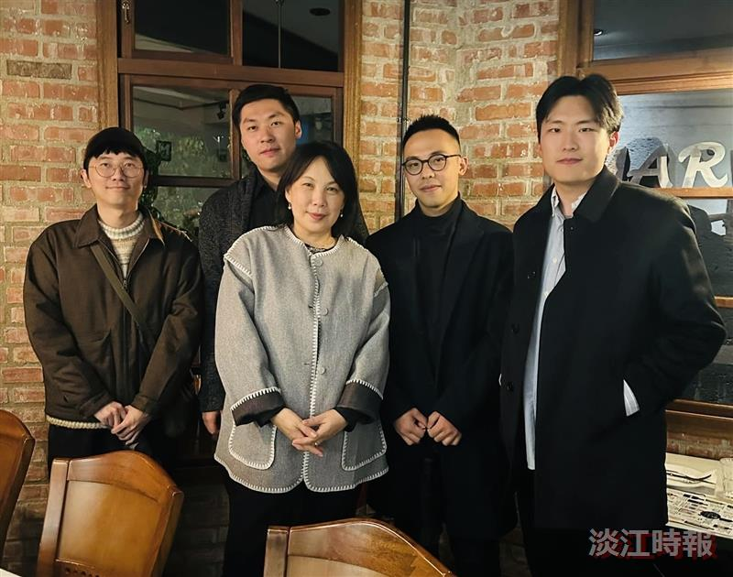
Professor Tzen-Ying Ling from the Department of Architecture poses for a photo with alumni admitted to Columbia University's Graduate School of Architecture this year. From left to right: Nien Li, Kuan-Yi Hsiao, Tzen-Ying Lin, Chi-Tung Wu, and Yen-Ting Cha.

