Tamkang Times No.1209
5 Undergraduate Programs in Engineering College Pass 2025 IEET Accreditation, Boosting International Competitiveness

5 undergraduate programs in Tamkang University’s College of Engineering—Civil Engineering, Mechanical and Electro-Mechanical Engineering, Electrical and Computer Engineering, Computer Science and Information Engineering, and Aerospace Engineering—have officially passed the 2025 IEET (Institute of Engineering Education Taiwan) accreditation. Dean Tzung-Hang Lee stated that this recognition affirms the college's engineering education quality as meeting international standards and that its graduates possess globally acknowledged academic credentials, giving them a competitive edge in domestic and international employment and further studies.

IEET accreditation is recognized by the Washington Accord. Tamkang University was among the first private universities in Taiwan to receive IEET accreditation in 2007. Since then, the university has continued to enhance its curriculum design and teaching quality to stay aligned with global standards. The newly granted accreditation is valid for 6 years, from August 1, 2024, to December 31, 2030. It verifies the departments’ performance in educational objectives, graduate core competencies, curriculum and teaching, faculty, equipment and facilities, administrative support, and funding, with a built-in mechanism for continuous improvement.

IEET places a strong emphasis on student learning outcomes. By requiring a comprehensive capstone course, the accreditation ensures departments cultivate students’ practical abilities and showcase their academic achievements. According to Dean Lee, each department in the College of Engineering includes a capstone course in its program. Students complete team-based senior projects to integrate and apply their learning. These are showcased through exhibitions and competitions that offer scholarships and encourage peer learning. For example, alumni of the Electrical and Computer Engineering Department sponsor the “Innovation and Creativity Competition” and the “Autonomous Delivery Challenge.” Departments like Civil Engineering and Computer Science have also established annual “Project Competitions” that have become signature traditions. Participation in national and international competitions has further motivated students. Electrical and Computer Engineering faculty and students have repeatedly won championships at FIRA’s Robot Soccer World Cup. The Computer Science and Information Engineering Department has received several awards in the “AI Talent” Competition hosted by the Administration for Digital Industries, applying classroom knowledge to real-world industry problems. The Aerospace Engineering Department has excelled in the “Taiwan UAV Innovation Design Competition,” achieving notable results.

Regarding facilities, the Department of Mechanical and Electro-Mechanical Engineering recently secured approximately NT$40 million through the Ministry of Education’s Machine Tool Teaching Equipment Renewal Program, enhancing students’ hands-on learning opportunities. Courses have been developed around the newly procured CNC machine tools, aligning closely with current industry demands. The department also continues its innovative work in assistive technology for the visually impaired, receiving over NT$85 million in MOE research funding.

Academically, graduates demonstrate high levels of achievement across the eight core competencies, reflecting strong alignment with the curriculum and teaching methods. Full-time faculty actively participate in National Science and Technology Council (NSTC) research projects and encourage students to apply for undergraduate research grants. For instance, the Department of Electrical and Computer Engineering has secured 41 such grants between the 2018 and 2023 academic years. To enhance student employability, the Department of Mechanical and Electro-Mechanical Engineering offers multiple certification courses for design software, maintaining a certification pass rate above 70% over the past three years.

Additionally, each department hosts annual industry-focused lectures and entrepreneurship and management talks and collaborates with the industry on talent development programs. These initiatives train students in professional knowledge and workplace skills, serving as a bridge between academia and employment. The Aerospace Engineering Department’s rocket team has successfully launched 3 rockets within two years, executing sounding rocket missions commissioned by the Taiwan Space Agency (TASA). The Civil Engineering Department's Wind Engineering Research Center and Research Development Center of Construction Law also participate in industry-academic collaborations, contributing practical value to society.
2025/04/22

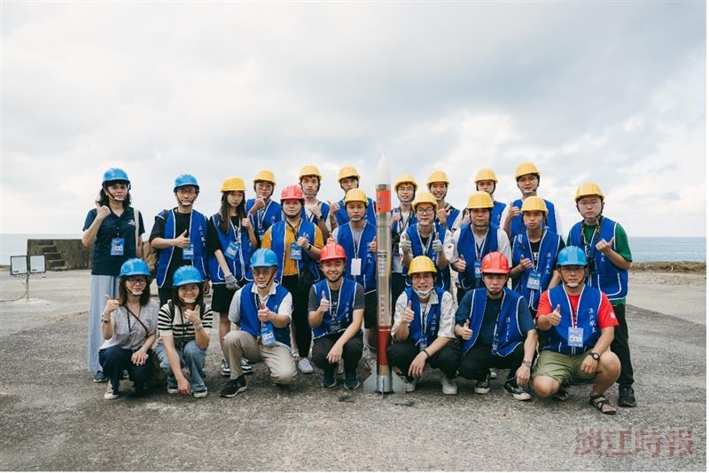
Faculty and students of the Space Technology Laboratory pose with the "TKU-I" research rocket at the Launch Site in Xuhai.

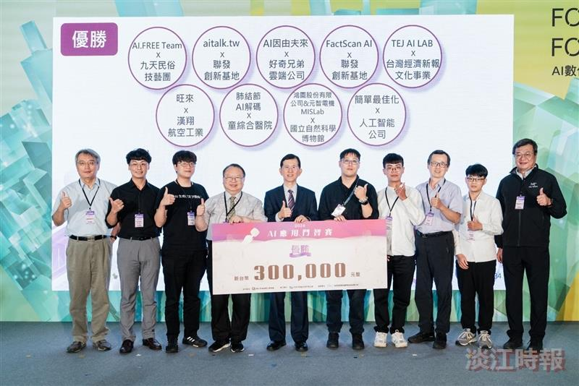
The Department of Computer Science and Information Engineering won the championship in the AI Application Challenge.

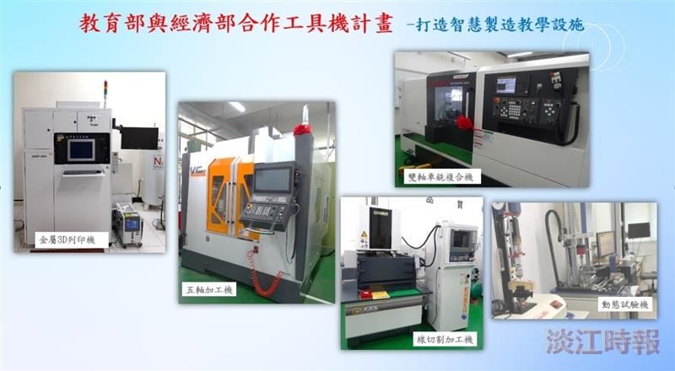
The Department of Mechanical and Electro-Mechanical Engineering secured approximately NT$40 million in funding through the Ministry of Education’s Machine Tool Teaching Equipment Renewal Program.

