Tamkang Times No.1209
Francophonie Festival Held at Tamkang: French Teacher’s Chanson Performance Showcases the Borderless Charm of Music

In collaboration with the Alliance Française de Taiwan, the Department of French at Tamkang University hosted a special event as part of the Taiwan Francophonie Festival. On March 21, the concert “A Journey Through the Champs-Élysées: French Chanson Recital” took place on campus, featuring French lecturer Nicolas Drouet as the soloist, accompanied by accordionist Wei-Ching Tsai. With a background in vocal performance, Drouet delivered an emotionally layered interpretation of several classic French chansons. From soft, whisper-like lyrical moments to powerful emotional outbursts, his voice was rich in texture and expression, captivating the audience and showcasing the universal appeal of music beyond borders.

The performance opened with Nicolas Drouet’s signature romantic ballad, “C’est Si Bon”—its gentle melody and Drouet’s soothing vocals instantly immersed the room in an atmosphere of French romance. He then performed a diverse repertoire, including heartfelt French love songs and darker, more introspective pieces. Among the highlights was his rendition of the traditional French song “Une jeune fillette”, which transported the audience through time and offered a glimpse into the musical charm of past eras.

Nicolas Drouet currently serves as a part-time lecturer in Tamkang’s Department of French, teaching French Composition and Contemporary French Thoughts. He also lectures at National Central University, Soochow University’s Department of Music, and Chung Yuan Christian University’s French Language Center. A former professional tenor and stage actor, Drouet brings extensive performance experience to the classroom and the stage. Honorary Professor Shu-Chuen Yang, who organized the concert, noted that Drouet and accordionist Wei-Ching Tsai have collaborated on many occasions to share the beauty of French songs. “March 20 is International Francophonie Day, and we hope this performance helps the audience better understand and fall in love with French chanson—and gain deeper insight into French culture.”

The performance venue was lit with warm, ambient lighting, creating a cozy atmosphere reminiscent of a street-side bar in Paris, infused with the spirit of French charm and jazz. “Music isn’t just for listening—it’s for feeling,” Drouet told the audience. He encouraged everyone to put down their phones, close their eyes, and fully experience the emotions conveyed through music. During the intermission, he invited French Department teaching assistant Nicola to accompany him on accordion, bringing the crowd to a peak of excitement with enthusiastic applause and cheers.

Second-year French majors Lou, Victoria, and Elliot, who attended as fans, said this was one of the most stunning concerts they had ever experienced. They were already enchanted by Drouet’s singing during a previous performance at Tunghai University and were thrilled to see him perform again at their own school. The most touching moment came during the encore, when Drouet performed Teresa Teng’s “May We All Be Blessed with Longevity” (但願人長久), expressing his deep affection for Taiwan and Chinese songs. Lou remarked, “I hope more people can hear Drouet’s voice. I also hope the university will host more events like this to further promote the Taiwan Francophonie Festival and the beauty of the French language.”
2025/04/22

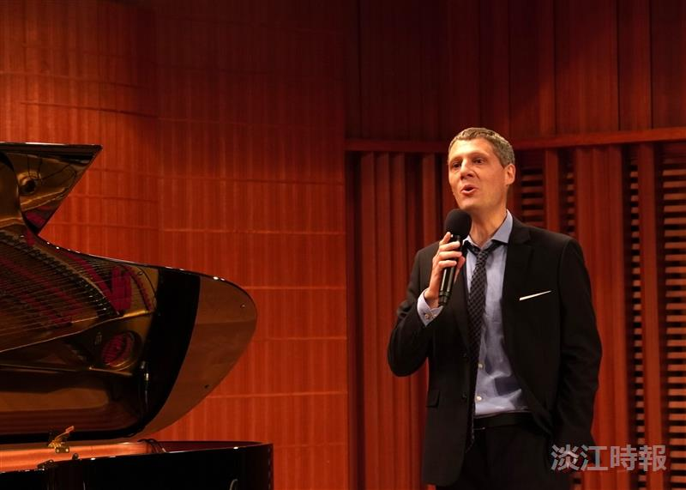
With a background in vocal performance, Nicolas Drouet delivered a delicate interpretation of several classic French songs.

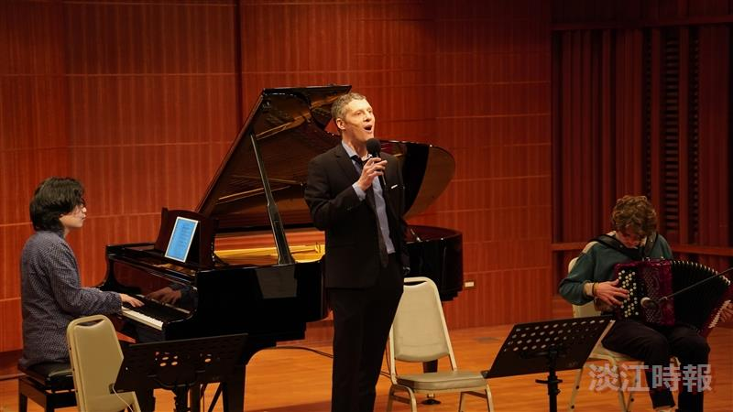
Accordionist Wei-Ching Tsai (left) and French Department teaching assistant Nicola (right) accompanied the performance, bringing the atmosphere to its peak.

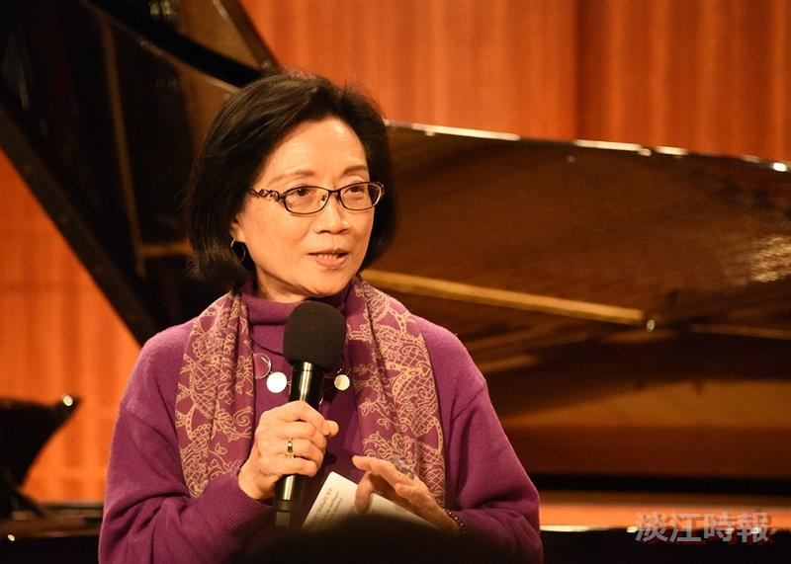
Honorary Professor Shu-Chuen Yang, organizer of the concert.

