Tamkang Times No.1207
Pots and Volleyballs as Props: “Lin Bei Tam Li” Battle Showcases Dance Skills and Creativity

The Hot Dance Club hosted the “Lin Bei Tam Li X Dance Battle” (「林盃淡麗X跳舞Battle」) competition at 6 p.m. on March 7 on the first floor of the Shao-Mo Memorial Gymnasium, drawing more than a hundred participants. Alumni Shuyang, Liangchi, and Xiaoji served as judges. Cheers and screams erupted with the rhythm of the music, creating an electric atmosphere.

The preliminary round was divided into a student group and an open group, with the top 8 and top 16 from each group, respectively, advancing to the main competition. The main event featured a dual-track, alternating battle format, with only the winners progressing to the next round. After the Top 8 round, the competition grew more challenging: 2 contestants from the open group and 1 from the student group were randomly grouped into a team and required to incorporate a randomly drawn prop into their performance, adding surprise and excitement. In the semifinals, dancers performed improvised routines to selected Mandarin pop songs. Ultimately, TKU students Chih-Wei Chang and Po-Chih Chen, along with Wei-Che Hu from Chinese Culture University, claimed the championship.

The event featured lighting, smoke effects, and flashes to create a lively and dazzling stage atmosphere. Contestants showcased various styles, including Locking, Popping, Hip-hop, Feminine Freestyle, House, and Dancehall, impressing the audience with advanced dance techniques. The 3 judges and the DJ also performed, captivating the audience. A highlight of the event was the Top 8 Props Round, where dancers wowed the crowd with creative performance using props such as pots, volleyballs, and floor mats—elevating the energy to its peak.

Vice President of the club, Cong-Ren Huang, a junior in Electrical and Computer Engineering, shared that it was the club’s first time organizing a competition of this kind. He initially worried that the prop challenge might hinder the dancers but was pleasantly surprised by their exceptional performances and endless creativity. Every routine left a lasting impression.

Runner-up Chen-Yu Lu, an alumnus of the Department of Information Management, said, “It’s very heartwarming to see juniors host such a successful event, and it gives me even more motivation to come back and participate.” Although he has trained for many years, he still feels nervous on stage—but that nervousness fuels his excitement and is part of the joy of competition. His teammate and fellow runner-up Yu-Hua Chang, a sophomore in the Department of German, shared, “The most difficult part of the competition was the audition stage, where dancers had to win over the judges through technique and on-the-spot reactions. The prop round pushed us to break through personal limits and overcome new challenges.”

Participant Shih-Rong Ceng, a sophomore in Banking and Finance, said that although the competition made her nervous, the lively atmosphere and the support of friends filled her with energy and joy. She also observed that many contestants came well-prepared and admired their impressive skills. Liang-Yan Chen, a sophomore in Information and Communication, shared that although she hasn’t been dancing long and lacks experience, she participated with a mindset to “enjoy the competition.” The experience motivated her to continue improving her dance skills in the future.
2025/04/15

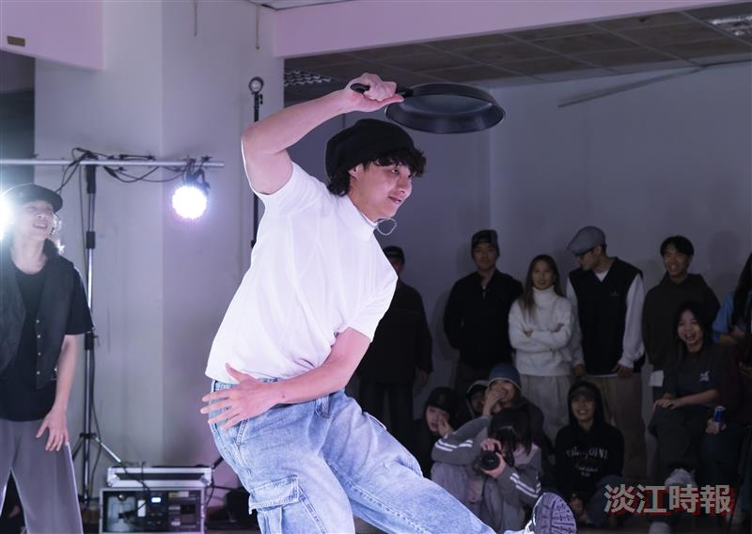
In the Top 8 Props Round, contestants creatively incorporated pots into their dance routines, capturing the audience’s attention.

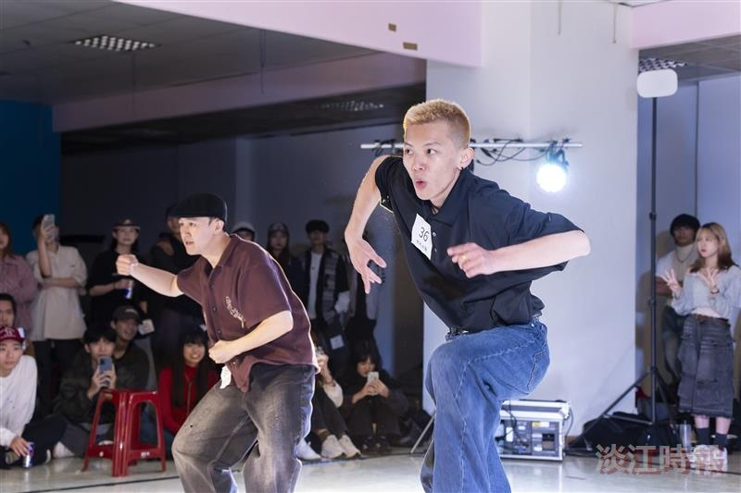
At the Hot Dance Club's "Lin Bei Tam Li X Dance Battle" competition, contestants fully showcased their dance skills.

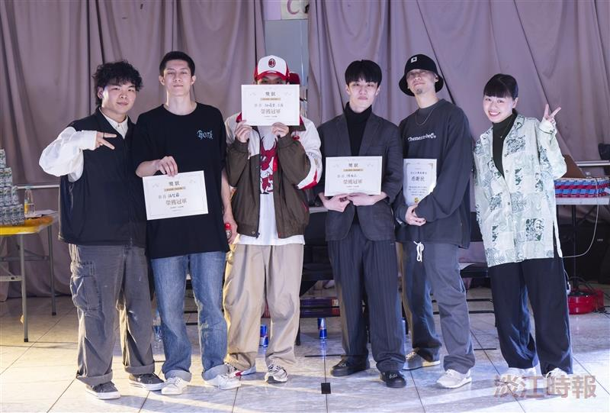
After presenting the award to the champion team, the 3 judges joined in for a joyful group photo.

