Tamkang Times No.1207
iST Talent Cultivation Scholarships: 4 Students in Physics and Advanced Materials Science Selected

On the afternoon of March 10 at 2 p.m., Department of Physics Chair Prof. Cheng-Hao Chuang led Tamkang University physics students on a visit to the First Plant of IntegratedService Technology (iST) in the Hsinchu Science Park, founded by alumnus Wei-Been Yu. The group visited the company’s Management Division and attended the 2nd iST Elite Scholarship award ceremony. This year, scholarship recipients include Cheng-En Lee, a first-year master's student in Physics; Chieh-Kai Hsu and Yu-Ju Lin, both seniors in the Bachelor's Program in Advanced Materials Science; and Yu-Pei Lee, a third-year student in the same program. Among them, Cheng-En Lee and Yu-Ju Lin were selected for the second time and will join iST after graduation. Together, the 4 students will receive NT$1.02 million in scholarships. Chair Chuang expressed his gratitude to iST for providing students with industry learning opportunities.

Following recommendations by faculty members of their departments, the 4 recipients passed multiple rounds of interviews conducted by department heads from engineering and human resources at iST. They outperformed more than 30 competitors from both public and private universities nationwide to earn the year-long iST Talent Cultivation Program scholarship. Undergraduate students receive NT$240,000 per academic year, while master’s students receive NT$300,000. Those who apply from their junior year through the end of their second year in graduate school may receive up to NT$1.08 million. Awardees are guaranteed employment at iST upon graduation.

iST Technology Vice President of Administration Division and Department of English alumna Judy Chen, Senior Vice President of Reliability Engineering Division Allan Tseng, Assistant Vice President of Hardware Solution Business Unit Jack Tseng, Assistant Vice President of Material Analysis Engineering Division Kim Hsu, Director of Failure Analysis Engineering Division SH Shen, and HR Manager Chia-Ru Wu hosted the delegation. In addition to presenting the awards, they discussed with the students to offer encouragement. Judy Chen noted that iST values talent cultivation as part of its corporate SDG initiatives. She praised TKU students for confidently showcasing themselves throughout the selection process and expressed the company’s joy in helping young people pursue their career dreams and life goals. Allan Tseng added, “iST is like a farmer, sowing the seeds of science and waiting for students to bloom after graduation into future top iST talents.”

Yu-Pei Lee from the Advanced Materials Science program shared her excitement about winning, saying she was pleasantly surprised. She now feels more motivated to study hard and enhance her skills, hoping to become an outstanding employee at iST. Returning awardee, Yu-Ru Lin also expressed gratitude for iST’s continued investment, which allowed her to study without the financial pressure of suspending her studies to work. This support enabled her to focus on her studies and even participate in international poster competitions, broadening her academic and life experiences.

Prof. Cheng-Hao Chuang emphasized, “Tamkang students are known for being ‘down-to-earth and eager to learn.’” He hopes iST will provide rigorous training and supervision to help students recognize their shortcomings and grow through learning. He also reflected emotionally, “Educating students and helping them land good jobs is the greatest sense of achievement for any teacher.”
2025/04/15

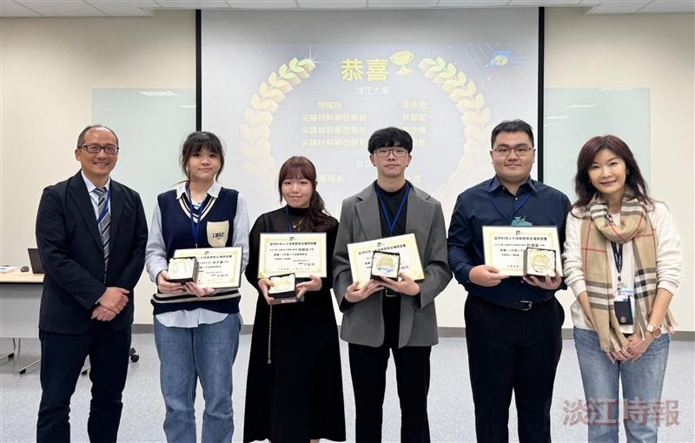
iST Technology Vice President Judy Chen (2nd from right) presented the iST Talent Cultivation Scholarship to Chieh-Kai Hsu, a senior in the Bachelor's Program in Advanced Materials Science; Cheng-En Lee, a first-year master's student in Physics; Yu-Ru Lin, a 4th-year student in the Advanced Materials Science Program; and Yu-Pei Lee, a 3rd-year student. They posed for a group photo with Physics Department Chair Prof. Cheng-Hao Chuang.

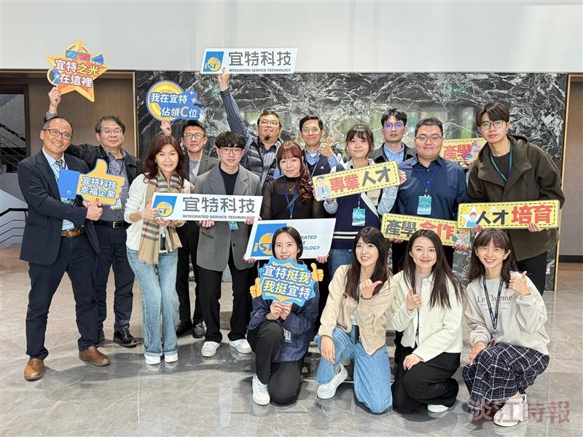
Department of Physics Chair Prof. Cheng-Hao Chuang (1st from left) led physics students on a visit to iST Technology’s First Plant in Hsinchu Science Park, founded by alumnus Wei-Been Yu.

