Tamkang Times No.1207
201st Administrative Meeting Held in Miaoli with Warm Welcome from Golden Eagle Alumni

The 201st Administrative Meeting of Tamkang University was held on March 7 at the meeting room of Porite Taiwan, presided over by President Huan-Chao Keh, with the participation of the 3 vice presidents and first-level administrators. The day's agenda included visits to alumni-owned companies Sinbon Electronics and Porite Taiwan.

In his address, President Keh reaffirmed Tamkang University’s key development strategy, “AI+SDGs=∞,” which should be implemented across teaching, research, industry-academia collaboration, and administrative services. He emphasized that “AI-led (driven) teaching innovation” will be a central focus in the future, and Tamkang should take the lead in this area. The initiative is already being actively promoted this semester and is expected to be fully implemented starting in the 2025 academic year.

President Keh also reminded colleagues to uphold TQM consistency. When using official university terminology, accuracy is essential—for example, the names of the three campuses: “Tamsui Campus,” “Taipei Campus,” and “Lanyang Campus”; the “Triple Objectives” of education: “Globalization, Information-oriented Education, and Future-oriented Education”; and concepts like “Glocalization, Intelligent Cloud, Sustainable Future” as part of the Resilient University City vision—must not be rearranged arbitrarily. He also stressed that under TKU’s unified department-graduate institute structure, only independent graduate institutes such as the Graduate Institutes of International Affairs and Strategic Studies, Educational Psychology and Counseling, Senior Healthcare Management, and Intelligent Healthcare Industry may be referred to as “institutes,” and their heads as “directors.” All other graduate programs under undergraduate departments should retain the department name, such as the master’s and doctoral programs of the Department of Electrical and Computer Engineering, with their head titled “department chair.”

During the meeting, 4 proposals were approved: The repeal of the “Tamkang University Campus Bullying Prevention Regulations”; A revision to Article 3 of the “Regulations for the Establishment of the Faculty Qualification Review Promotion Group”; Revisions to Articles 5 and 6 of the “Tamkang University Regulations for the Review of the Establishment and Adjustment of Colleges, Departments, Graduate Institutes, Degree Programs, and Enrollment Quotas”; A revision to Article 2 of the “Tamkang University Incentive Measures for Full-English Instruction by Full-Time Faculty”. Among them, the repeal of the “Tamkang University Campus Bullying Prevention Regulations” was due to the Ministry of Education’s newly amended and clearly defined “Campus Bullying Prevention Guidelines” released on April 17, 2024. To reduce administrative burden, universities are now required to follow the national guidelines, making the university’s own version redundant.

In the extempore motions section, Chief Information Officer Prof. Kuei-Ping Shih reminded everyone that Windows 10 support will end on October 14 this year, and no further security updates will be provided. He urged colleagues to upgrade to Windows 11 as soon as possible to avoid cybersecurity risks. Offices with incompatible hardware may apply for idle equipment from the Property Section or request available devices from the Office of Information Services. Dean of Academic Affairs Prof. Tzong-Ru Tsai called on all colleges and departments to ensure their websites are updated with accurate information promptly, which is vital for promoting enrollment. He suggested that departments link their recruitment content to the Office of Academic Affairs website to enhance focus on the high school student section.

Before the meeting, the delegation visited 2 alumni-associated companies: Sinbon Electronics and Porite Taiwan. Both Golden Eagle alumni—Sinbon Chairman Joseph Wang and Porite Taiwan General Manager Chiu-Lung Chu—extended a warm welcome, personally delivering presentations and arranging tours of their factories, product lines, technology, and business operations, helping the visitors better understand the scope of these enterprises. In his presentation, Wang shared that some of Sinbon’s operations focus on customized services, which, though low in volume, yield considerable profits. He also mentioned the company’s ongoing plans to expand manufacturing abroad and expressed a desire to collaborate with TKU’s Colleges of Business and Management, and Foreign Languages to recruit and train students as future management personnel. Engineering graduates would be targeted for domestic factories to enhance production capacity. “If our alma mater needs it, we’re also willing to help promote international student recruitment—creating a win-win outcome,” he said.

Chu presented the global reach and client distribution of the Porite Corporation. He explained that their products primarily include transportation-related parts, fuel cell plates, and power tools. Their specialty in powder metallurgy is used in various auto components, with innovations that reduce material waste. In the green energy sector, the company is actively developing solid oxide fuel cell plates, capable of converting natural gas directly into electricity. These systems were installed last year at their campus, working with solar panels to support sustainability and environmental protection. President Keh expressed gratitude for the warm hospitality of the alumni and presented each of them with a printmaking work of “Lantern Boulevard” by alumnus Fu-Hsing Lian and local specialties from Tamsui as tokens of appreciation.
2025/04/15

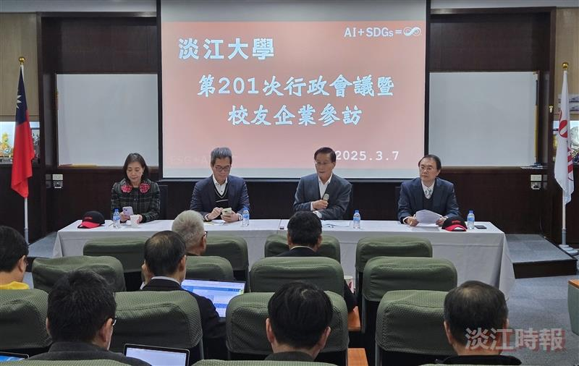
The 201st Administrative Meeting was held at Porite Taiwan, presided over by President Huan-Chao Keh (second from right).

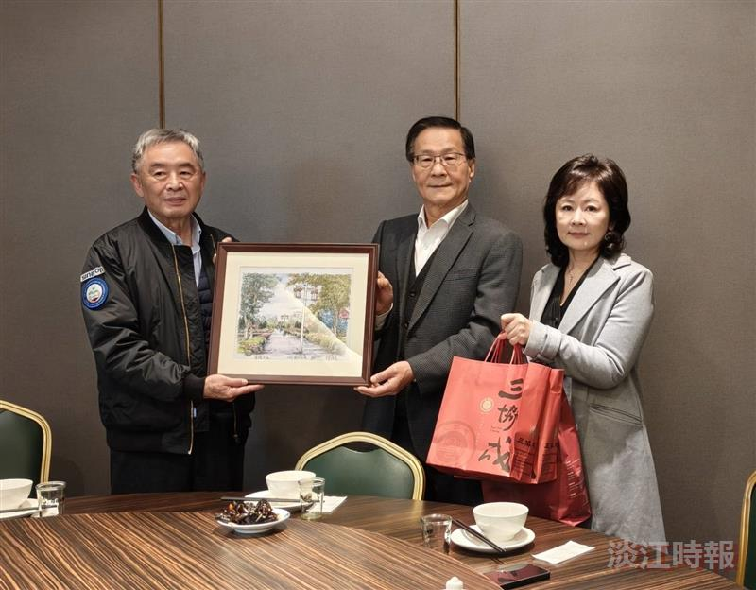
President Huan-Chao Keh (center) presented a painting of “Lantern Boulevard” and local Tamsui specialties to alumnus and Sinbon Electronics Chairman Joseph Wang (left).

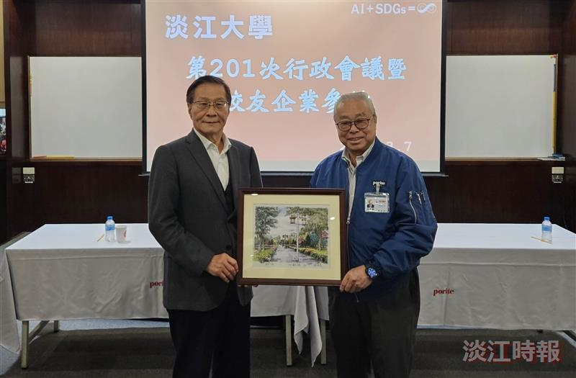
President Huan-Chao Keh (left) presented a painting of “Lantern Boulevard” to the alumnus and General Manager of Porite Taiwan, Chiu-Lung Chu (right).

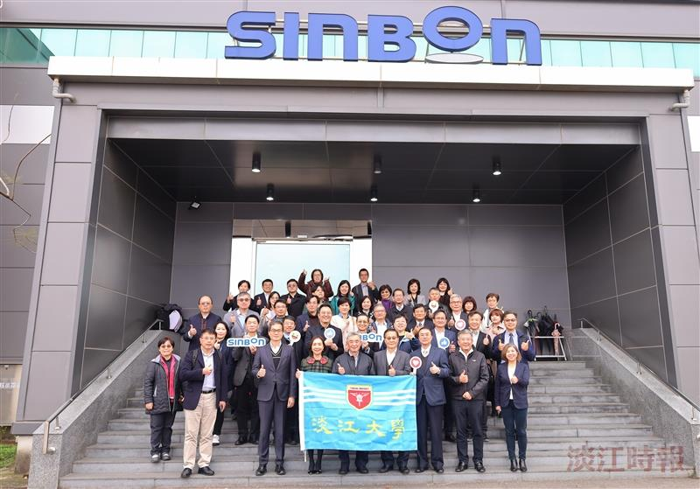
Before the meeting, a visit was arranged to the alumni-owned company Sinbon Electronics.

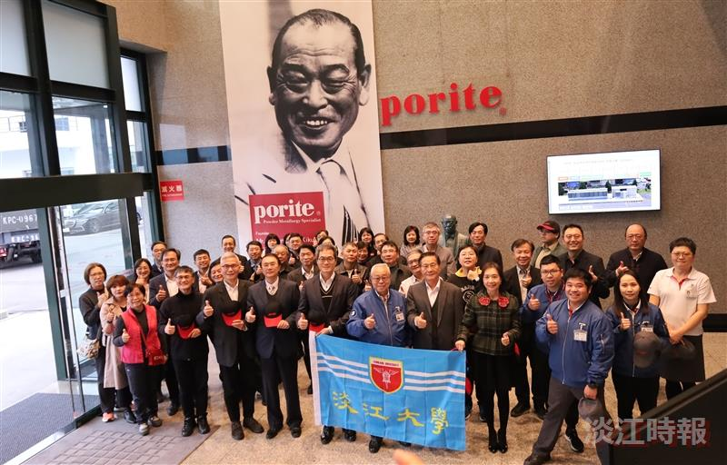
Before the administrative meeting, a visit was arranged to the alumni-owned company, Porite Taiwan.

