Tamkang Times No.1207
VP Hui-Huang Hsu Leads Delegation to Vietnam to Strengthen International Sports Exchange

The Office of Physical Education implemented the "School Sports Exchanges Implementation Plan under the Promotion of the New Southbound Policy by Sports Administration, Ministry of Education." From February 11 to 15, Vice President for Academic Affairs Prof. Hui-Huang Hsu led a 17-member delegation—including Dean of the College of Science Prof. Tzenge-Lien Shih, Dean of Physical Education Prof. I-Cheng Chen, and faculty members from the Office of Physical Education—to the College of Physical Education at the University of Danang, Vietnam, for a sports and teaching exchange visit. The delegation also toured the Da Nang University of Physical Education and Sports and its local sports venues and facilities to learn from their successful practices.

Prof. Hsu stated that the Office of Physical Education has actively aligned with the university’s globalization policy, frequently engaging in exchange activities with New Southbound partner institutions and interacting directly with local faculty. This visit not only enhanced Tamkang University’s international visibility but also introduced the university to students and teachers in New Southbound countries, increasing the likelihood of attracting students to study in Taiwan. The Office of Physical Education, having won the MOE Excellence in Sports Performance Award 5 times, also shared its successful experiences in elective sports interest courses and teaching practice research projects with the University of Da Nang. He expressed hope that all colleges and departments within the university can make good use of internal and external resources to proactively build connections with local institutions and lay the groundwork for future collaboration.

On February 11, the delegation visited the College of Physical Education at the University of Da Nang, where they met with Dean Vo Dinh Hop and several administrators to exchange views and discuss topics such as physical education instruction, academic research, and student exchange. TKU showcased its applications of sports technology (such as AI image analysis for athletic performance assessment) and its achievements in competitive sports. Both sides explored possible future collaborations in student exchange, academic research, and athletic events.

On February 13, the delegation toured the Da Nang University of Physical Education and Sports (Da Nang National Sports Training Center), where they were warmly received by Director Pham Hoang Tung and his team. The hosts introduced their training facilities and teaching resources. Both parties reached a preliminary consensus on promoting faculty exchange lectures, jointly organizing international sports seminars, and holding friendly sports events.

During the 5-day visit, the Tamkang delegation also toured the Tien Son Sports Center and Da Phuoc Mini Football Field in Da Nang to understand the current state of these venues’ facilities, management models, and their roles in the development of local sports and cultural initiatives. The team aimed to learn from these successful examples to serve as references for promoting similar sports activities on the Tamkang campus in the future.
2025/04/15

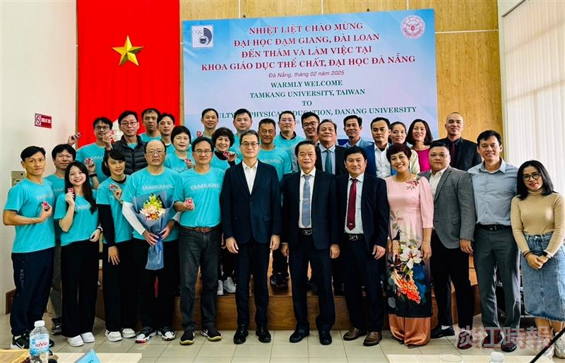
The TKU delegation visited the College of Physical Education at the University of Da Nang in Vietnam for an exchange visit, and participants from both sides gathered for a group photo.

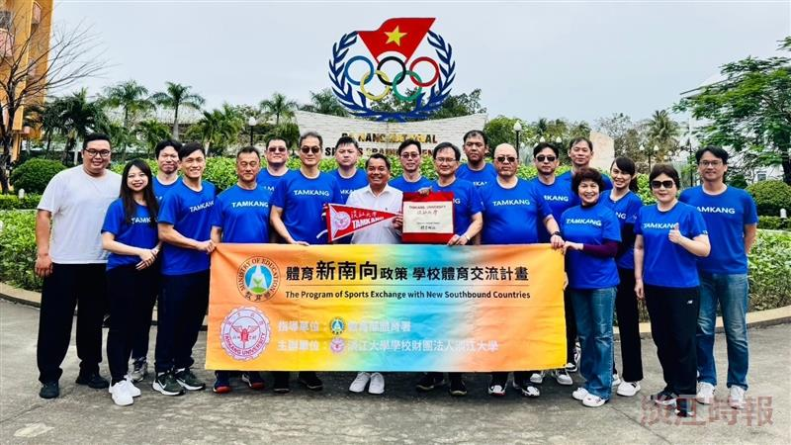
The TKU delegation conducted an exchange visit to the Da Nang University of Physical Education and Sports, Vietnam.

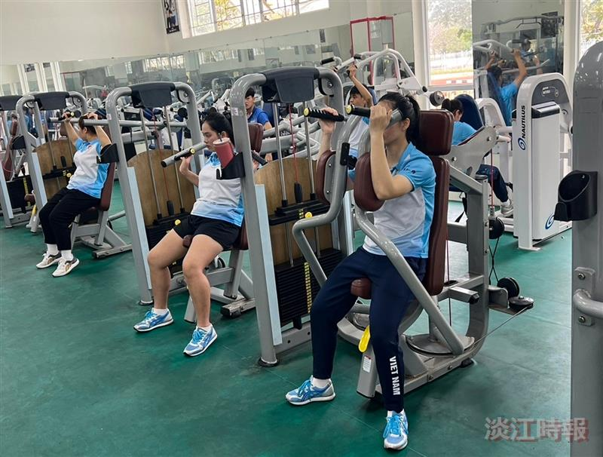
The TKU delegation visited the Da Nang University of Physical Education and Sports, Vietnam (National Training Center) to observe the local students' sports training environment.

