Tamkang Times No.1207
Crowds Flock to TKU Booth at University Expo as Faculty and Students Assist with Inquiries

The Admissions Strategy Center participated in the “2025 University and Technical College Multi-Admission Expo” held at the NTU Sports Center on March 1–2. Student representatives from various colleges distributed flyers and provided preliminary introductions to their departments, while professors from each department answered individual questions from high school students and parents regarding differences between departments, unique features, and future development prospects. This helped enhance their understanding of Tamkang University and increased their willingness to choose TKU for further studies.

The TKU booth was crowded with students and parents seeking consultation. Staff members provided personalized counseling services based on individual needs. Due to high demand, the booth was packed, and many people had to consult alongside the nearby aisles. Dean of Academic Affairs Prof. Tzong-Ru Tsai noted that most students and parents visiting the booth already had a preferred department in mind and were mainly inquiring whether their entrance exam scores would be sufficient for admission. Through these conversations, he learned that many were particularly interested in TKU’s dual-degree programs and flexible curriculum, which should be further promoted as a key attraction for prospective students. Professor Mei-Ling Wang from the Department of Business Administration mentioned that many visitors were focused on practical aspects such as career prospects and industry-academia collaboration. She noted that although business administration has sometimes been perceived as too general, TKU’s interdisciplinary learning opportunities and innovative teaching models allow students to explore broadly before diving deeper into areas of personal interest.

Student Tsai shared that TKU’s College of Business and Management has a strong reputation, and her family also recommended the university, which prompted her to inquire about the Department of Economics. Student Sung mentioned that he had previously seen the news about TKU being ranked “No. 1 Among Employers’ Top Choices,” giving him a positive impression of the university. After consulting with department staff, he received thorough answers to all his questions. Student Lin, whose parents are both TKU alumni, encouraged him to apply, so he came to learn more about the Department of Electrical and Computer Engineering. “Tamkang is my first choice, and after the consultation, I’m even more certain about choosing Electrical Engineering.” Parent Mr. Hsiao said he learned from the media that Tamkang has achieved outstanding results in promoting AI and all-English education. After the consultation, he gained a clear understanding of the differences among the English-Taught Program in Computer Science, the Department of Computer Science and Information Engineering, and the Department of AI. He expressed deep appreciation for the professors' detailed explanations. Ms. Chao, another parent, said her child is interested in Public Administration and came specifically to learn more about the program. Ms. Wu, whose child is interested in both Business Administration and Finance, said, “After listening to the professor’s introduction, I believe Business Administration offers broader career prospects, so I’ll encourage my child to choose that path.”
2025/04/15

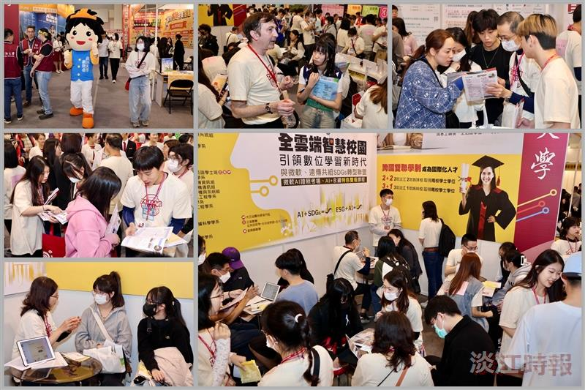
Tamkang University's Admissions Strategy Center participated in the University Expo on March 1–2, where various departments actively promoted enrollment, attracting many students to stop by and ask questions.

