Tamkang Times No.1207
Wind Ensemble Club Dominates, Winning Top Honors at National Student Music Competition 10 Years in a Row

Tamkang University’s student music clubs, the Wind Ensemble and the String Ensemble participated in the Northern Regional Finals of the 2024 Academic Year National Student Music Competition and earned one top honor and two excellence awards. The Wind Ensemble delivered an outstanding performance, winning the top honor in the "Wind Ensemble – College Group B" category for the 10th time and receiving an excellence award in the "Percussion Ensemble – College Group B" category. The String Ensemble also received an excellence award in the "String Ensemble – College Group B" category.

The Wind Ensemble competed at the Hsinchu County Cultural Affairs Bureau Performance Hall on March 9 and 12. This year, they selected “Gloriosa - Symphonic Poem for Band” as their free-choice piece. The piece depicts the persecution of Christians during Japan’s Edo period under the isolation policy. It is not only technically demanding but also rich in musical and academic depth. For the percussion ensemble, they chose “Blue Thunder” and “On the Night the Beautiful Star Falls” as their free-choice pieces, which fully showcased the ensemble’s musical capabilities.

The conductor, an alumnus of the Department of Economics Ping-En Song, led the members in intensive training, including off-site practice at the Lanyang campus, allowing students to focus in a high-quality environment with excellent facilities. He stated that the chosen pieces required a solid foundation in music theory to interpret accurately due to their academic nature, posing a significant challenge for members without formal music training. Fortunately, the group overcame the difficulties and successfully delivered a performance that conveyed the depth and atmosphere of the music. “Every top honor the Wind Ensemble has earned over the past decade is the result of collective effort and dedication. I’m grateful to all members who have fought side by side and to the university’s offices for their support. The Wind Ensemble will continue striving forward into the next decade.”

Club president Pei-Syuan Yu, a sophomore from the Department of Information and Library Science, shared, “Thank you to Mr. Song for his guidance and to everyone for giving their all. We hope to win top honors again next year and look forward to welcoming new members to the Tamkang Wind Ensemble family as we continue aiming to remain the best in the nation.”

The String Ensemble, under the direction of conductor Cheng-Mu Chang, led 22 members to the competition held at the Hsinchu City Cultural Affairs Bureau Performance Hall on March 6. Their required piece was Dvořák’s “Serenade for Strings, Op. 22,” and their selected piece was Joseph Suk’s “Serenade for Strings, Op. 6.” To fully prepare, the ensemble began intensive practice before the winter break and assigned “homework” during the break: section leaders were required to record demonstration videos for other members to learn from, and all members had to submit their own practice videos to the group chat to ensure steady progress.

Club president Pei-Chen Tsai, a sophomore from the Department of Banking and Finance, said that despite their preparation, it was natural to feel nervous before the competition. She expressed gratitude for the conductor’s encouragement, which helped calm the group and keep them focused. She noted that the selected piece posed challenges, especially in achieving perfect intonation and rhythm, and required thoughtful interpretation to bring out the best tone and instrumental expression. To address this, the members watched numerous performance videos from other orchestras to gain insight. “During breaks in winter training, we organized some light-hearted games to relax and bond with each other, which helped strengthen our team spirit.”
2025/04/15

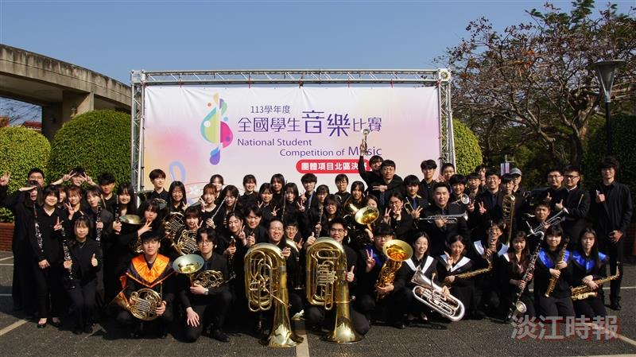
The Wind Ensemble Club won top honors for the 10th time in the "Wind Ensemble – College Group B" category and received an excellence award in the "Percussion Ensemble – College Group B" category.

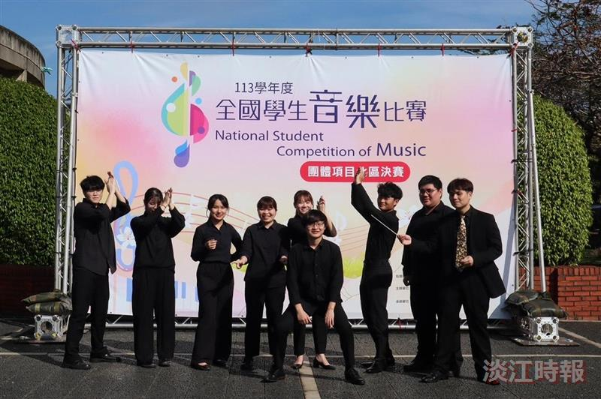
The Wind Ensemble Club received an Excellence Award in the "Percussion Ensemble – College Group B" category, and the participating students were overjoyed.

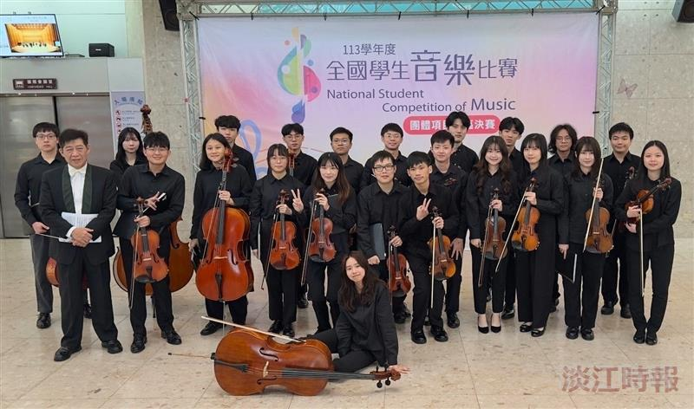
The String Ensemble Club received an Excellence Award in the "String Ensemble – College Group B" category, and everyone happily posed for a group photo.

