Tamkang Times No.1207
Chia-Sheng Wu Wins Bronze at World Sports Photography Awards for “Lim Si-Hyeon and the Bug”

During the 2024 Paris Olympic Games, Chia-Sheng Wu, an alumnus of Tamkang University's Department of Mass Communication and a photojournalist for Central News Agency (CNA), captured a moment where South Korean archer Lim Si-Hyeon released an arrow during a competition. At that exact instant, a small bug appeared in the frame alongside the arrow. This photo, titled “Lim Si-Hyeon and the Bug,” earned Wu the bronze medal in the “Other” category at the 2025 World Sports Photography Awards. Wu expressed gratitude to the international judges for their recognition, which allowed the world to see how Taiwanese photojournalists capture the fleeting moments of athletes in action.

The World Sports Photography Awards, established in 2020, invites submissions from around the globe and features 24 sports categories, including American football, basketball, cycling, gymnastics, extreme sports, and soccer. This year’s competition received entries from over 2,200 professional sports photographers across more than 96 countries, with more than 13,000 photos submitted. Each category awards a gold, silver, and bronze medal, along with seven special mentions. The “Other” category selects winners regardless of the sport depicted.

2020, Wu also received the gold medal and an honorable mention in the Editorial category at the Moscow International Foto Awards for his series on the 2019-2020 Hong Kong protests. On February 22, he was invited to share his Olympic photography experiences at the Winter Training Workshop for reporters held by the Tamkang Times and Media Center. During the session, he showcased archery photos and explained techniques such as using slow shutter speeds to capture a sense of motion and fast shutter speeds to freeze key moments. He noted that archery is among the more challenging sports to photograph, as it requires prior knowledge of the athletes’ routines and timing to successfully capture impactful images. Speaking about the award-winning photo, he mentioned that bugs frequently flew around the competition area: “Capturing this photo was lucky. It’s already difficult to get a clear shot of the arrow being released—let alone with a bug in the same frame.”

Wu expressed gratitude to his company for the opportunity to photograph both the Tokyo and Paris Olympics, witnessing top athletes in action. He also gave special thanks to Tamkang University for laying his foundation, noting that the school’s rich cultural environment, local humanistic charm, and free learning atmosphere allowed him to explore the possibilities of visual storytelling. His four years at Tamkang helped shape a unique perspective he views the world. “Returning to campus this year to teach at the winter workshop and seeing how dedicated the younger students are—I'm confident they’ll shine in the industry in the future.”
2025/04/15

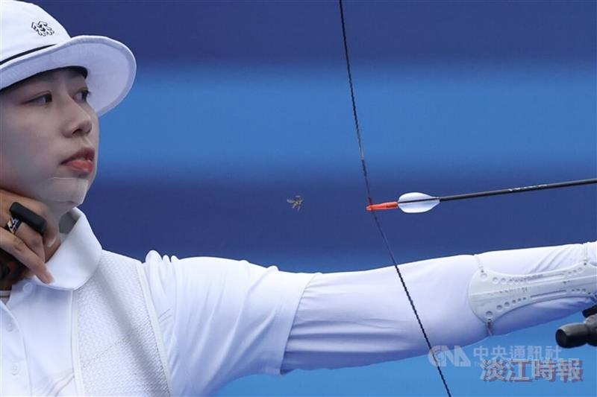
Chia-Sheng Wu, an alumnus of the Department of Mass Communication and a reporter for Central News Agency, won the bronze medal at the World Sports Photography Awards with his archery photo titled "Lim Si-Hyeon and the Bug," taken during last year’s Paris Olympics.

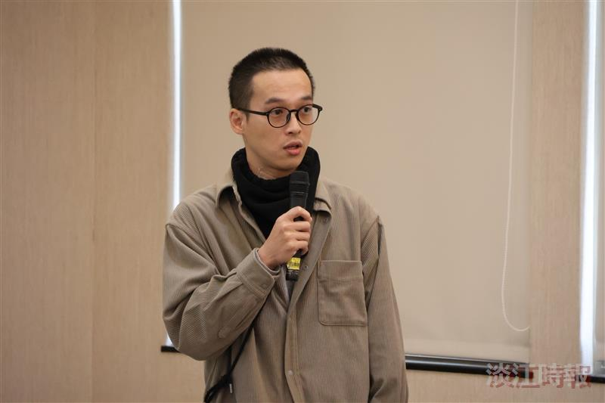
Chia-Sheng Wu, an alumnus of the Department of Mass Communication and a reporter for the Central News Agency, shared his photography experiences from the Tokyo and Paris Olympics during the Winter Training Workshop for reporters by the Tamkang Times.

