Tamkang Times No.1207
Top Choice Among Private Universities: TKU Shines at New Taipei Job Fair with Record-High Match Rate

Tamkang University, in collaboration with the New Taipei City Government, hosted the “2025 Tamkang University Campus Job Fair,” which kicked off at 10 a.m. on March 12 at the Student Activity Center and Poster Street. President Prof. Huan-Chao Keh, Vice President for Academic Affairs Prof. Hui-Huang Hsu, Vice President for Administrative Affairs Prof. Chun-Hung Lin, Commissioner of the New Taipei City Labor Affairs Department Jui-Chia Chen, Director of the New Taipei City Employment Services Office Chien-Neng Yeh, Deputy Director Cheng-Yuan Chen, along with other first- and second-level university administrators, attended the event. 95 companies participated in the fair, offering more than 4,400 job openings. According to statistics from the New Taipei City Employment Services Office, 2,069 resumes were submitted, with 1,057 intended hires, resulting in a matching rate of 51.1%.

This year’s event incorporated the theme of sustainable development, with the slogan “ESG+AI=∞, AI+SDGs=∞, Tamkang University: Enterprises’ Top Choice,” and began with a performance by a lion dance troupe. President Keh expressed his gratitude to the New Taipei City Labor Affairs Department for partnering with Tamkang for the 16th time, providing students and enterprises with the best matching platform. He stated that Tamkang adheres to its “Triple Objectives of Education” and “Three Circles and Five Disciplines” philosophy, staying in step with the times and emphasizing students' employment competitiveness and strong industry connections to cultivate future talents favored by enterprises. He also referenced the CommonWealth Magazine Group’s 2025 university rankings, in which Tamkang has been named the top private university for 28 consecutive years. Moreover, Tamkang ranked first among private schools in Global Views Monthly’s “Most Desired Graduates by Listed Companies” survey and 1111 Job Bank’s “2025 Enterprises’ Most Favored Universities” ranking—proof of TKU students’ strong competitiveness in the job market.

Commissioner Jui-Chia Chen praised Tamkang University’s well-recognized educational philosophy and quality, noting that it consistently receives high ratings in various surveys, demonstrating that TKU students are well-liked by employers. This is one of the key reasons New Taipei City chose Tamkang as the venue for this campus job fair. He concluded by wishing all graduating students success in entering the workforce, leveraging their strengths, and finding ideal jobs.

A special "Alumni Zone" featured 34 companies led or significantly managed by Tamkang alumni, such as Everlight Chemical, Sinbon Electronics, Grand Dynasty Industrial, and IntegratedService Technology. These successful alumni returned to their alma mater with job opportunities, inviting younger schoolmates to build a bright future together. Kuan-Hong Lee, Manager of the Human Resources Department at Union Bank and a TKU Business Administration alumnus, shared that the current financial job market does not require a finance-related background. The company offers comprehensive training and mentorship programs. “I came back to recruit because I hope to offer more opportunities for students and give them additional career choices.”

In addition to company booths, the event also featured an AR/VR tech job zone, youth employment zone, resume review services, and a newly added job search area where students could use computers to explore openings by industry and learn more about job details. Students gathered at booths, actively inquiring and listening to company introductions. Some, prepared with resumes, submitted them directly to their target employers. The venue was packed, creating a vibrant and energetic atmosphere.

Manda, a second-year international student from Indonesia majoring in Business Administration, expressed her strong interest in the finance industry and her intention to stay in Taiwan after graduation. She visited the Hua Nan Bank booth to inquire about internship opportunities, training programs, and human resource management information. Chi-Ying Lu, a graduate student in Aerospace Engineering, shared his deep passion for the space technology industry. After learning more from representatives of the Taiwan Space Agency, he gained clearer insight into his career planning. Dong-Lin Yeh from the Department of Information and Library Science said he hopes to use the job fair to explore future career directions. “My ideal goal is to pursue a public service career, but considering uncertainties, I decided to visit different booths. After hearing MUJI’s presentation, I was impressed by their salary and shopping benefits, so I’m adding them to my list of options.”
2025/04/15

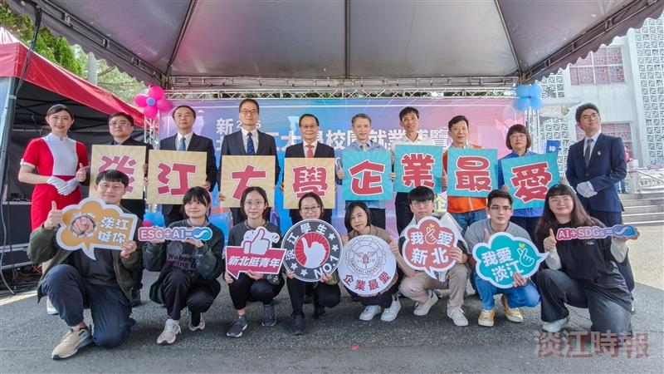
The "2025 Tamkang University Campus Job Fair" was officially launched by President Huan-Chao Keh (back row, 5th from left), New Taipei City Labor Affairs Department Commissioner Jui-Chia Chen (back row, 5th from right), and New Taipei City Employment Services Office Director Chien-Neng Yeh (back row, 4th from right), along with other officials.

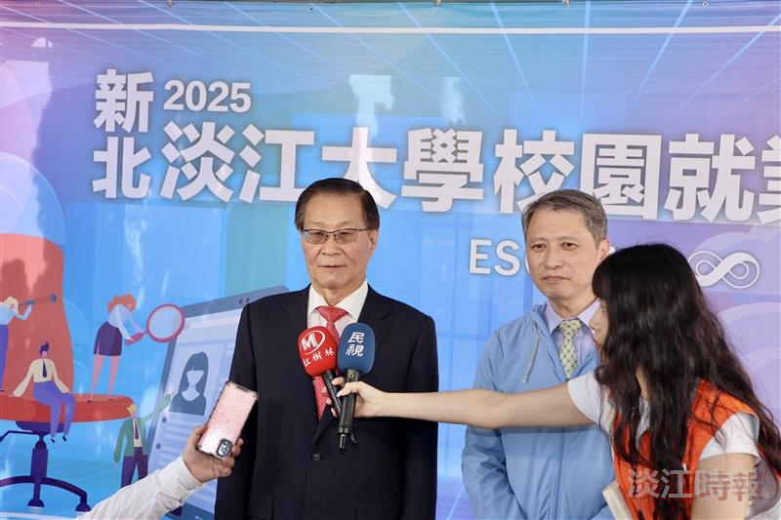
President Keh Huan-Chao (left) and New Taipei City Labor Affairs Department Commissioner Jui-Chia Chen were jointly interviewed by the media.

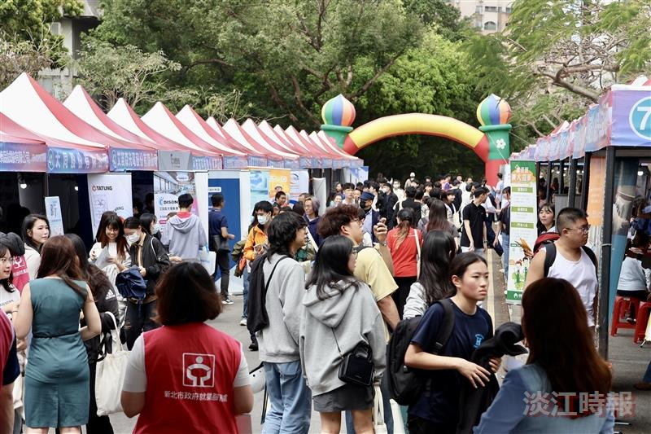
The 2025 Tamkang University Campus Job Fair kicked off with great excitement on March 12, with enthusiastic student participation.

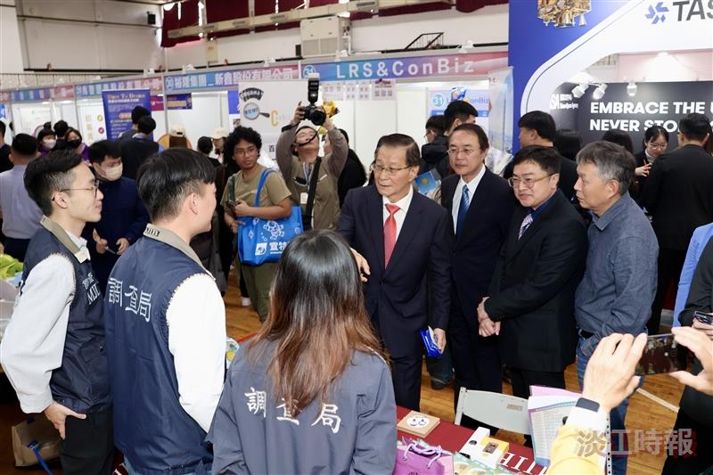
President Keh visited the exhibition booths to gain insight into current employment demands.

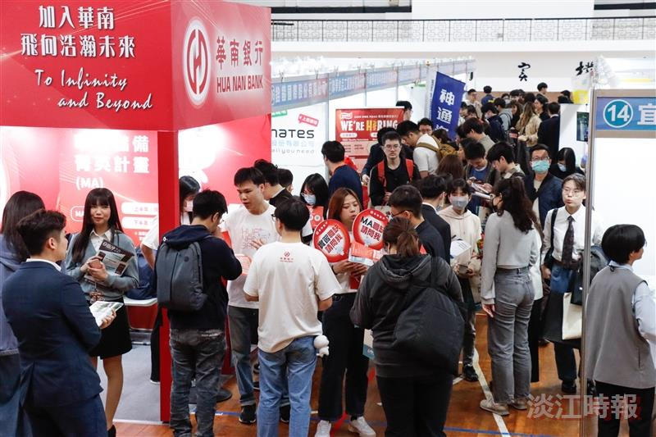
Booth staff and students engaged in lively interactions.

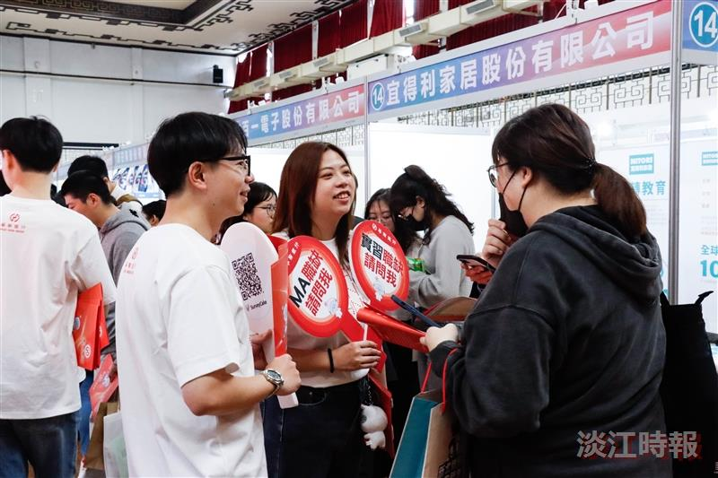
Many companies offered internship opportunities, and students inquired about related information at the booths.

