Tamkang Times No.1207
2025 Most Favored University by Enterprises Survey: TKU's IT and Engineering Graduates Top Among Private Universities

In the “2025 Most Favored University by Enterprises” survey conducted by 1111 Job Bank in collaboration with TUN University Network, Tamkang University’s Information Technology and Engineering groups ranked 5th nationwide in the “Workplace Performance” category, securing the top spot among private universities.

This survey was published in the January edition of the “2025 University Entrance Guide” by 1111 Job Bank. In addition to ranking as the leading private university in overall performance, Tamkang University had 5 academic groups ranked in the national top list for “Workplace Competitiveness across 18 Groups.” The Information Technology and Engineering groups ranked 5th nationally and 1st among private universities. The “Information Technology” groups were only preceded by NTU, NTUST, NYCU, and NTHU, while the Engineering group followed NTU, NCKU, NYCU, NTHU, and CCU. Additionally, in Mass Communication, Foreign Languages, and Architecture groups, TKU ranked 5th, 6th, and 8th respectively.
2025/04/15

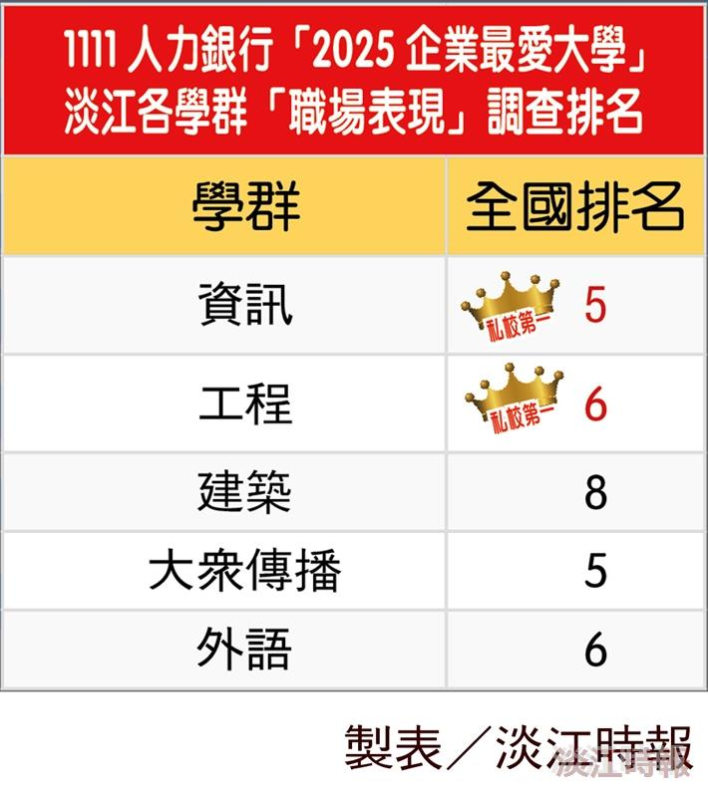
Tamkang University Rankings in the "Workplace Performance" Category of the 2025 "Most Favored University by Enterprises" Survey by 1111 Job Bank.

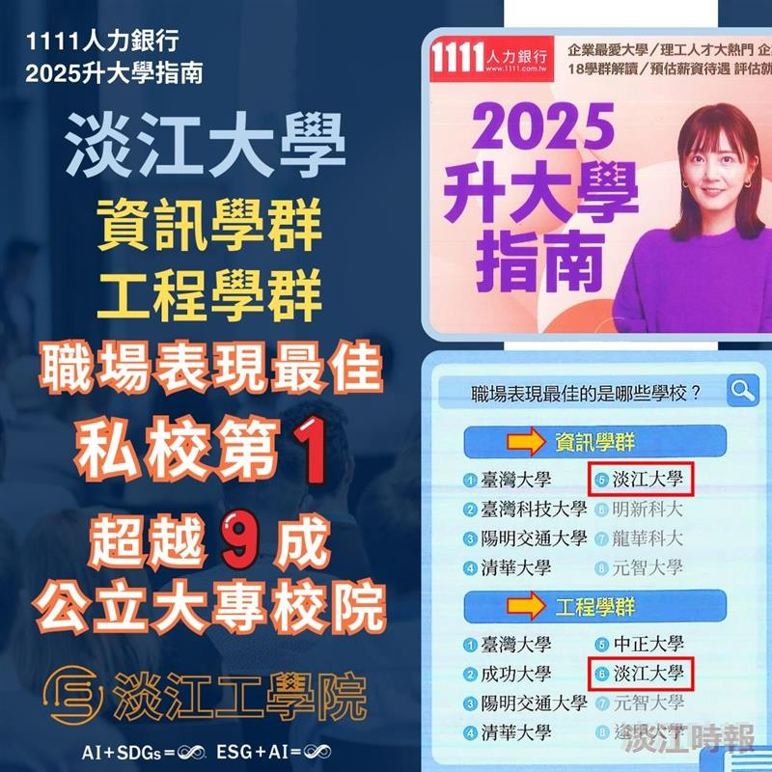
In the “2025 Most Favored University by Enterprises” survey conducted by 1111 Job Bank in collaboration with TUN University Network, Tamkang University’s Information Technology and Engineering groups ranked 5th nationwide in the “Workplace Performance” category, securing the top spot among private universities.

