Tamkang Times No.1207
Spring Feast Unites Alumni as President Keh Unveils TKU's Transition to Smart Cloud Campus 3.0

The Tamkang University Alumni Association Headquarters of Departments, in collaboration with the Office of Alumni Services and Resource Development, held the 2025 Spring Feast themed “75 Glorious Years: Spring in Tamkang” (「75芳華，春in映淡江」) on March 15, from 10 a.m. to 4 p.m. at the Shou-Chlien International Conference Center. Nearly 400 alumni returned to their alma mater to joyfully participate in the celebration. During his speech, President Huan-Chao Keh announced that Tamkang University is officially entering the Smart Cloud Campus 3.0 era. Chih-Jen Su, President of the Tamkang University Alumni Association Headquarters of Departments, praised the alumni's strong sense of unity, saying, “Even though it’s pouring rain today, it can’t extinguish the love everyone has for our alma mater.”

President Keh explained to the alumni that Smart Cloud Campus 3.0 encompasses 4 key areas: “AI-Driven Cloud Administration,” “Digital Twin Energy Management,” “AI-Driven Teaching Innovation,” and “Smart and Sustainable Industry-Academia Collaboration.” These initiatives integrate AI with sustainable development goals to ensure the efficient operation of the university. He especially noted Tamkang’s outstanding performance in student recruitment for the 2024 academic year, having admitted the highest number of first-year students in the country and achieving a registration rate of 101.12%. He credited this achievement to the tireless efforts of faculty and staff and the unwavering support of alumni, who traveled across Taiwan to host orientations for incoming students and parents. This played a key role in promoting Tamkang University. Additionally, TKU has been named the most favored private university by businesses in the CommonWealth Magazine Group rankings for 28 consecutive years, further affirming its outstanding reputation.

Lawrence Lin, President of the Tamkang University Golden Eagle Club and Chief Advisor of the Tamkang University Alumni Association Headquarters of Departments, shared that in celebration of Tamkang’s 75th anniversary, he raised NT$15 million from alumni within just one month. The funds will be used to improve the Tamsui campus landscape. Phase one, the renovation of the University Commons, is expected to begin after the commencement ceremony. He also announced that a 75th Anniversary Appreciation Banquet will be held in Hsinchu on October 18. Chih-Jen Su added that a lavish luncheon was prepared for alumni, encouraging them to enjoy the flowers and scenery on campus and give back to their alma mater. Alumni who donated over NT$100 via QR code received a limited-edition TKU cooler bag on the day.

As the birthplace of Taiwan’s campus folk songs, TKU honors its musical legacy with a guitar sculpture on the Shepherd’s Meadow commemorating alumnus Shuang-Tze Li. In celebration of the 50th anniversary of the campus folk song movement, the Spring Feast featured an exceptional musical performance titled Time Story. Performers included Department of Electrical and Computer Engineering alumnus Yi-Min Liao (formerly Department of Electronics), keyboardist Chien-Yi Lin, and Cheng-Sheng Li from the Department of Water Resources and Environmental Engineering. They performed classic folk songs such as Scenes in the Rain (〈雨中即景〉), Let’s Watch the Clouds Go By (〈讓我們看雲去〉), A-Mei A-Mei (〈阿美阿美〉), Kapok Road (〈木棉道〉), A Story in the Rain (〈雨中的故事〉), A Story of Spring (〈春天的故事〉), Thinking of You (〈想你〉), Seasonal Rain (〈季節雨〉), The Closing Film (〈散場電影〉), Descendants of the Dragon (〈龍的傳人〉), and Formosa (〈美麗島〉), composed by alumnus Shuang-Tze Li. Accompanied by nostalgic songs, old campus photos and youthful images of alumni association leaders were shown, stirring warm memories and touching the hearts of all attendees. At 2 p.m., the celebration continued at Tong-Zhou Square with the “Folk Song Banquet – You and Me at Tong-Zhou Plaza” (「民歌饗宴-同舟廣場民歌你和我」), reviving the tradition of Tamkang’s folk music roots and helping alumni reminisce about their youthful campus days through songs.

During the event, donors with cumulative contributions ranging from NT$500,000 to NT$1,000,000 were recognized. Honorees included Hsiao-Hsien Lo, Chung-Jung Ouyang, Li-Na Hung, Yi-Chieh Chen, ManySplendid Infotech Ltd., Geo Gin Trading Co., Ltd., and Shyanghang Investment Co., Ltd (祥行投資有限公司). Notably, Tsai-Lieh Yang, an alumnus of the Department of Water Resources and Environmental Engineering, donated a brand-new LED display board to the Chang Yeo Lan Conference Hall, which was officially launched on the same day. President Keh personally presented certificates of appreciation, recognizing their deep affection and selfless contributions to Tamkang University and their collective efforts to build a brighter future.

A total of 51 outstanding alumni were honored, representing departments across the university: Yao-Hua Wang (Chinese), Wen-Tso Chen (History), Cheng-Liang Tsai (Information and Library Science), Shu-Chao Lin and Yen-Ming Chen (Mass Communication), Yu-Ling Chang and Po-Hung Liu (Mathematics), Chih-Tsung Lee and Chun-Hsien Lee (Chemistry), Chung-Hsien Shih and Chiu-An Hsiao (Civil Engineering), Ping-Chung Chen and Chen-Tao Hsieh (Water Resources and Environmental Engineering), Chun-Nan Ou (Mechanical and Electro-Mechanical Engineering), Hung-Chen Shih and Hsu-Hsien Chang (Chemical and Materials Engineering), Jung-Huang Wu and Ming-Fang Hsu (Electrical and Computer Engineering), Nan-Kuang Chen and Yi-Hsueh Chen (Computer Science and Information Engineering), Ching-Chin Lin and Ping-Yao Chung (International Business), Chien-Ying Chen and Hsiao-Ping Lai (Banking and Finance), Chien-Fa Chen (Risk Management and Insurance), Yen-Ju Lin and Yi-Chi Chen (Industrial Economics), Jui-Feng Chang (Business Administration), Hsiao-Ling Chiang and Wan-Jung Lin (Accounting), Tsai-Ling Yeh and Chao-Tsung Pan (Statistics), Chih-Ching Wang and Chia-Hsien Lee (Information Management), Chun-Fu Wu and Shao-Yuan Chen (Public Administration), Keng-Hao Chang and Tzu-Cheng Su (Management Sciences), Yi-Feng Lan and Chi Chung (Spanish), Run-Pei Liao (French), Wei-Chieh Hu (German), Shih-Min Tian and Hung-Yueh Lan (Japanese), Pei-Chien Chuang (Russian), Cheng-Fang Lee and Wen-Chih Huang (International Affairs and Strategic Studies), Sheng-Liang Liu and Chung-Lung Chang (Diplomacy and International Relations), Yi-Chun Chou and Chen Wei-Hung (Educational Technology). The awards were presented by Deans Prof. Huei-Chun Chi (Liberal Arts), Prof. Tzenge-Lien Shih (Science), Prof. Tzung-Hang Lee (Engineering), Prof. Pei-Chien Lin (representing College of Business Dean Li-Ren Yang), Prof. Yi-Ti Lin (Foreign Languages), Prof. Cheng-Hao Pao (International Affairs), and Prof. Kuo-Hua Chen (Education).

Executive Director of the Office of Continuing Education Prof. Yi-Nan Lin introduced the “Global Trends Insight” (「觀勢匯天下」) course series, which covers 6 key fields: Digital Transformation, Sustainable Development, Corporate Strategy, Marketing, Human Resources, and Financial Management. The program features Golden Eagle Award winners, industry experts, and professors. Prof. Lin emphasized that the curriculum is designed to meet contemporary needs, offering professional certifications and opportunities for networking and resource sharing. It aims to help SMEs tackle challenges such as financing, talent development, market shifts, and digital transformation.

At 1:30 p.m. and 3 p.m., 2 sessions of “Happiness DIY – Colorful Aroma Stones” were held in rooms HC405 and HC406. The alumni association provided materials, and Deputy Secretary-General Nei-Chih Lin guided participants in crafting personalized aroma stones. Yung-Jung Tsang, event coordinator for the Department of Management Sciences Alumni Association, noted that the activity held special meaning for alumni. As they chose and matched flower colors, they engaged in conversation and exchanged their creations, enhancing camaraderie and team spirit. He praised Nei-Chih Lin’s meticulous instruction, which resulted in nearly flawless creations, and alumni happily took group photos with their handmade works.
2025/04/15

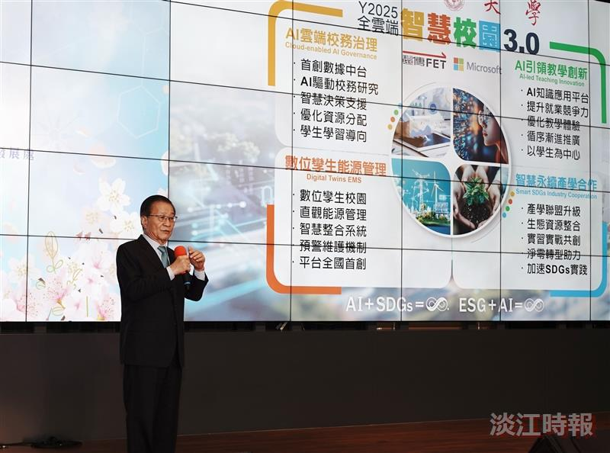
At the Spring Feast, President Huan-Chao Keh announced that Tamkang University is officially entering the Smart Cloud Campus 3.0 era this year.

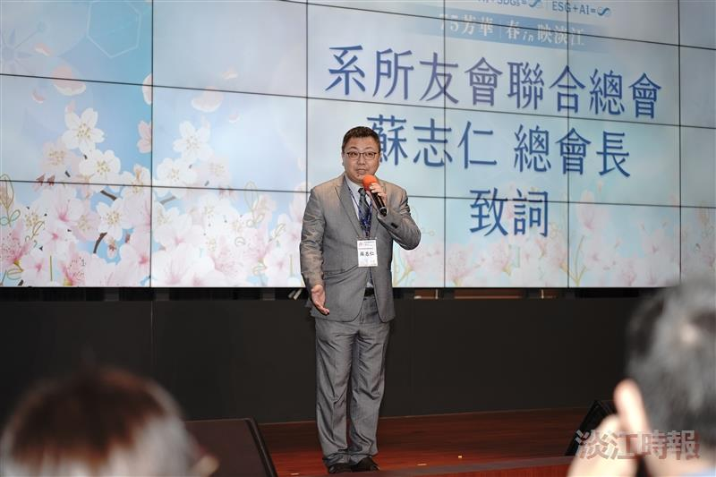
In his speech, Chih-Jen Su, President of the Tamkang University Alumni Association Headquarters of Departments, expressed his hope that alumni would return to their alma mater to enjoy the flowers and scenery while giving back to the university.

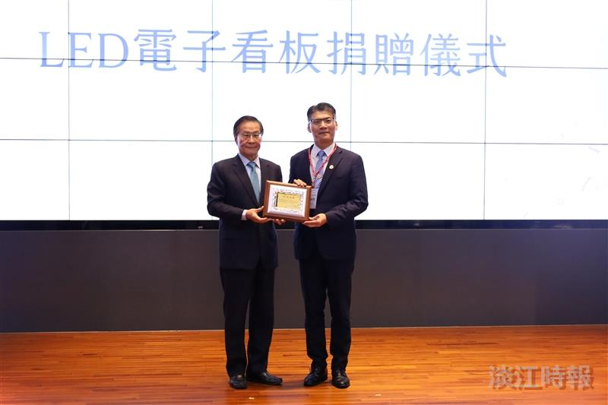
Tsai-Lieh Yang (right), an alumnus of the Department of Water Resources and Environmental Engineering, donated a brand-new LED display board to the Chang Yeo Lan Conference Hall, which was officially launched today. President Keh presented him with a certificate of appreciation.

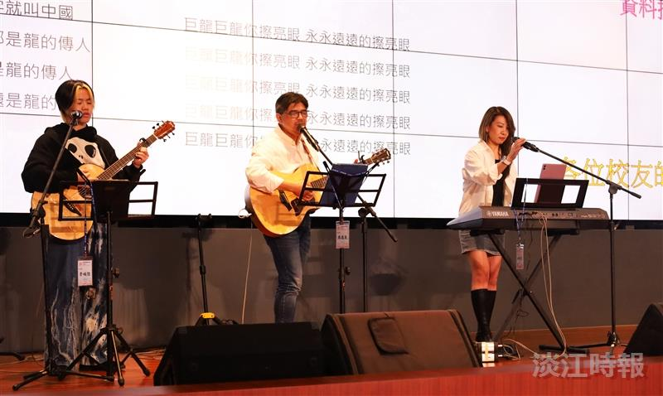
The "Time Story" musical banquet featured performances by Yi-Ming Liao (center), an alumnus of the Department of Electrical and Computer Engineering (formerly the Department of Electronics), keyboardist Chien-Yi Lin (right), and Cheng-Sheng Li from the Water Resources and Environmental Engineering year 4, as they teamed up to sing several folk songs.

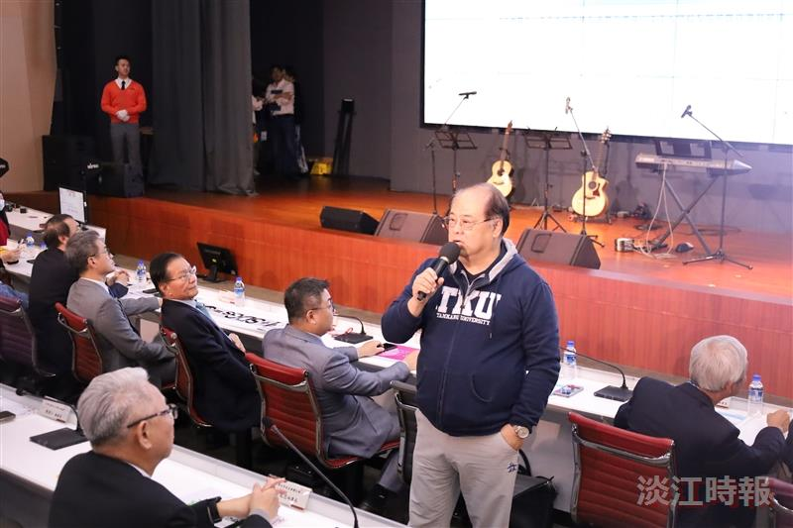
Chien-Hsiang Lin, President of the Tamkang University Golden Eagle Club and Chief Advisor of the Tamkang University Alumni Association Headquarters of Departments, called on alumni to donate to improve the Tamsui Campus landscape.

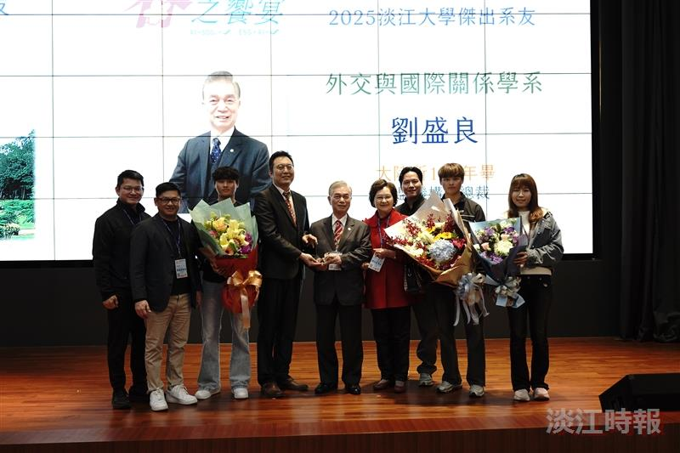
At the Spring Feast, outstanding department alumni were honored. Former legislator and Department of Diplomacy and International Relations alumnus Sheng-Liang Liu (5th from the right) took the stage to receive the award, joined by family and friends in celebration.

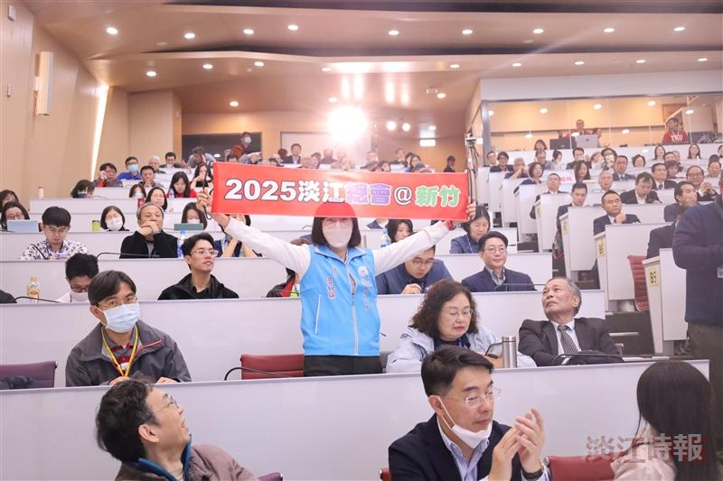
Lawrence Lin announced that a 75th Anniversary Thanksgiving Banquet will be held in Hsinchu on October 18. Ju-Ying Lan, President of the TKU Alumni Association of Hsinchu, held up a banner inviting everyone to participate actively.

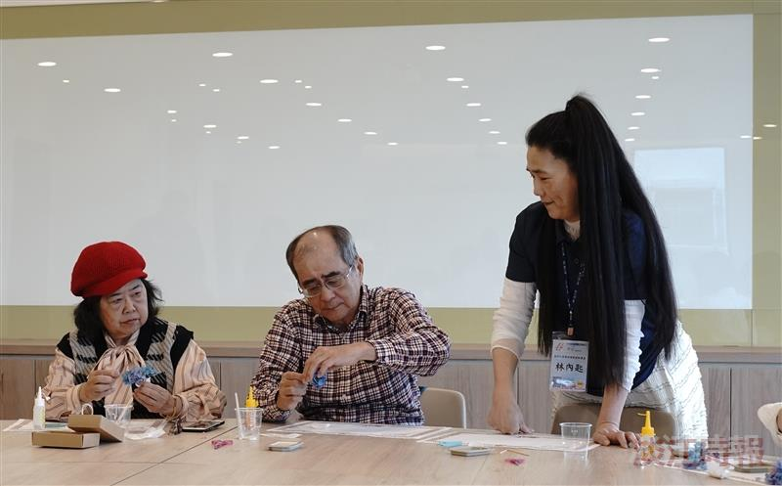
Nei-Chih Lin (first from the right), Deputy Secretary-General of the Tamkang University Alumni Association Headquarters of Departments, led alumni in making personalized aroma stones.

