Tamkang Times No.1207
Tamkang in Action: Leading High School Students to "Chase the Light" Together

On the afternoon of March 8, the Office of Academic Affairs held the “Chasing the Light – 2025 Tamkang University Academic Expo” at the Tamsui Campus. All 36 departments from the university’s 8 colleges showcased their distinctive programs, development highlights, and future career prospects. The event aimed to help high school students, teachers, and parents understand Tamkang’s academic offerings, explore infinite possibilities for learning and future development, and increase students’ interest in enrolling at Tamkang. The event attracted over 1,200 participants.

The opening ceremony occurred at the Chang Yeo Lan International Conference Hall in the Hsu Shou-Chlien International Conference Center. Vice President for Academic Affairs Prof. Hui-Huang Hsu opened the event by introducing Tamkang University’s history, educational philosophy, holistic education approach, flexible academic system, strong alumni network, and abundant scholarship resources. Under the university’s development vision of “AI+SDGs=∞,” Tamkang is promoting digital transformation and a green campus by building a “Smart Cloud Campus” and “Campus Sustainability Cloud” while actively integrating AI into teaching. Tamkang is also committed to providing interdisciplinary learning opportunities. Each college offers unique programs and professional certification courses to enhance students’ future career competitiveness. Prof.Hsu expressed his hope that through this event, students would gain deeper insight into Tamkang’s diverse learning environment, departmental features, and enrollment advantages, ultimately encouraging them to choose Tamkang for their studies.

Starting from 2 p.m., departmental exhibitions were held on various floors of the Hsu Shou-Chlien International Conference Center and at the Tong-Zhou Plaza. The atmosphere was lively, with faculty and students enthusiastically engaging visitors, explaining each department’s curriculum and career paths, and offering analysis tools to help students prepare for college applications. Students and parents asked various questions, demonstrating strong interest and enthusiasm. A new feature, “Empowering with AI, Connecting to the Future,” highlighted AI integration and interdisciplinary learning achievements from each college and provided personalized advice for high school students on choosing their preferred majors. The Office of International and Cross-Strait Affairs also set up a booth explaining the dual-degree program. It hosted a “Chat Corner,” where high school students interacted with international students from Tamkang and heard exchange students share their overseas study experiences, drawing significant interest.

The “College Briefings” segment featured the College of Liberal Arts and the College of International Affairs sharing insights into their colleges and departments. The College of Liberal Arts also led participants to visit its student media labs, while other colleges conducted “College Site Visits,” guiding students through locations such as the College of Science laboratories, the multifunctional presentation room in the College of Business and Management, the Reality Field in the College Artificial Innovative Intelligence, and the Wind Engineering Research Center, all accompanied by college introductions. Campus tours allowed participants to explore Tamkang’s environment, dormitories, and student activity venues. To showcase the vibrant campus life, student clubs—including the Guitar Club, Choir, Hip-Hop Research Club, and Classical Guitar Club—performed at the University Commons, attracting many spectators.

Student participants Wu and Wang expressed interest in the Departments of Banking & Finance and Mass Communication. They appreciated the friendly and enthusiastic guides and received detailed answers regarding career paths and course structures. They found the campus facilities modern and the activities diverse and engaging. Student Chi learned about the event through Tamkang University’s website and stated that Tamkang is currently his top choice. He hopes to enroll in either the Department of Mass Communication or Information and Communication, believing that the skills learned there will be highly applicable to future careers. Students Li and Shih commented on the great atmosphere of the expo. They mentioned their fun interaction with the Department of European Languages, which included dancing and a surprise birthday song, leaving them with a memorable impression. Although they were concerned about whether their grades met Tamkang’s admission requirements, the experience gave them a better understanding of the university and an unforgettable memory.

Parent Ms. Hsu attended on behalf of her daughter, a junior in high school who excels in mathematics. She focused on exploring the Departments of Computer Science and Artificial Intelligence. The event helped her better understand these departments' course content and features. She found the expo’s itinerary rich and diverse, and the campus tour helped her become familiar with the university’s environment and teaching facilities.
2025/04/15

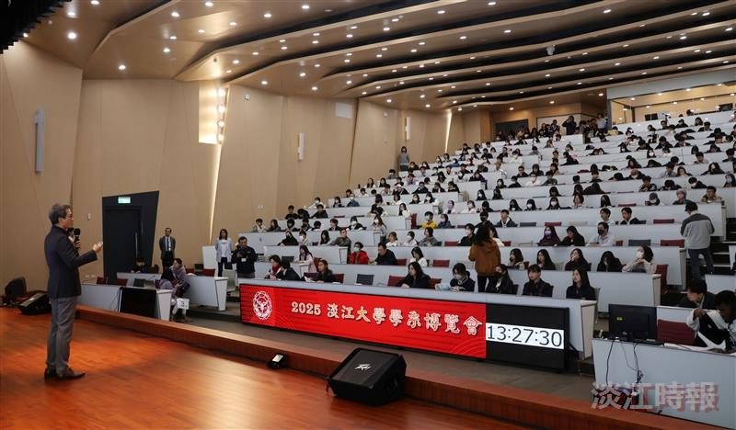
At the "Chasing the Light – 2025 Tamkang University Academic Expo," Vice President for Academic Affairs Prof. Hui-Huang Hsu introduced the university’s distinctive features to the participants.

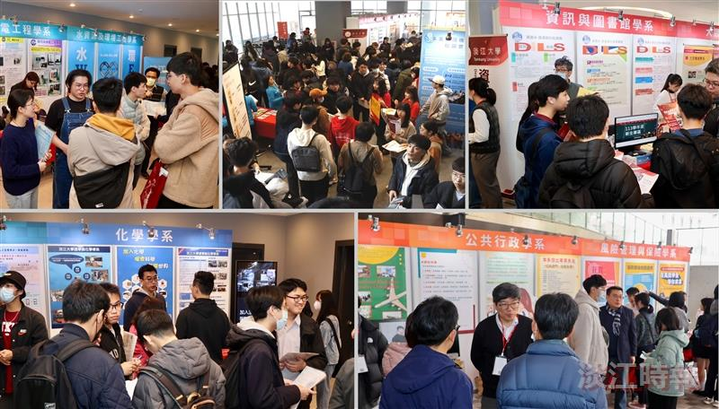
All departments from Tamkang University’s 8 colleges set up booths on various floors of the Hsu Shou-Chlien International Conference Center to showcase their programs and unique features.

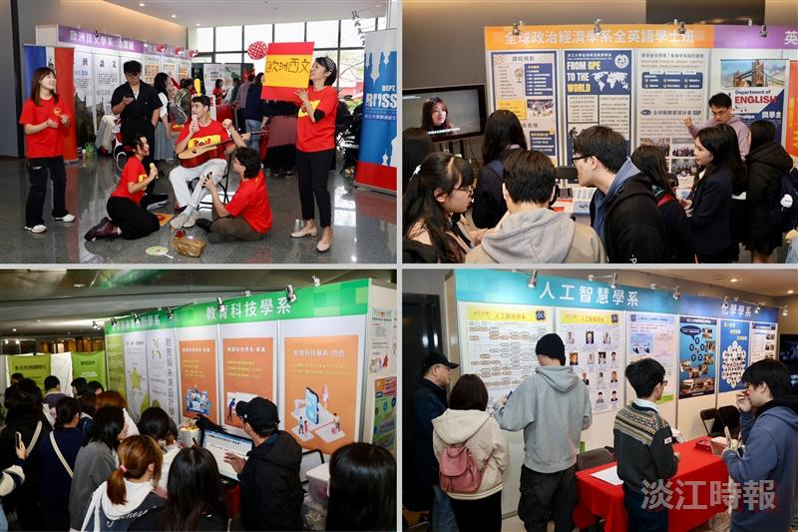
All departments from Tamkang University’s 8 colleges set up booths on various floors of the Hsu Shou-Chlien International Conference Center to showcase their programs and unique features.

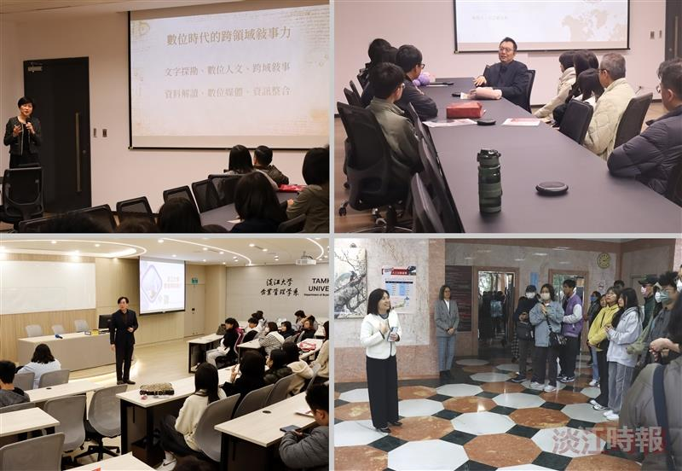
(Top) “College Briefings” featured deans from the Colleges of Liberal Arts and International Affairs introducing their colleges and departments.?
(Bottom) “College Site Visits” guided participants to visit each college to explore their teaching environments and facilities.

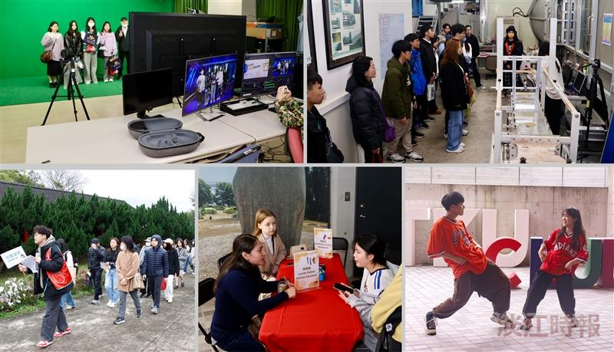
The event included campus tours and college site visits, invited international students from Tamkang and high school students for language and cultural exchanges, and featured performances by student clubs to showcase the university’s diverse development.

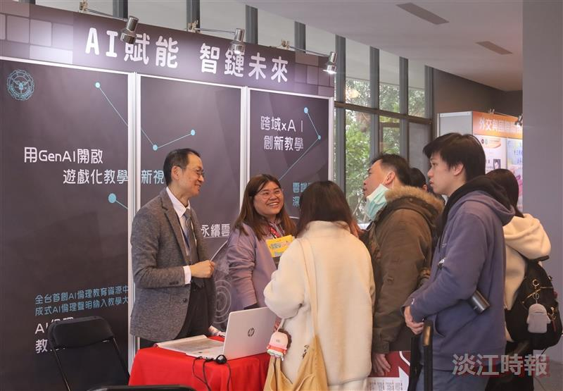
“Empowering with AI, Connecting to the Future” showcased each college’s achievements in AI integration and interdisciplinary learning and addressed questions related to departmental admission criteria and other relevant topics.

