Tamkang Times No.1207
Tamkang University Launches Smart Cloud Campus 3.0, Pioneering a New Blueprint of AI+SDGs=∞

Under the vision of “AI+SDGs=∞” for university development, Tamkang continues to push the boundaries of digitalization in higher education, empowering students with broader and more effective learning experiences. Since 2020, the university has partnered with Microsoft Taiwan to create the nation’s first fully cloud-based smart campus. In 2022, we further collaborated with Far EasTone Telecommunications (FET) to complete the deployment of cloud switches, advancing to the 5G-enabled Smart Cloud Campus 2.0. On March 15, during the Spring Feast event, President Huan-Chao Keh announced to alumni that Tamkang University will join hands with FET to launch the “Y2025 Smart Cloud Campus 3.0.” This new initiative showcases the university's achievements in digital and net-zero transformation. It aims to deepen the application of AI technologies, injecting fresh momentum into developing a sustainable campus. Tamkang continues to lead in digital transformation and sustainable development in higher education and contributes actively to advancing smart, sustainable education in Taiwan.

The Y2025 Smart Cloud Campus 3.0 project centers around 4 significant initiatives: Cloud-enabled AI Governance, AI-led Teaching Innovation, Digital Twins EMS (Energy Management System), and Smart SDGs Industry Cooperation. These initiatives aim to enhance the efficiency of school governance, optimize teaching quality, and uphold the student-centered learning philosophy. They are designed to cultivate students with interdisciplinary capabilities in “AI+SDGs” while leveraging Tamkang’s academic strength and industry collaboration. Through strong partnerships with alumni enterprises, FET, and Microsoft Taiwan, Tamkang seeks to accelerate industry efforts to achieve the SDGs with practical and value-added solutions.

Regarding school governance and teaching innovation, Tamkang will establish the first mid-end data platform for school administration among universities and colleges in Taiwan. This system will integrate key campus data in real time to support precise decision-making by university leaders. Additionally, the university will develop an AI knowledge application platform to assist teaching and learning, boost students’ future employability, and improve teaching experiences through integrated AI tools. These enhancements will further advance a student-centered learning environment.

On the smart energy management front, Tamkang will implement digital twin technology for the first time, creating a visualized real-world simulation model to serve as an energy monitoring system. It will integrate data from solar panels, EV charging stations, smart streetlights, and security systems. Beyond monitoring, it will offer real-time alerts to improve administrative response efficiency. This will become Taiwanese universities' first digital twin energy management platform, offering a better sustainable environment for faculty, staff, and students.

Tamkang University will establish a robust industry-academia service platform for alumni and industry collaboration. By integrating on-campus software, hardware, and human resources and cooperating with alumni businesses, Far EasTone, and Microsoft Taiwan, Tamkang will provide excellent internship opportunities for students and co-develop practical digital transformation solutions. These tools will help industries implement net-zero transitions more efficiently and effectively, collectively accelerating and enhancing the realization of the SDGs.
2025/04/15

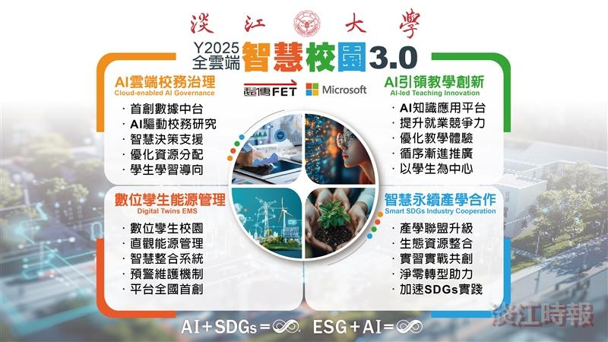
On March 15, Tamkang University officially launched its Smart Cloud Campus 3.0.

