Tamkang Times No.1205
Architecture Students Win Recognition in Mumbai Flood Response Competition, All 8 Students Praised for Effective Use of AI

Led by part-time instructor Wei-Xiang Song, students from the Department of Architecture at Tamkang University participated in the international competition organized by Indian firm Ketham’s Atelier Architects. Themed " Rethink Mumbai Flooding: Open Competition and Exhibition," the competition saw 8 students from Tamkang join, with 4 receiving awards—including one first place—and 4 others being shortlisted. Song noted that students effectively utilized AI tools to enhance efficiency in data collection. The competition strategy aligned well with the organizer's expectations, resulting in an excellent performance. He added that they will continue participating in international competitions to enhance global competitiveness.

Sung, who leads his studio students to international competitions annually, said this was their first time entering this contest. Drawing on recent experiences with AI in design contests, he encouraged students to use generative AI tools in their creations. He was pleasantly surprised by the results. “This helps students step outside of their comfort zones and allows them to hear perspectives from around the world—an invaluable experience.”

First-place winner Guan-Yu Pan, a 4th-year architecture student, tackled flood issues from a sustainability perspective, proposing a dynamic architecture system that adapts to environmental changes. His design uses floating modules to intercept sediment and form natural seawalls, allowing the city to self-adjust in the face of flooding. He extensively used AI tools to collect and organize information and employed Midjourney to assist in rendering. With the help of various tools, efficiency greatly improved. He believes AI provides powerful support, but architectural logic and aesthetics still depend on the designer's judgment.

4th-place winner Yong-Jyun Yeh, also a 4th-year student in architecture, referenced the concept of a "sponge city" to enhance urban resilience against flooding. His proposal seeks to balance urban development and ecological restoration, using infrastructure and vegetation techniques to reduce stormwater runoff, mitigate the urban heat island effect, and improve water recycling. Unfamiliar with the local environment, he conducted virtual field studies using YouTube and Google Street View to better understand local residents' daily lives and needs. Through the competition, he deeply realized that architecture must be aesthetically pleasing and socially responsible, solving real problems for the community.

In addition to the first- and fourth-place awards, Wen-Li Lu (4th year) won seventh place, and Po-Chih Yang (5th year) placed ninth. 4 others—Meng-Jun Wei (2nd year), Jhong-Wei Li (2nd year), Heng-Jia Chen (4th year), and Wei-Teng Huang (5th year)—were shortlisted, resulting in what could be called a clean sweep for Tamkang. The top 10 entries will be exhibited at The Bombay Art Society from April 14 to 20. The 20 awarded and shortlisted works will also be published in an official publication by the organizers, showcasing innovative solutions to Mumbai’s flooding problems.
2025/03/31

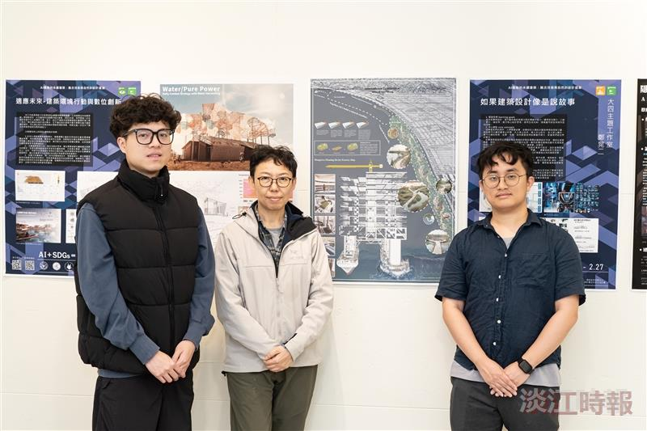
Award-winning students and faculty: From left – 4th-year Architecture student Guan-Yu Pan (First Place), advisor instructor Wei-Xiang Song, and Architecture 4th-year Yong-Jyun Yeh (Fourth Place).

