Tamkang Times No.1205
Let Students Wake Up, Listen AI Telling Stories: Architecture Department Exhibition Showcases Rich and Diverse Teaching Energy

AI integration into teaching has become a prominent trend on campus. In response to the university's development strategy of AI+SDGs=∞, the Department of Architecture held a four-day exhibition titled “AI-Driven Sustainable Architecture: Design Proposals Integrating Technology and Nature,” showcasing how AI technology can be deeply integrated with disciplinary knowledge. The 4-day exhibition attracted faculty from various departments who came to gain insights, resulting in cross-disciplinary teaching inspiration.

The exhibition was presented in two sections: “Promises of Tomorrow” and “Actions of Today,” demonstrating how faculty and students in the Department of Architecture are currently incorporating AI tools into teaching. “Promises of Tomorrow” was led by Professor Hoang-Ell Jeng, who also served as the exhibition curator. Together with 4th-year Architecture students Shao-En Huang, Yu-Hsuan Tsai, and Kuan-Ting Lu, they applied the concept of “narrative architecture” to tell stories through architectural design and proposed 10 sustainable architectural proposals. “Actions of Today” showcased the application and expansion of AI technology in architectural design education, featuring how 8 professors utilize AI tools to present diverse design methods. This reflects the department’s strong focus on cutting-edge digital technology and sustainability issues, highlighting the potential for interdisciplinary collaboration and teaching innovation.

The exhibition also included workshops, lectures, and dialogues, with faculty from various departments exploring concepts of interdisciplinary AI collaboration. On the first day, a workshop was held on the theme of the collaborative project “People-Centered Transportation and Livable Streets” between the Department of Architecture and the Department of Transportation Management. The New Taipei City Transportation Department initiated this project, selecting Yingzhuan Road near the Tamsui MRT Station as a starting point for the interdisciplinary exploration of AI narrative scenarios and data science. Chair Chun-Ying Chen of the Transportation Management Department, Professors Jeng and Mei-Huei Li, Associate Professor Yi-Cheng Lai from the Architecture Department, and USR project leader “Tamsui Good Life Project” Jui-Mao Huang, also a professor from Architecture Department, shared their visions of integrating AI technology.

The event's highlight was a dialogue titled “AI-Driven Innovations in Professional Teaching” between Professor Jeng and Distinguished Professor Hui-Ling Pan from the College of Education, organized by the Center for Teacher Professional Development and attended by nearly 60 faculty members. The session was moderated by Vice President for Academic Affairs Hui-Huang Hsu, who expressed hopes that faculty across disciplines would embrace AI to enhance students’ career readiness. Prof. Pan raised the key question of how teachers could quickly adapt to this “paradigm shift in teaching and learning,” given the widespread adoption of AI tools in all fields. Prof. Jeng responded by sharing methods used in his theory classes, such as the “knowledge escape room” game and AI teaching assistants. He noted that research shows humans can only endure boring information for 3 seconds, and to re-engage students distracted by phones or falling asleep, one must identify the pain points — “know what you need AI to do for you,” so you can “wake up the students and let AI tell the story.”

Assistant Professor Jun-Pei Liao from the Department of French shared her impressions, expressing amazement that architecture students, with ChatGPT's help, could produce copy in the style of 19th-century Romanticism. She also observed the aesthetic transitions between literature and film in student works, affirming that “architecture is the first chapter of Hegelian aesthetics.” Associate Professor Wen-Her Chen from the Physical Education Office participated in the workshop during his lunch break, collaborating with ChatGPT to produce a story and storyboard script within one hour. He later successfully generated a storyboard and generously shared it in the LINE faculty learning community. Among the 24 participants that day, 17 completed their work on-site under the guidance of Prof. Jeng, all marveling at the astonishing power of AI technology.
2025/03/31

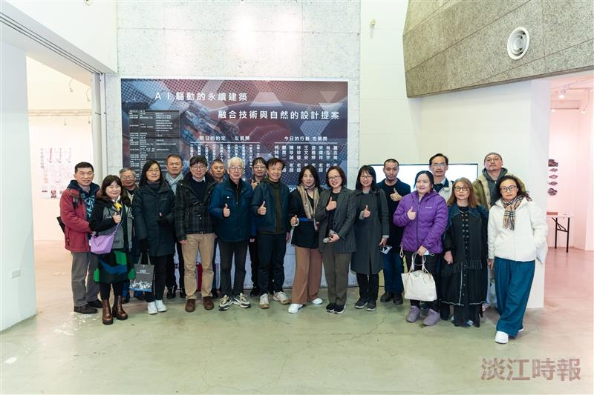
The Department of Architecture held the exhibition “AI-Driven Sustainable Architecture: Design Proposals Integrating Technology and Nature,” attracting faculty from various departments who came to gain insights and spark interdisciplinary teaching inspiration.

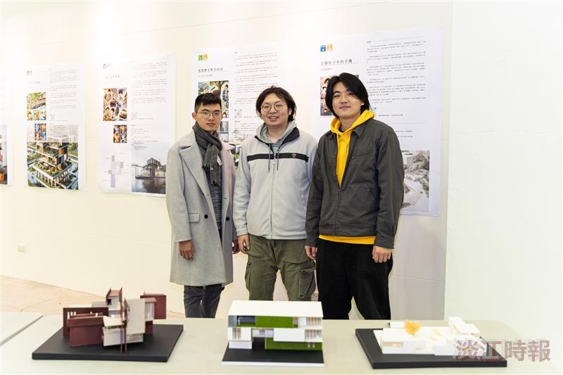
4th-year Architecture students Shao-En Huang (from left), Yu-Hsuan Tsai, and Kuan-Ting Lu applied the concept of “narrative architecture” to tell stories through architectural design, presenting ten sustainable building proposals.

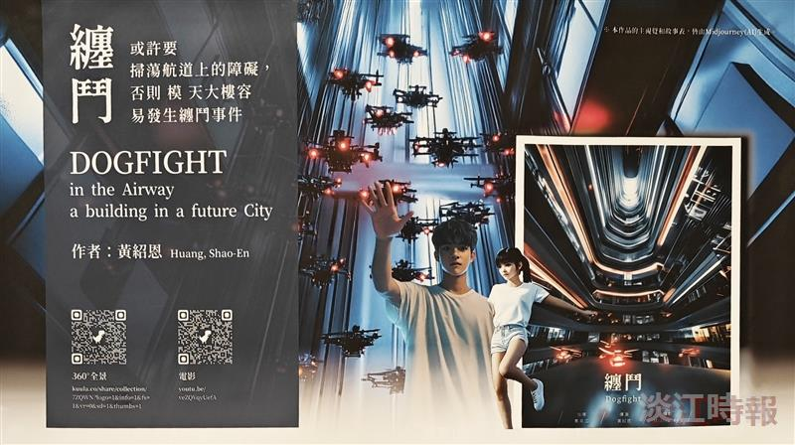
Architecture students collaborated with AI to propose sustainable architectural designs. Pictured is 4th-year student Shao-En Huang, who drew inspiration from drones to design a super high-rise residential building that allows drones to freely navigate through it. The concept envisions a human-machine coexisting environment, giving back a more open sky.

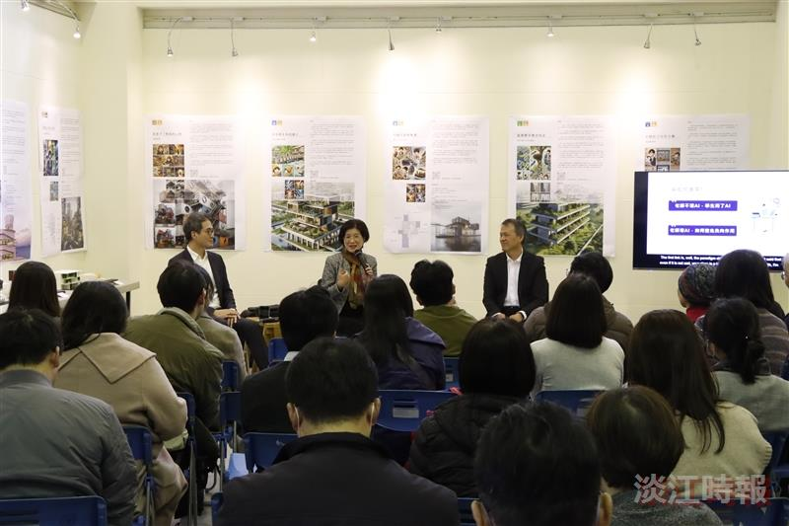
Professor Hoang-Ell Jeng (right) from the Department of Architecture and Distinguished Professor Hui-Ling Pan from the College of Education engaged in a dialogue on "AI-Driven Innovations in Professional Teaching," encouraging faculty to swiftly adapt to this "paradigm shift in teaching and learning."

