Tamkang Times No.1205
Arizona State University Polytechnic School Visits Tamkang to Explore Dual-Degree Program Possibility

On February 20, 3 representatives from our sister school—Arizona State University (ASU), the United States — Director Kurt Paterson of the Polytechnic School, Outreach and Recruitment Director Adam Henry, and Outside Consultant Daniel Gerbatch from the Fulton Schools of Engineering, visited our campus. A discussion was arranged by the Office of International Affairs in Room 1005 of the Ching-Sheng Hall to explore the possibility of a dual-degree program and teaching resource collaboration.

The discussion was hosted by Dean of International Affairs Chien-Mu Yeh and attended by Dean Tzung-Hang Lee of the Colleges of Engineering, Artificial Innovative Intelligence, and Precision Healthcare, Architecture Department Chair Chun-Jung Ko, Professor Tzen-Ying Ling, and Associate Professor Feng-Cheng Chang of the Department of Computer Science and Information Engineering. During the discussion, the possibility of establishing a dual-degree program between the Architecture Department and Polytechnic School of ASU was examined, with hopes to eventually extend this collaboration to other departments within the College of Engineering of Tamkang. In addition, the potential for sharing the visiting school’s rich and diverse online courses was discussed, so Tamkang students could benefit from more comprehensive educational resources.

At 3:40 PM, in room G508, Professor Kurt Paterson delivered a keynote lecture titled “Climate Solutions: Accelerate and Delay,” exploring how global architecture and infrastructure can play a key role in reducing carbon emissions. Drawing on his experience as a Jefferson Science Fellow at the National Academies of Sciences, Engineering, and Medicine, he shared insights on how collaboration between technology and policy can accelerate global decarbonization efforts.

Prof. Paterson pointed out that although international efforts have actively promoted climate agreements and scientific research for many years, carbon dioxide concentrations continue to rise, indicating that current policies and actions are progressing slowly. He emphasized that technological innovation and economic affordability are key factors in the effectiveness of climate action. He cites the rapid proliferation of artificial intelligence as an example to illustrate that reducing the cost of green energy technology could accelerate the global energy transition. He believes that professionals in architecture and design will play a crucial role in future climate action and encourages industry and academia to actively participate through data-driven decision-making and innovative design to bring about faster changes in global decarbonization.

After the lecture, an Architecture Department student asked Prof. Paterson whether, based on research grounded in the Biden administration’s policies, there would be any changes after President Trump’s inauguration. In response, Paterson stated that green architecture will be an inevitable trend and, regardless of changes in political parties or leadership, it will remain an important issue in the future and continue to evolve.
2025/03/31

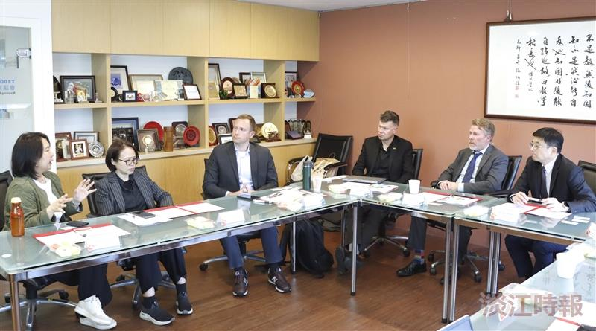
The Polytechnic School delegation of Arizona State University visited, and the International Affairs Office arranged a discussion to explore the possibility of dual-degree programs and cooperation on teaching resources.

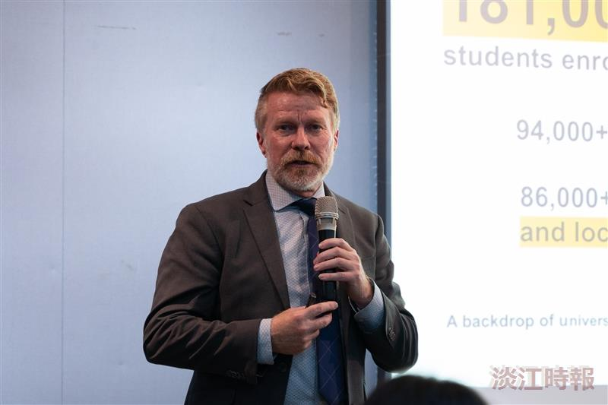
Professor Kurt Paterson, Director of the Arizona State University Polytechnic School, delivered a lecture on the theme "Climate Solutions: Accelerate and Delay."

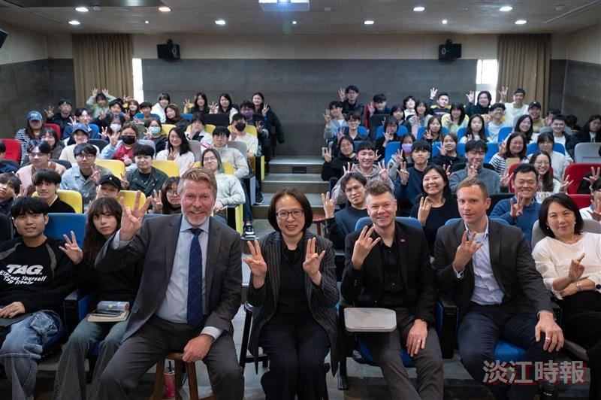
The Architecture Department faculty and students took a group photo with the speaker after the lecture.

