Tamkang Times No.1205
E-Pen & Ben-Hang Chang Calligraphy and Painting Exhibition Praised by Ambassador I-Yang Li and Japanese Parliament Members

Tamkang University, in cooperation with the Taipei Representative Office in Japan, is jointly hosting the "Tradition and Technology of Calligraphy – e-Pen and Ben-Hang Chang's Calligraphy Exhibition," which has been on display at the Taiwan Culture Center in Tokyo from February 13. The opening ceremony attracted the Ambassador to Japan, I-Yang Li, numerous Japanese Diet members, and figures from the calligraphy community to show their support. Ambassador Li stated, "Professor Chang Ping-Huang is regarded as a national treasure in the field of calligraphy. Not only has he preserved and promoted the art of calligraphy, but he has also dedicated himself to calligraphy education and talent cultivation. Through the program 'A Character a Day,' he has brought calligraphy into people's daily lives. In collaboration with Tamkang University, he has developed the Smart E-Pen, integrating technology into calligraphy learning. The widespread adoption of smart calligraphy is just around the corner."

The president of the Japan-Taiwan Diet Members' Consultative Council and MP Keiji Furuya could not attend due to the House of Representatives budget review but sent a recorded video to express his greetings, praising Ben-Hang Chang as one of Taiwan’s most representative calligraphers who made tremendous efforts in merging calligraphy with digital technology and actively promoted Taiwan’s cultural exchange, for which he expressed sincere admiration and gratitude.

Ben-Hang Chang, the Director of Carrie Chang Fine Arts Center, explained that, in the past, the promotion of calligraphy through traditional teaching methods had limited success. However, after many years of collaboration with Tamkang University's College of Engineering, they have successfully integrated AI technology into the Smart e-Pen, significantly reducing the obstacles of learning calligraphy. During the event, he demonstrated writing with the e-Pen, leaving attendees in awe and eager to try it themselves. Senator Eriko Yamatani was impressed by the e-Pen’s innovative technology allowing for fluid and natural strokes, while Senator Shimono Rokuta was equally astonished, writing "継続は力" ("Continuity is Power") on-site. Ambassador Li wrote "無欲則剛" ("He who is without desires is strong"), and Representative Takahiro Inoue, who rushed to the opening ceremony after the House of Representatives session, also wrote his name while experiencing the e-Pen.
2025/03/31

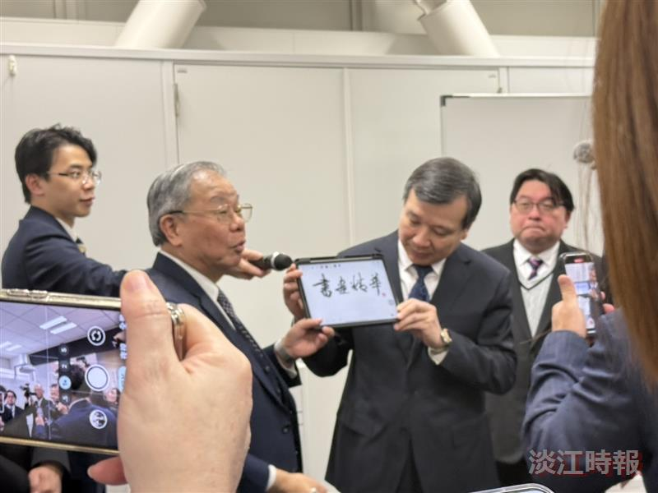
Ambassador to Japan I-Yang Li (right) holds a tablet for Carrie Chang Fine Arts Center Director Ben-Hang Chang (left) while he explains e-Pen calligraphy.

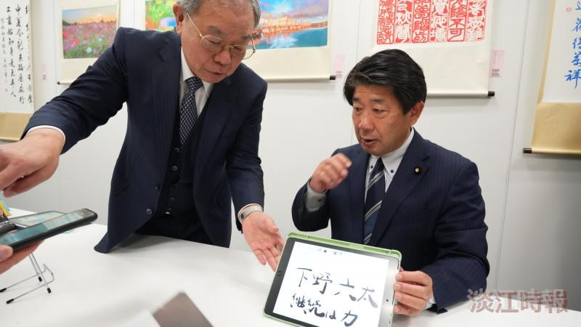
Japanese member of the House of Councillors Rokuta Shimono experienced the e-Pen on site and wrote "継続は力" (Perseverance is Strength).

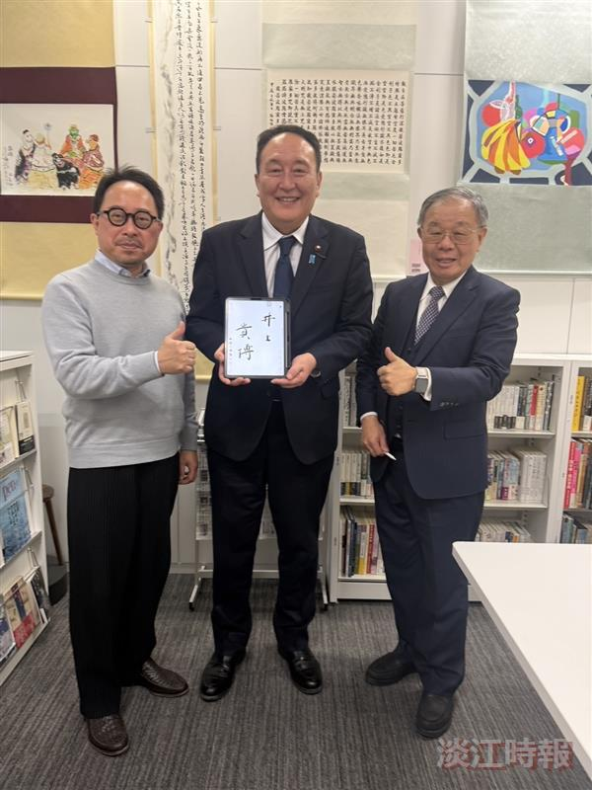
House of Representatives member Inoue Takahiro (center), who rushed to the calligraphy and painting exhibition venue, wrote his own name while experiencing the e-Pen.

