Tamkang Times No.1205
Tamkang and Ateneo de Davao University of Philippines Forge Sister School Partnership

Tamkang University and Ateneo de Davao University (AdDU) of the Philippines, on February 19 in HC405 of the Hsu Shou-Chlien International Conference Center, with President Huan-Chao Keh and AdDu President Fr. Karel S. San Juan representing the two schools, signed an academic exchange and student exchange agreement, establishing a sister school relationship. International Affairs Vice President Hsiao-Chuan Chen, Dean of the College of Science Tzenge-Lien Shih, Dean of the College of Engineering Tzung-Hang Lee, Dean of International Affairs Chien-Mu Yeh, Chair of the Department of Physics Cheng-Hao Chuang, Academic and AdDU Administrative Vice President Fr. Antonio M. Basilio, Dean of the College of Engineering and Architecture Dr. Randell U. Espina, Associate Dean Dr. Renyl B. Barroca, and others participated.

President Keh first welcomed Fr. Karel S. San Juan and his delegation to Tamkang University, and then introduced Tamkang’s adherence to the educational philosophy of “Triple Objectives” and campus characteristics and expressed the hope that the two schools could establish a long-term friendship, increase opportunities for academic exchanges and student exchanges, and jointly enhance the development and reputation of international cooperation, finally sincerely inviting them to participate in our university’s 75th-anniversary celebration. Fr. Karel S. San Juan shared the campus atmosphere of Ateneo de Davao University. He expressed his expectation that in the future, in terms of teaching and research, the two schools could learn from each other.

The discussion was chaired by Professor Hsiao-Chuan Chen, with Professor Chien-Mu Yeh introducing Tamkang University's campus environment and educational resources. Professor Cheng-Hao Chuang elaborated on the development and characteristics of the Department of Physics, as well as the academic structure and regulations of the "International Intense Master’s Program on Semiconductor and Quantum Testing" in the department. Fr. Karel S. San Juan also introduced the unique features of his university, fostering mutual understanding. Additionally, the delegation was given a tour of the University History Museum to learn about Tamkang University's history and development.

Ateneo de Davao University, established in 1948, is located in Davao City, Philippines, and enjoys a high academic reputation in the southern Philippines. Adhering to Jesuit educational principles, the university is committed to integrating academic excellence with moral education, emphasizing social responsibility and public service. It also prioritizes international collaboration, establishing partnerships with higher education institutions worldwide to provide students with opportunities for dual-degree programs and international exchanges. AdDu delegation visited Tamkang's Department of Physics on June 4, 2024, laying the foundation for today's collaboration.
2025/03/31

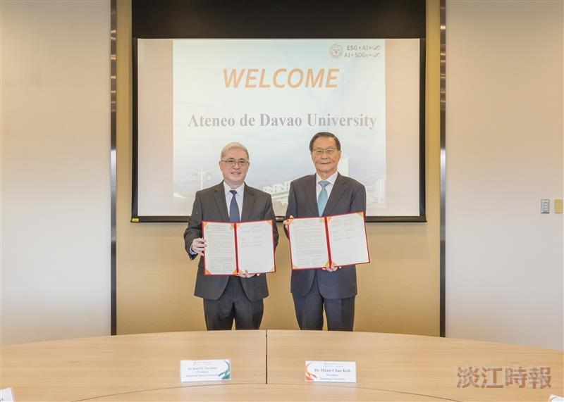
President Huan-Chao Keh (right) and Ateneo de Davao University President Fr. Karel S. San Juan (left) signed an academic exchange and student exchange agreement on behalf of the two schools, establishing a sister school relationship.

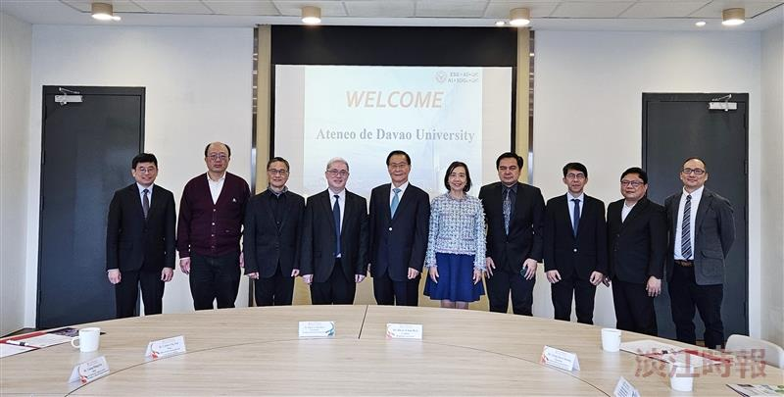
President Huan-Chao Keh (5th from left) and Ateneo de Davao University President Fr. Karel S. San Juan (4th from left) took a group photo after signing as representatives.

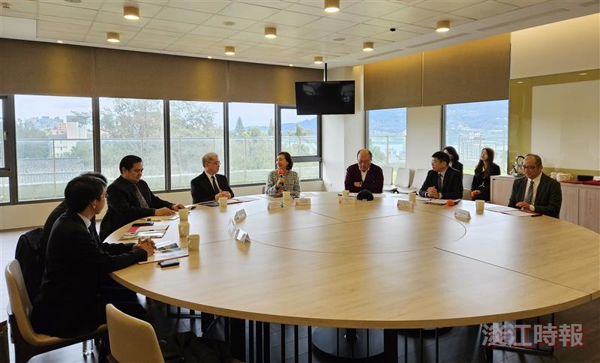
The discussion was hosted by International Affairs Vice President Hsiao-Chuan Chen (4th from right).

