Tamkang Times No.1205
President Keh Leads Delegation to 4 Sister Universities in Japan to Strengthen Academic Exchange

President Huan-Chao Keh led a delegation to Japan from February 24 to March 2 to deepen academic exchange and cooperation with sister universities and show concern for exchange students' lives and studies. The delegation included Vice President for International Affairs Hsiao-Chuan Chen; Dean of the Colleges of Engineering, Artificial Innovative Intelligence, and Precision Healthcare Tzung-Hang Lee; Dean of the College of International Studies Cheng-Hao Pao, Chair of the Department of Japanese Pei-Ching Tsai, and Secretary to the President Charles Hsiang-Chuan Chang. They visited Hokkaido University, Reitaku University, Waseda University, and Meiji University in Hokkaido and Tokyo to discuss opportunities for deeper collaboration.

On the morning of the 26th, the delegation visited Hokkaido University, which has been a sister university since 2010. Since the 2000 academic year, the two universities have exchanged students, with 14 Tamkang students having studied at Hokkaido University as of the 2024 academic year. In 2017, then-President and current Chairperson Flora Chia-I Chang led a delegation to visit the university. The visit began with a meeting with 2 Tamkang students currently studying at Hokkaido University. The delegation also toured the Center for Ainu and Indigenous Studies, where they exchanged insights with Professor Hirofumi Kato and Associate Professor Ken-ichi Ochiai. Professor Hsiao-Chuan Chen introduced Tamkang University’s Indigenous Student Resource Center, emphasizing Tamkang’s commitment to indigenous students’ well-being and academic success. Tamkang also regularly organizes exhibitions related to indigenous cultures. Professor Cheng-Hao Pao shared a comparative analysis of Taiwan and Japan’s indigenous policies from a sociological perspective.

Following this, the delegation participated in discussions and a luncheon with President Houkin, Vice President for International Affairs Aya Takahashi, and Dean of the Graduate School and Faculty of Engineering Hiroki Habazaki. The conversation focused on the current status of international students, with in-depth discussions on international recruitment, student support, and English-taught courses. Prof. Tzung-Hang Lee and Prof. Habazaki noted the similarities in developing engineering disciplines at both universities and expressed hopes for future substantive collaborations. After the meeting, President Keh personally invited President Houkin to attend Tamkang University’s 75th Anniversary Celebration and to serve as a speaker at the World University Presidents’ Forum.

The delegation traveled to Tokyo on the 26th, beginning their visit on the morning of the 27th at Reitaku University. The two universities established their sister school relationship in 2001, maintaining close faculty and student exchanges. Since then, Reitaku University has sent 170 students to Tamkang, while Tamkang has sent 491 students to Reitaku. In 2002, then-Vice President for Administration Flora Chia-I Chang led an administrative delegation to Reitaku University, and President Keh visited in 2019. In 2024, Reitaku University also sent a delegation to visit Tamkang. The visit began with the opening ceremony of the Tam-Rei Center, an office for Tamkang University at Reitaku University. The center's name is derived from both universities' names and reflects the philosophy of friendship and learning from the I Ching: "Li Ze, Dui; A gentleman engages in discussions and learning with friends" (「麗澤，兌；君子以朋友講習」). This milestone symbolizes the strong relationship between the two universities and provides a dedicated space for future collaboration. Additionally, Tamkang University is preparing to establish a Tam-Rei Center office within its College of Foreign Languages and Literatures.

The delegation then met with 4 Tamkang exchange students before attending a luncheon with Reitaku University President Suminori Tokunaga, Vice President for International Affairs Kazunobu Horiuchi, Dean of the College of Engineering Ryosuke Shibasaki, Assistant to the President Yoshikazu Hiroike, and Professor Urara Shimizu and Associate Professor Kyuu Iki from the College of Foreign Languages. Discussions focused on the international student system, with President Tokunaga committing to increase the quota for recommended exchange students from 15 to 30 to further enhance student exchanges. Horiuchi proposed that Reitaku University professors could offer free lectures at Tamkang University on fostering moral values among university students. He also suggested jointly organizing international academic conferences. Shibasaki said their College of Engineering was established just a year ago and expressed his desire for more collaborations with Tamkang’s College of Engineering.

On the afternoon of the 27th, the delegation visited Waseda University, which has been a sister university since 1997. Since the 1999 academic year, Tamkang has sent 28 students to Waseda, while Waseda has sent 12 students to Tamkang. In 2016, then-President Flora Chia-I Chang led a delegation to Waseda University. During this visit, President Keh and the delegation met with Waseda University President Aiji Tanaka, Board Member Masahiko Gemma, Dean of International Affairs Elwood Kate, and Professor Cheng-Yin Chiang of the Waseda Institute for Advanced Study. Discussions focused on international exchange, including developing customized short- and medium-term exchange programs. Elwood Kate was impressed by the diversity of international students at Tamkang and inquired about the university’s support system for foreign students. He also mentioned that Waseda University holds study abroad fairs every spring and fall, but no Taiwanese universities have participated. He expressed hope that Tamkang University would join the event.

On the 28th, the delegation visited Meiji University and discussed over lunch with President Masao Ueno, Vice President for International Affairs Kyoko Koma, Director of International Affairs Hideki Eto, and Professor Tomoaki Tanaka from the Department of Architecture. Since establishing their sister school relationship in 2013, the two universities have engaged in research and academic exchanges between faculty members but have not yet established a student exchange program. During the discussions, both universities expressed their desire for deeper collaboration in the future. President Keh also invited President Ueno to attend Tamkang University’s 75th Anniversary Celebration and hoped that a student exchange agreement could be signed during the event.
2025/03/31

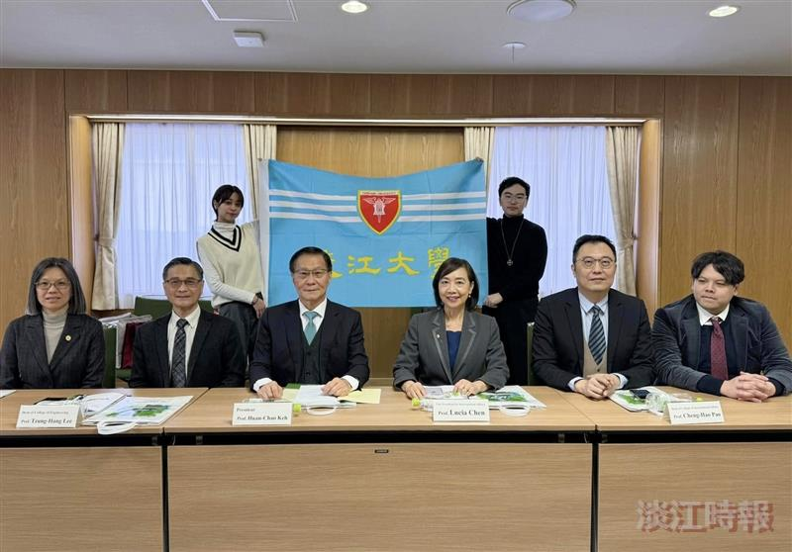
President Keh (front row, 3rd from left) meets with Tamkang students on exchange at Hokkaido University.

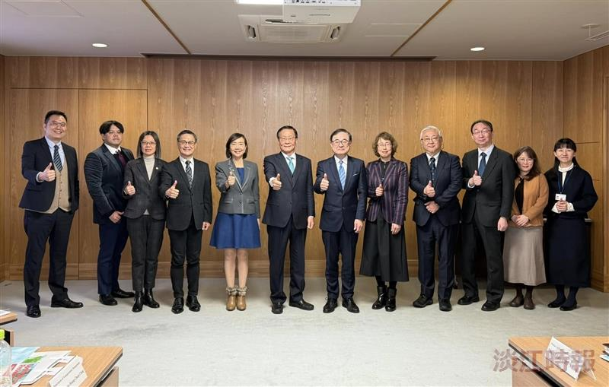
President Keh (6th from left) and the delegation visited Hokkaido University, where they were received by President Kiyohiro Houkin (6th from right) and participated in a discussion session.

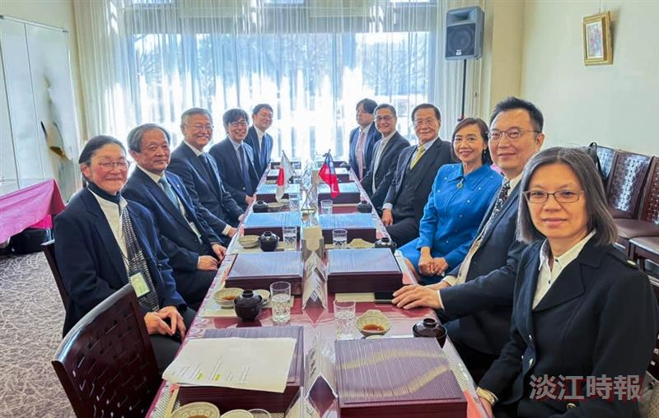
President Keh (4th from right) and the delegation visited Reitaku University, where they were hosted by President Suminori Tokunaga (3rd from left) for a luncheon to discuss further collaboration.

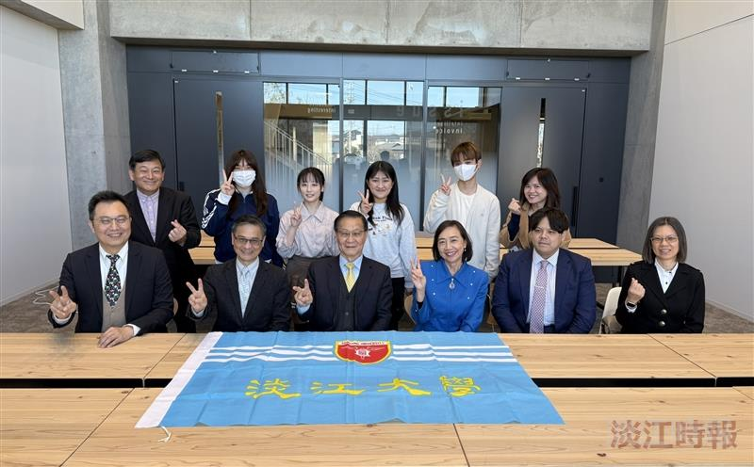
President Keh (front row, third from left) meets with exchange students at Reitaku University, inquiring about their study abroad experiences.

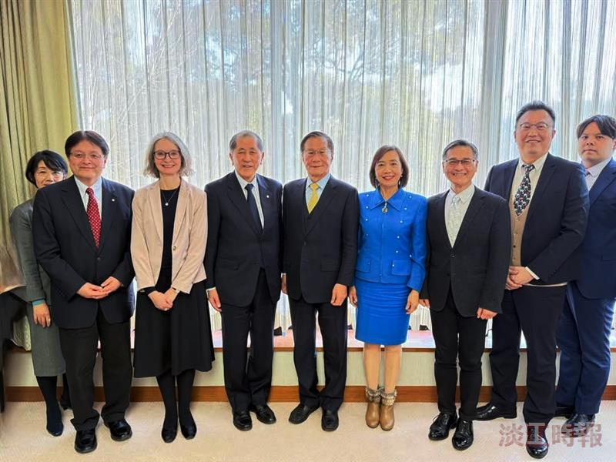
President Keh (5th from left) and the delegation visited Waseda University, where they discussed with President Aiji Tanaka (4th from left) and others to exchange ideas on internationalization.

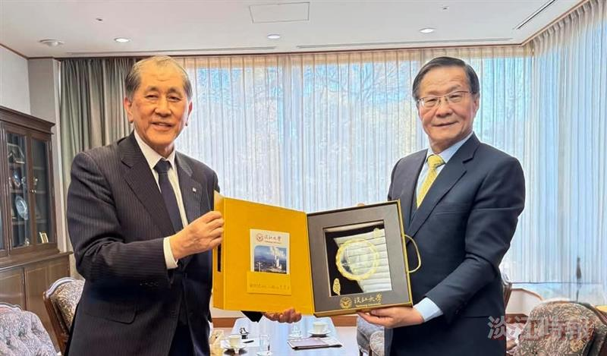
President Keh (right) presents a Tamkang University commemorative gift to Waseda University President Aiji Tanaka (left).

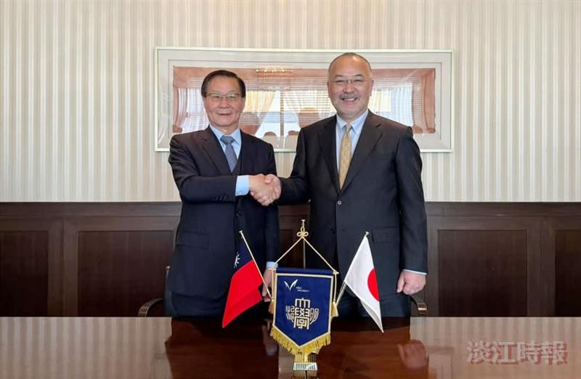
President Keh (left) meets with Meiji University President Masao Ueno (right) in a warm exchange.

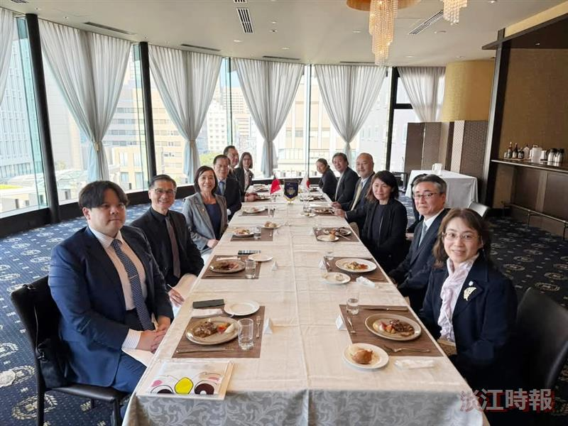
President Keh (4th from left) and the delegation visited Meiji University, where they were received by President Masao Ueno (4th from right) for a discussion and luncheon.

