Tamkang Times No.1204
AI Calligraphy Takes Off: e-Pen and Ben-Hang Chang's Japanese Debut in Tokyo

Tamkang University, in cooperation with the Taipei Representative Office in Japan, is jointly hosting the "Tradition and Technology of Calligraphy – e-Pen and Ben-Hang Chang's Calligraphy Exhibition," which has been on display at the Taiwan Culture Center in Tokyo from February 13. This exhibition promotes the merging of traditional calligraphy with AI technology, showcasing our university's unique "Smart e-Pen" and demonstrating achievements from our dual transformation efforts. President Huao-Chao Keh also visited the exhibition during this period to participate and show support.

The exhibition featured 48 calligraphy works, 12 of which are by Ben-Hang Chang, the Director of Carrie Chang Fine Arts Center, depicting profound literary themes with superb calligraphy techniques. The remaining 36 pieces, created using the e-Pen, are a collaboration between Chang and seven Taiwanese artists. At the exhibition's introduction area, attendees can scan a QR Code to watch dynamic demonstrations of the artwork and even download the pieces for later enjoyment. On the afternoon of February 28, a forum was held where Ben-Hang Chang discussed the possibilities of calligraphy creation, its transition from tradition to modernity, and the development process of AI and technology integration, with live e-Pen demonstrations.
2025/03/11

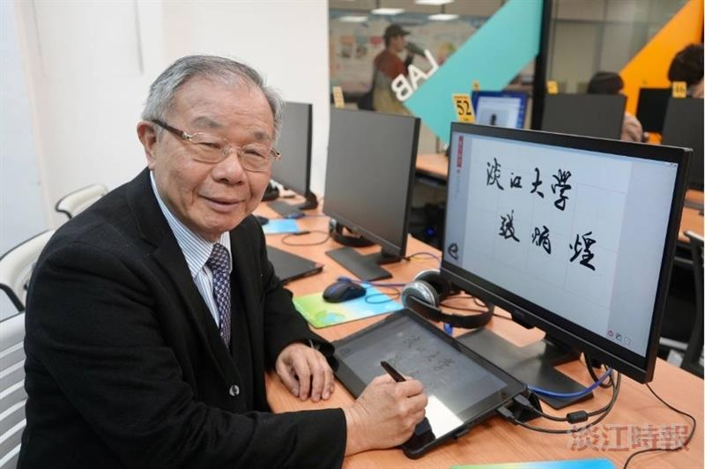
Carrie Chang Fine Arts Center Director Ben-Hang Chang and the team from the Department of Computer Science have successfully developed a smart e-Pen and held a calligraphy and painting exhibition at the Taiwan Culture Center in Tokyo, Japan, on February 13.

