Tamkang Times No.1204
Carbon Credit Research Project Signed – Chemical Materials Department Partners with Skwentex Energy to Advance Sustainability

The Department of Chemical and Materials Engineering, in collaboration with the "Energy and Photovoltaic Materials Research Center," is assisting the alumni company Skwentex Energy Co., Ltd. (Senergy) with the research project "Exploring the Application of Carbon Credit Trading Market and Geothermal Technology in Carbon Sequestration." The industry-academia cooperation contract was signed on January 17, witnessed by Senergy Chairman and Chemical and Materials Engineering Department alumnus Andy Chen, along with several members from both sides. Department Chair Cheng-Lan Lin and Senergy General Manager Jeffrey Chuang signed the contract on behalf of their respective parties. This one-year collaboration plan is funded by Senergy with NT$500,000, with an additional NT$500,000 donation for the department's development expenses. The project leader is Department Chair Lin, with co-leaders Professor Chao-Tsai Huang and Associate Professor Yi-Wen Wang from the Department. Tamkang University will assist Senergy by providing abundant information through industry data collection, conference participation, training programs, and certification courses to help the company understand domestic and international carbon trading markets, geothermal power generation, and trends in carbon sequestration markets.

This project extends from a research plan signed in 2023, titled "Exploring the Corporate Response to the Initiation of Taiwan's Carbon Credit Trading." Prof. Lin stated that with the European Union formally implementing a Carbon Border Adjustment Mechanism in 2026—mandating carbon content limits for exported goods, with penalties for exceeding these limits—both parties will further focus on the international carbon tariff and Taiwan’s carbon levy system, along with analyzing carbon trading systems and price trends. Tamkang will work as a think tank for Senergy’s development.

Moreover, Senergy has developed geothermal energy and plans to collaborate with foreign companies to make geothermal energy one of Taiwan’s top three renewable energy sources. The contract also mentions that the Chemical Materials Department will provide technical and market analysis-related literature and academic consultations, advancing sustainability through industry-academia collaboration.
2025/03/11

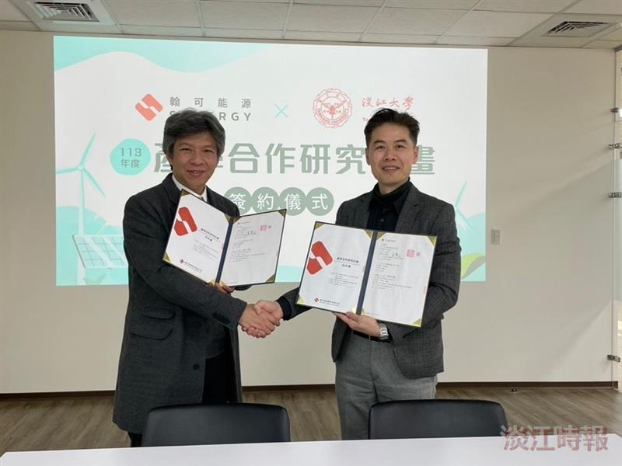
Department Chair Cheng-Lan Lin (left) from our Chemical and Materials Engineering Department and General Manager Jeffrey Chuang of Skwentex Energy sign on behalf of both parties.

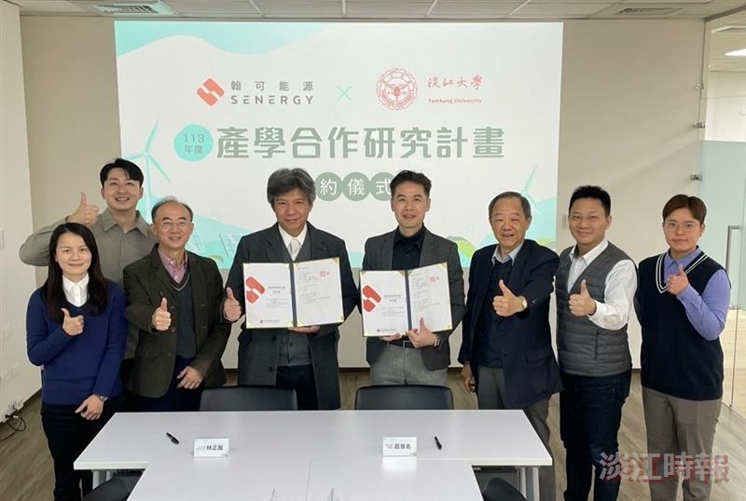
Skwentex Energy Chairman Andy Chen (third from right) and several members from both sides participated in the ceremony, completing the contract signing.

