Tamkang Times No.1204
Winter Break Service Team Flag Ceremony: President Keh Encourages Students to Benefit Others and Themselves

The Extracurricular Activities Guidance Section held the "2024 academic year winter break service team flag presentation ceremony" on the first day of the winter break, January 13, at 2:00 PM at the Student Activity Center. President Huan-Chao Keh, Administrative Vice President Chun-Hung Lin, Vice President for International Affairs Hsiao-Chuan Chen, and first- and second-level supervisors from relevant departments attended. This year, there are 13 service teams, including the bicycle club, the guzheng club, the Chinese Music Club joint service team, and the Tainan Second Senior Hight & Chia-Chi Senior High alumni association, with 238 enthusiastic students who will serve in various locations to spread love.

President Keh, in his speech, expressed that since he began serving as the leader of the Extracurricular Activities Guidance Section, he has participated in nearly 60 service team flag presentations. He greatly appreciates the students' spirit of service, saying, "Service not only benefits others but also brings positive effects to oneself, society, and even the world." Through the learning in the service process, students can experience the idea that "helping others is the root of happiness," which not only enhances personal learning but also leaves beautiful memories. He finally reminded everyone to prioritize health and safety while serving, wishing the process to go smoothly and successfully. Then he presented flags to each service team, with robot research club president Yun-Hui Chu, a third-year electrical and computer engineering student, leading the service members in an oath.

After the flag presentation ceremony, the Counseling, Career Development & Learning Center counselor, Hsuan-Ying Chen, conducted a "Gender Equality Awareness Workshop," themed "Gender is not about us being different." The workshop emphasized the importance of gender equality, respect for individual differences and needs, including bodily autonomy and personal privacy, and reducing the likelihood of sexual abuse and bullying incidents. Te-Yu Chang, a staff member of the Extracurricular Activities Guidance Section, gave a pre-departure briefing for the service members, reminding them that safety is the top priority and that they should pay attention to copyright issues concerning music and images used in the event. Finally, an encouragement video recorded by the team leaders was shown, gearing up the teams and wishing them success in their missions.

The Chiayi-Yunlin Alumni Association hosted a camp at the Gangqian Elementary School in Chiayi County from January 22 to 24, inspiring the children's learning interest through hands-on scientific experiments, plant experiments, and fine arts creation. Service team leader Yuan-Sheng Wang, a second-year international business student, expressed, "We hope the camp gives the children an enjoyable learning experience, and we expect the team members to give their sincere efforts and service, feeling the meaning and value of service and passing on this spirit to future generations."

The Wind Ensemble Club hosted a camp at the Lanyang campus from January 21 to 24, with the service slogan "Go forward bravely, break through the limits" (「勇往直前，突破極限」). The camp guided children in practicing musical instruments and enhancing their musical skills. Club leader Pei-Syuan Yu, a second-year student of information and library science, stated that the camp invited professional teachers to guide instrument practice, with team members assisting the students in mastering diverse music knowledge and techniques. "We hope to help enhance their musical talents and ensure that the participants feel warmth and joy during the practice and interactions," she concluded.
2025/03/11

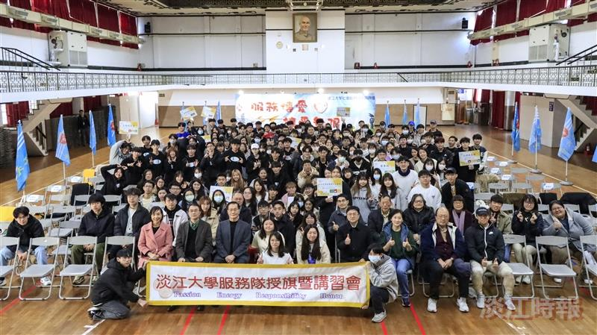
The Winter Break Service Team Flag Presentation Ceremony was held at 2:00 PM on January 13 at the Student Activity Center, with a group photo of the attendees.

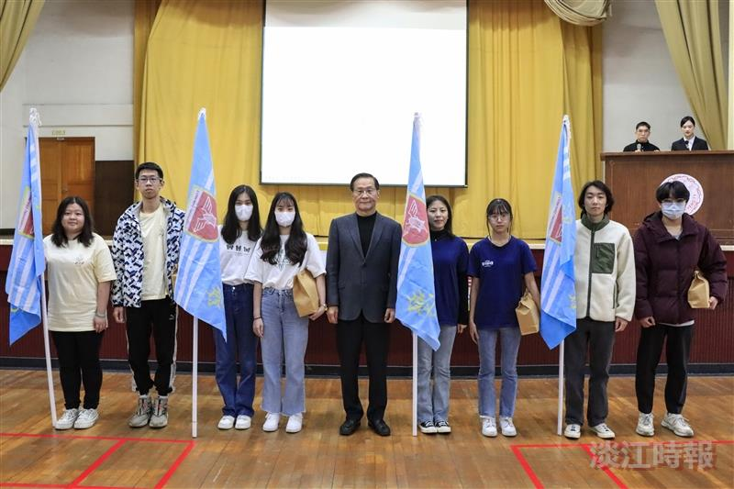
At the Winter Break Service Team Flag Presentation Ceremony, President Keh (center) presented the flag to the service team.

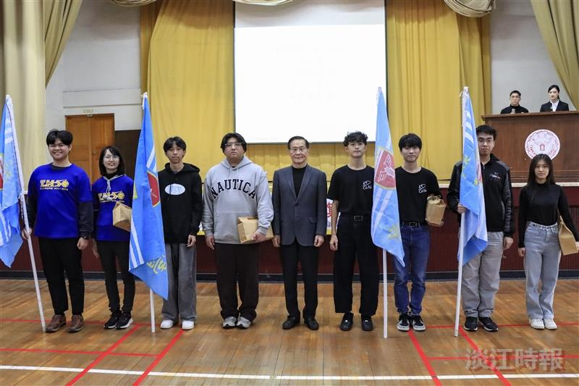
At the Winter Break Service Team Flag Presentation Ceremony, President Keh (center) presented the flag to the service team.

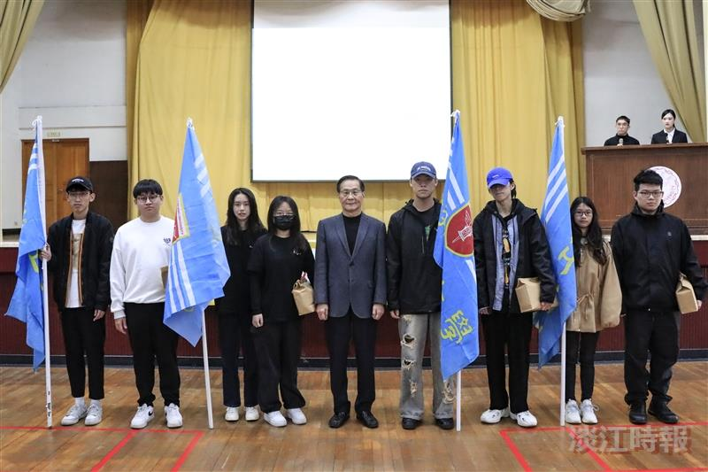
At the Winter Break Service Team Flag Presentation Ceremony, President Keh (center) presented the flag to the service team.

