Tamkang Times No.1204
International Students Lunar New Year Celebration: Food, Performances, and Lucky Draw Bring Faculty and Students Together

On January 7 at 6:30 PM, the Office of International and Cross-Strait Affairs held the 2025 International Students Spring Festival Celebration at the 1st-floor banquet hall of the Golden Tulip Fab Hotel Tamsui. The theme was "Auspicious Snake Brings Prosperity for the New Year." President Huan-Chao Keh, Vice President for International Affairs Hsiao-Chuan Chen, Secretary-General Yu-Pei Ma, first-level academic and administrative executives, as well as Commissioner Yi-Wei Lin of the Overseas Community Affairs Council, Section Chief Meng-Chie Tsai of the Mainland Affairs Council's Hong Kong, Macau, Inner Mongolia, and Tibet Affairs Department, and Director Szu-Hao Chen from the Straits Exchange Foundation’s Cultural and Education Department attended the event, where 260 faculty and students gathered together to celebrate the Lunar New Year.

President Keh first expressed New Year’s greetings, thanking all sectors for their long-term support and assistance for international students, enabling Tamkang to continue hosting such events. He then mentioned that in the 2024 academic year, Tamkang hosted 1,457 international degree students from 61 countries, including 783 international students, 638 overseas Chinese students, and 36 students from Mainland China, highlighting Tamkang’s excellent local implementation of internationalization. President Keh explained that this celebration represents Tamkang's care and service to international students, aiming to provide them with a nurturing environment akin to home, and he encouraged students to take good care of themselves during the winter break, ensuring a safe journey home and a happy return for the new semester.

Commissioner Yi-Wei Lin pointed out that the Overseas Community Affairs Council provides various scholarship supports, including the "Outstanding Overseas Chinese Student Scholarship" of up to NT$1.04 Million, health insurance, and numerous support programs. He also praised the collaboration between Tamkang University and the Overseas Community Affairs Council, encouraging overseas Chinese students to seek assistance whenever needed. Section Chief Meng-Chieh Tsai expressed his support for Tamkang’s diverse activities and friendly environment, which ensure students can pursue their studies and dreams with peace of mind. He confidently stated, “Tamkang is the best!” and encouraged students to cherish their learning opportunities and wished them a healthy, safe, and successful new year in their academic journey. He also hoped more students would choose Tamkang in the future.

The event began with an exciting lion dance performance, followed by a series of enthusiastic presentations by international students, including a dance by Indonesian students, a saxophone performance, and vocal performances by students and exchange students from Malaysia, the United States, Indonesia, Vietnam, and Japan. These performances added joy and vibrancy to the celebration, with the audience cheering on the music’s rhythm. Prize draws were interspersed throughout the event, with a rich variety of prizes, including water bottles, garment steamers, vacuum cleaners, electric toothbrushes, dehumidifiers, portable headphones, FamilyMart gift cards, and various monetary red envelopes — 129 prizes in total. The biggest prize, a NT$6,000 red envelope, was received by the lucky winner, In Kang Yang from the Economics department, who hails from Malaysia.

At the end of the evening, various unit representatives and faculty members personally distributed red envelopes to the students to wish them a happy New Year. The students from the Malaysian Students Association led everyone in singing the Lunar New Year greeting song, "Joyful New Year" (「開心過年」) taking the atmosphere to its peak, and allowing participants to embrace the new year joyfully. The event concluded on a warm and pleasant note. Kaori Tee Jun Ling, a student from the Department of Mass Communication who performed in the event, stated that this activity not only gave her the opportunity to perform but also allowed her to strengthen friendships and make new friends. She said, "The ceremonial atmosphere made me feel like I completed the year in a fulfilling way." Regarding her performance, she felt the sincerity of every performer and mentioned that she had been preparing for the song’s performance months in advance, hoping to create unforgettable memories for everyone.
2025/03/11

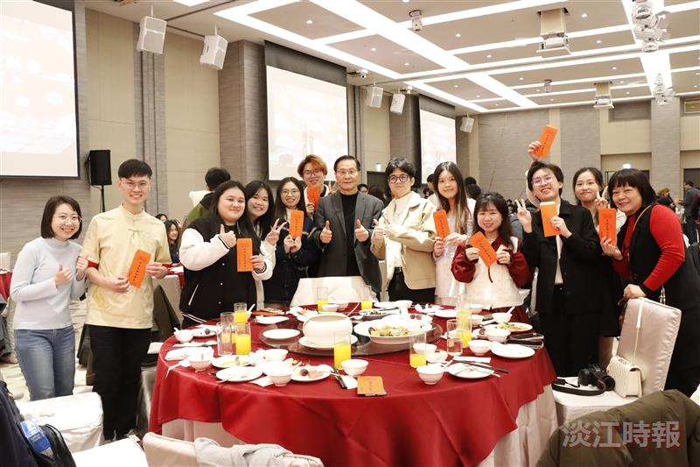
President Huan-Chao Keh (center) hands out red envelopes to students and takes a cheerful photo with them.

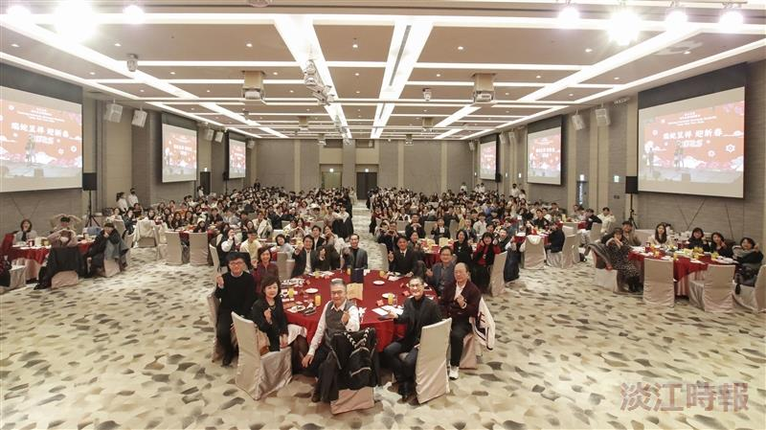
The International Affairs Office held the "2025 International Students' Spring Festival Celebration" on January 7, with faculty and students happily posing for a group photo.

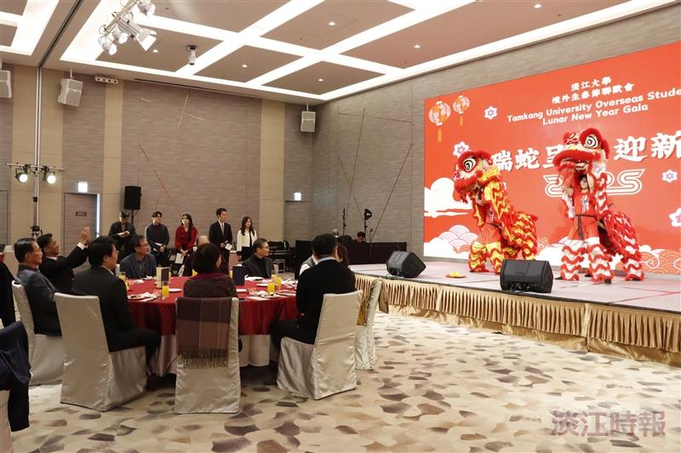
The lion dance troupe's performance energetically kicked off the event.

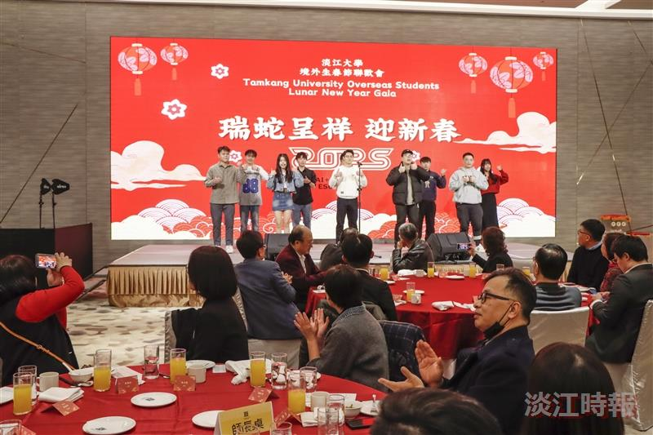
The Malaysian Students Association performed the Lunar New Year greeting song "Happy New Year," energizing the atmosphere throughout the event.

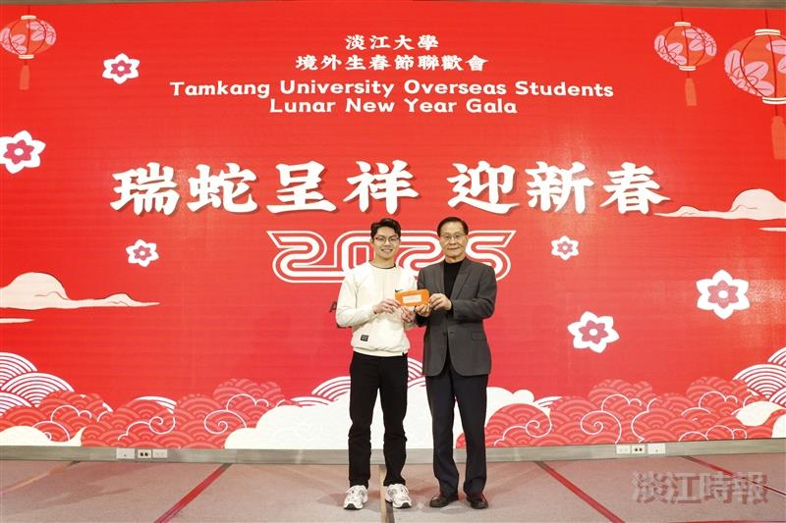
President Keh (right) presents the grand raffle prize of a 6,000 NTD red envelope to economics freshman In Kang Yang.

