Tamkang Times No.1204
Golden Eagle Club New Year Gala: Lawrence Lin Calls on Alumni to Support Tamkang’s Future Long-Term Development

Tamkang University Golden Eagle Club, composed of Tamkang Elite Golden Eagle Award alumni, held the 2025 Membership Meeting and Lunar New Year Gala on February 9 at the Dian Shui Lou Huaining store in Taipei City. Nearly 70 Golden Eagle alumni gathered together. Golden Eagle Club President Lawrence Lin stated that this year marks the 75th anniversary of the school’s founding, and various alumni associations will soon launch a series of events. This Spring banquet is one segment of the alumni activities, and he urged everyone to contribute their efforts to the development of their alma mater, thereby enhancing both the quality and quantity of Tamkang admissions.

Tamkang University selects Golden Eagle alumni yearly and publicly awards and recognizes them at the anniversary celebration. To date, there have been 38 sessions, with 269 outstanding alumni selected, and the Golden Eagle Club also holds a Lunar New Year Gala each year as per tradition. In this year’s event, 93-year-old alumnus and Honorary President of the Tamkang University Worldwide Alumni Association and Golden Eagle Club, Teng-Chien Hou, a graduate of the English Department, and 80-year-old alumnus and President of the Mainland Alumni Association, Wen-Fu Chuang, a graduate of the former Surveying Department of the Civil Engineering Department, both attended in person to participate in the grand event. Chairperson Flora Chia-I Chang, President Huan-Chao Keh, former President Ron-Yaw Chao, three vice presidents, and several first-level executives attended, warmly shaking hands and exchanging greetings with the alumni. For this gathering, Lawrence Lin specially selected a restaurant under the Namchow Group operated by Alfred F.L. Chen, the Honorary President of the World Alumni Association. Although Chen was unable to attend, he still asked Lin to convey his congratulations and sent a gift; additionally, Wen-Fu Chuang presented a cute teddy bear, and Rong-Kui Chang gifted his latest book, "New Business Thinking in the AI2.0 Era" (《AI2.0時代的新商業思維》).

Chairperson Chang, in her speech, stated that Tamkang now has 320,000 alumni, and those selected as Golden Eagle alumni have all achieved a certain level of accomplishment, with the interaction between the Elite Association and the school being very lively; Honorary Doctor Douglas Hsu praised the strong cohesion among Tamkang alumni, noting that our school implements AI+SDGs=∞, and that this year, the Year of the Snake, coincides with the ∞ symbol. He believed there would be new and better developments and wished everyone a safe and peaceful “Snake” year. President Keh mentioned that over the past month, there has been abundant good news about Tamkang, especially as the investigative report by CommonWealth Magazine pointed out that Tamkang has the most significant "alumni power." Not only do Tamkang alumni perform excellently, but they also possess an exceptionally strong sense of cohesion. He expressed gratitude to the outstanding Golden Eagle alumni across various industries. World Alumni Association President Chin-Tsai Chen stated, "Alumni supporting their alma mater is both a responsibility and an obligation."

The event featured three speakers. Golden Eagle alumnus architect Quey John Lin, began his talk with the University Commons Square, mentioning that he was invited by the founder, Dr. Clement C.P. Chang, to return to the school to teach and that he designed the University Commons Square—located at the school’s central landmark (nicknamed "Egg Roll Square" by students)—which is of symbolic significance. He believes that campus landscape design should be comprehensively considered. His latest book, "The City’s Attractiveness," also features explicitly the Tamsui campus. The winner of the National Award for Arts and Landscape Architect, Chung-Dwan Kuo explained the plans related to the optimization of the internal landscape of the Tamsui campus; Executive Director of the Office of Continuing Education, Professor Yi-Nan Lin, introduced the collaboration with the Golden Eagle Club to launch the entrepreneurial leadership elite class "Guan Shi Hui Tianxia" (「觀勢匯天下」, Observing Trends, Uniting the World), inviting everyone to recommend business owners and mid-to-senior-level executives for enrollment actively.

Lawrence Lin encouraged the alumni to support their alma mater's development actively. He mentioned that last month, he visited another Honorary President of the Worldwide Alumni Association, Senior Alumnus Ding-Chuan Chen, and the two reached a consensus that the Golden Eagle Club, composed of the most outstanding alumni, should embody the spirit of "giving back to the alma mater" by uniting to provide strong support. He then mentioned that last year, the school’s enrollment was quite good and received much recognition through awards; in the future, the Golden Eagle Club will organize more corporate exchanges to enhance Tamkang's global reputation.
2025/03/11

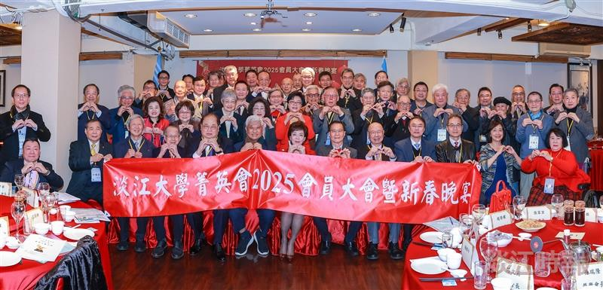
The Golden Eagle Club, composed of Golden Eagle Award-winning alumni, hosted the 2025 Annual Meeting and Lunar New Year Gala Group Photo.

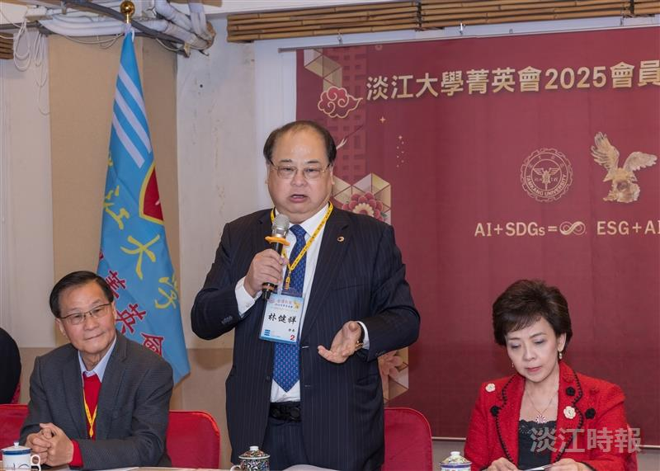
Golden Eagle Club President Lawrence Lin reported on the club's operations.

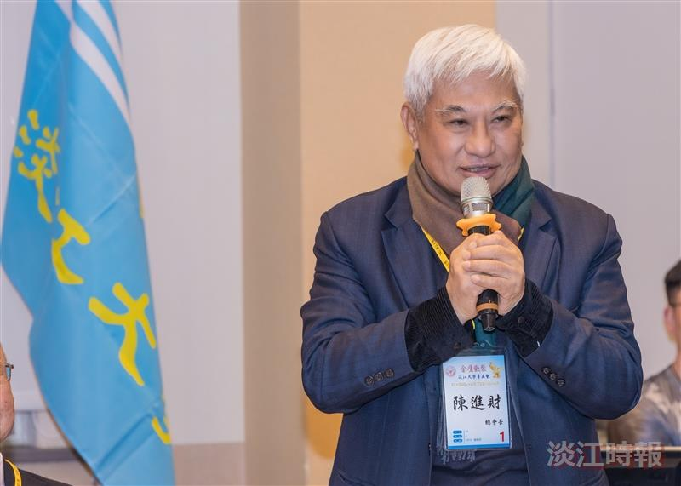
Elite Alumni, Tamkang University Worldwide Alumni Association President Chin-Tsai Chen delivered a speech, emphasizing: "Alumni support for alma mater is both a responsibility and an obligation.

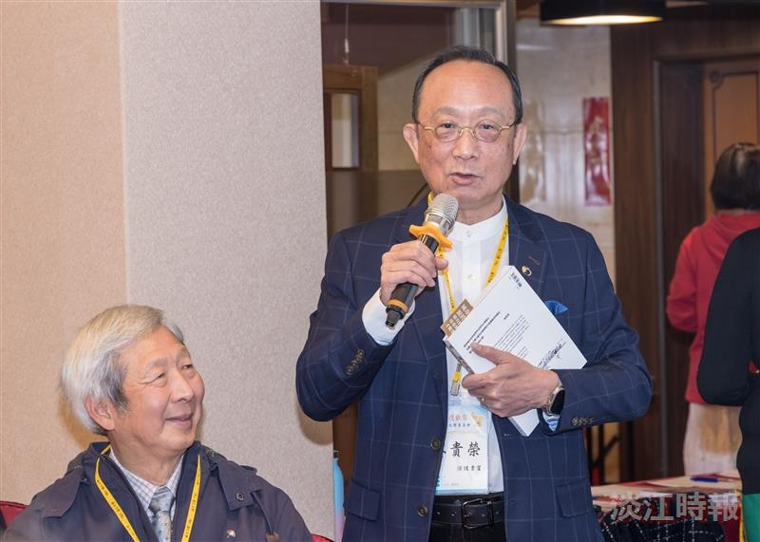
Elite alumni, Department of Architecture's Quey John Lin explains the origin of the University Commons Square design.

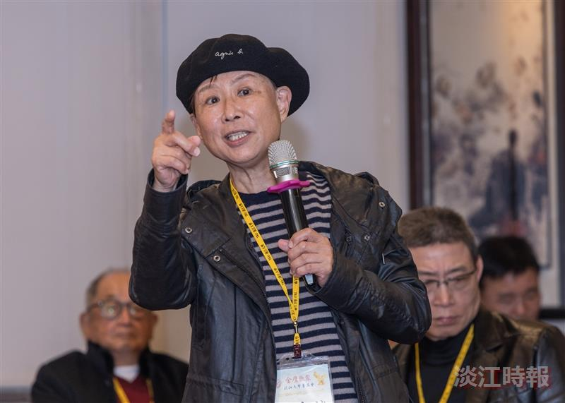
Elite alumnus, Department of Architecture's Chung-Dwan Kuo, explains his involvement in the landscape planning of the Tamsui campus.

