Tamkang Times No.1204
USR Tour & Banquet Program Aims to Leverage Tamsui's Cultural and Historical Resources to Boost Tourism Industry

In the Ministry of Education’s Center for University Social Responsibility’s fourth phase (2025–2027) USR case projects, Tamkang University’s approved “Walking into Tamsui, Facing the World: Promoting Taiwan’s Most Influential Classic Tours and Signature Banquets” project plans to develop the most valuable land–sea guided tour routes by reshaping profound travel experiences through local history and culture, training students to translate guided tours into several international languages, and establishing a commercial transition base, all to achieve self-sustainability while extending its influence to foreign travelers and marketing Taiwan on a global scale.

The project’s earlier phase, “Tamsui Northern Flavor e-Line Connection, Full Experience of Land and Sea Tourism,” was executed in Tamsui and the Tamsui River basin, combining diverse and distinctive land and water activities, rap, picture books, translation, and on-site guided tour services to enrich the diversity of Tamsui tourism and enhance visitors’ understanding of Tamsui and Mackay historical culture; “Tamsui–Lan Land and Sea Light Tourism, Smart Interactive Wandering” is a collaboration with restaurants to develop the “Sino-French War Huwei Banquet,” and subsequently design the “The Immortal’s Hometown Taoyuan Banquet,” “The Baozhong Yimin Banquet,” and “The Mackay Banquet,” all of which have successfully transitioned to commercial operation. Among these, the Huwei Banquet, from its inaugural banquet on October 8, 2020, has reached two thousand tables and has developed take-out New Year’s dishes as well as peripheral activities combining walking tours, land guided tours, and waterway rowing tours, serving many industry-academia–research partners and creating derivative value of over tens of millions. It has also received recognition with the 2024 “5th Global Views Monthly University Social Responsibility Award Outstanding Program: Industry Co-Creation Model Award,” a one-star award at the 2024 Food Creation Awards, the SDG4 Quality Education Bronze Award at the 2023 and 2022 TSAA Taiwan Sustainability Action Awards, and was selected as a test item for the 2021 Annual Teacher Qualification Examination for Senior Secondary Schools and Below and Kindergartens, while the student team received a NT$500,000 startup fund subsidy from the Ministry of Education’s “U-start Innovation and Entrepreneurship Project” in 2024, clearly demonstrating that historical culture has the advantage of driving the tourism industry.

The project leader, Professor Chi-Lin Lee of the Department of History, expressed gratitude for the efforts of previous team members and explained that since the project’s pilot seed phase initiated by the Ministry of Education in 2017, it has continuously received recognition, having now entered its eighth year of implementation and the fourth phase. Although it is the project's final phase, it marks a new starting point for establishing sustainable development! Therefore, the ultimate goal of the project is “the self-sustainability and comprehensive commercial transition of Taiwan’s signature banquets and tourism,” with team members widely incorporating various expertise from the industrial value chain—including aesthetic design (Hui-Ju Lai), foreign languages (Yi-Ti Lin, Ai-Ling Liou, Yu-Chin Lai, Kazunori Kikushima, Yen-Chen Chuang), business models and marketing promotion (Yi-Wen Chen, Chi-Lin Lee), and AI applications (Chih-Yung Chang, Shih-Jung Wu)—to create and promote classic tours with rich experiences.

Currently, the project is actively proceeding with trademark applications and the operation of its business model. It is hoped that a commercial transition base will be established to allow teachers and students to settle in the long term to provide services, including guided tour registration, market testing and promotion of signature products, and the design of more personalized or small-scale signature banquets so that Tamsui and other event venues truly become hubs and strongholds for promoting Taiwan’s significant cultural and historical content.
2025/03/12

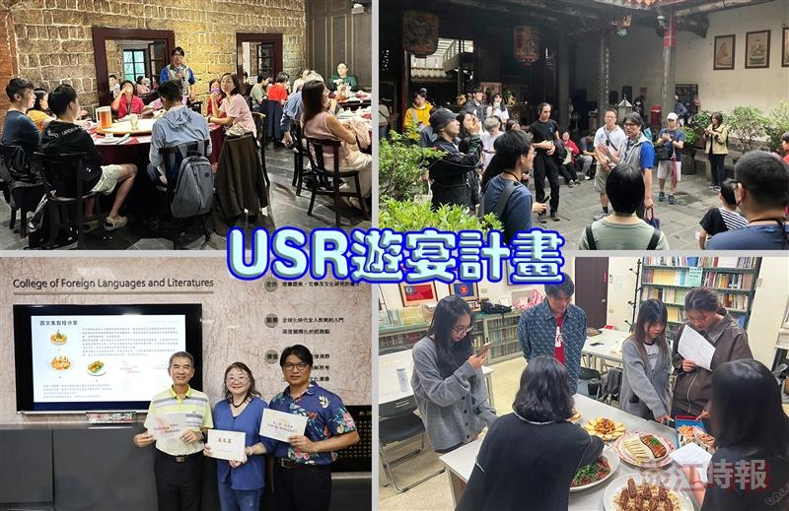
Tamkang University's USR "Walking into Tamsui, Facing the World: Promoting Taiwan's Most Influential Classic Tours and Unique Banquets" project has been approved for Phase IV of the MOE USR initiative, aiming to create and promote classic tours with rich experiences.

