Tamkang Times No.1204
CommonWealth Magazine Ranks Tamkang University as the Most Preferred by Employers for the 28th Time, Leading Private Universities in 3 Major Rankings

The CommonWealth magazine's "Most Preferred Universities by Employers" ranking 2025 was released on February 5. Tamkang University secured a spot in the top 10 overall rankings and maintained its position as the top private university for the 28th consecutive time. Leveraging its vast alumni network, our university also claimed the top position in the "Number of Graduates Hired by Companies" category. Additionally, in the "Top 5 Industries’ Most Preferred Students" ranking, our university ranked third in the financial industry category and was the only private university to make the list.

The survey report highlighted the 5 most important qualities employers consider when selecting talent: personality traits, learning potential, academic background, professional skills, and educational qualifications. Among these, the significance of "learning potential" has risen significantly, while "professional skills" have declined in priority. Employers also emphasized the key abilities university students should focus on developing, ranked in order as resilience and adaptability, communication and expression, problem-solving, teamwork, and self-learning. This reflects that in an uncertain and rapidly changing environment, employers are more likely to favor fresh graduates who can flexibly adapt.

This survey targeted HR managers from CommonWealth Magazine's Top 2000 Enterprises over the years. The survey was conducted from November 11, 2024, to December 4, 2024, evaluating universities based on 9 indicators: professional knowledge and skills, international perspective and foreign language ability, strong willingness to learn and high adaptability, stress tolerance and stability, innovation ability, interpersonal communication and teamwork, problem-solving and adaptability, interdisciplinary integration ability, and AI and digital tool application skills. Respondents ranked their top 3 universities for each indicator, with first place receiving 3 points, second place 2 points, and third place 1 point. Each university’s scores for each indicator were standardized, summed, and ranked accordingly.

Tamkang University performed outstandingly in the 3 major 2025 "Most Preferred by Employers" rankings. Besides ranking ninth nationwide and first among private universities in the 1111 Job Bank survey, it also ranked first among private universities in Global Views Monthly's survey across 3 categories: "Most Preferred University Graduates by Listed Companies," "Large Capital Enterprises (Over NT$3 Billion)," and "Large-Scale Enterprises (Over 500 Employees)." In a recent media interview, President Keh stated that Tamkang University’s "Three Circles and Five Disciplines" educational philosophy not only equips students with professional knowledge but also enhances their soft skills. Furthermore, under the university’s strategic direction of "AI+SDGs=∞," students can stay up-to-date, engage in interdisciplinary learning, and remain highly adaptable, making Tamkang the top choice among private universities favored by employers.
2025/03/11

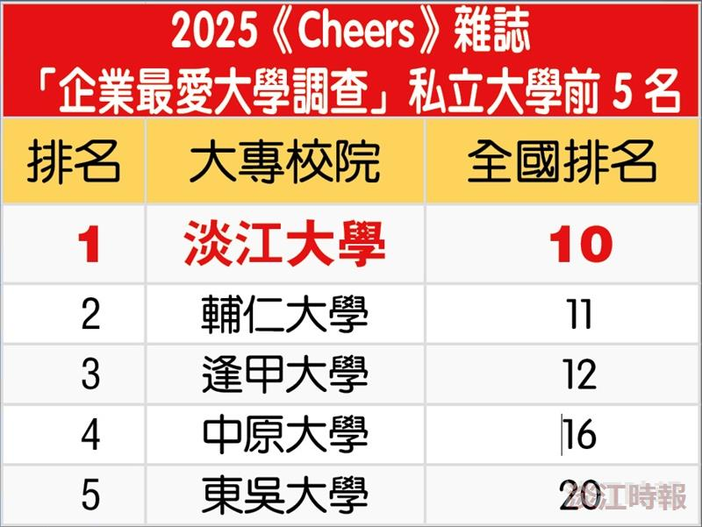
. In the 2025 "Most Preferred Universities by Employers" ranking by CommonWealth magazine, Tamkang University has retained the top spot among private universities for the 28th consecutive time.

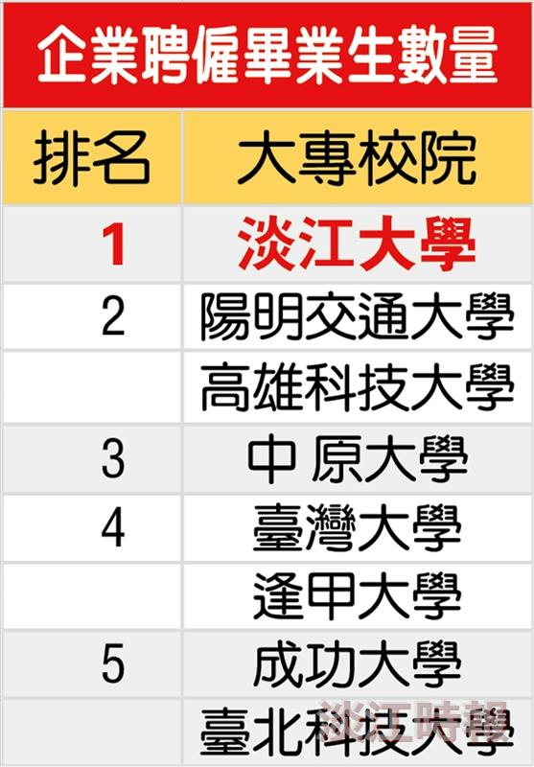
Tamkang University, leveraging its vast alumni network, secured the top spot in the "Number of Graduates Hired by Companies" category.

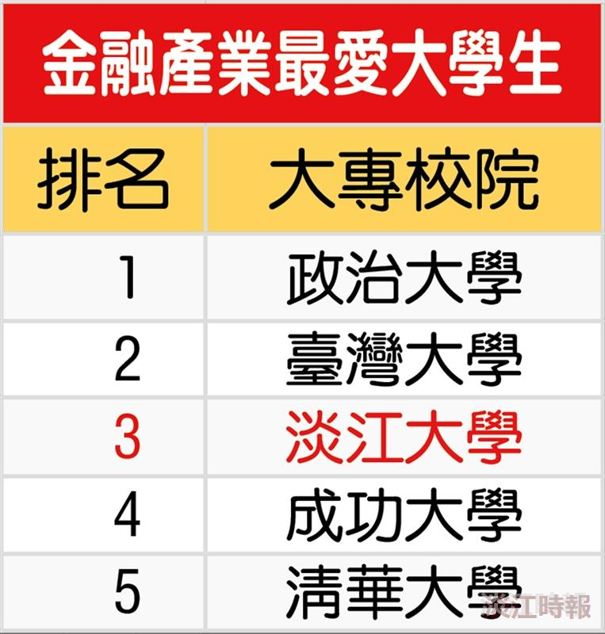
Tamkang University is the only private university ranked in the "Most Preferred Universities by the Financial Industry" category.

