Tamkang Times No.1202
Digital Transformation and Net-Zero Transition Soar Together: Hackathon Showcases Innovative Power

On December 25, 2024, the Office of Information Services held the "2024 Digital Transformation and Net-Zero Transformation Hackathon Award Ceremony" in Room I501 of the Chueh Sheng Memorial Building. The project "OCR Scholarship Application," created by Computer Science and Information Engineering seniors Yu-Cheng Chang and Yen-Chen Lin and Electrical and Computer Engineering freshman Cheng-Cheng Chuang, won the Extraordinary Excellence Award. The project "Equipment Borrowing and Return System" by Graduate Institute of Educational Technology students Ming-Ming Fan, Hsin-Yu Tseng, and Kai-Lun Lin received the Excellence Award. 2 Honorable Mention Awards were given to "Three-Level Review System for Image Recognition" and "Rental Safety System." Additionally, 3 projects from the Graduate Institute of Educational Technology were awarded the "Creative Idea Award."

The Creative Idea Award winners included the 24-hour Personal Essay Tutor project by the "Your 24-hour Personal Essay Tutor" team (「你的24hr專屬作文家教小組」), an optimized learning chatbot using RAG technology by the "Classroom Hackers" team (「課堂駭客小組」), and a "Net-Zero Transition Assistant" project by the "So Green" team.

Executive Vice President Chun-Hung Lin emphasized that Tamka University's 2 main development focuses are digital transformation and net-zero transformation. In particular, the university has been actively promoting digital transformation through its partnership with Microsoft Taiwan, providing training for all faculty and staff. The goal is to enable the use of advanced digital tools in their work to become "non-programming experts," improving teaching and administrative efficiency. Lin also thanked the Office of Information Services for cultivating and training "Microsoft Campus Cloud Ambassadors," whose achievements were showcased in the competition. He encouraged students to seize these opportunities to enhance their digital transformation skills.

The competition evaluation criteria included innovation, practicality, alignment with SDGs, project completeness, and AI technology application. Awards were given as follows: 1 Extraordinary Excellence Award (NTD 20,000), 1 Excellence Award (NTD 16,000), 2 Honorable Mention Awards (NTD 10,000 each), and multiple Creative Idea Awards (NTD 4,000 per team).

The Extraordinary Excellence Award went to the "CSAOCR" team's OCR Scholarship Application System, addressing inefficiencies and errors in the scholarship application process. The system featured a front-end interface, data processing, and back-end management, utilizing OCR technology to automate workflows and eliminate manual form-filling. It also aligned with SDGs for quality education, good health and well-being, and industry, innovation, and infrastructure.

The Excellence Award was won by the "Ale Ale" team (「阿勒阿勒小組」) for their Equipment Borrowing and Return System, which improved management efficiency and streamlined processes. Users could fill out borrowing and return forms via Power App, with the system automatically filtering and checking equipment status. Notifications for approval and data updates were automated through tools like Power Automate, Teams, SharePoint, and Outlook. The system also reminded users of upcoming return deadlines and allowed administrators to monitor equipment return dates for timely approvals, enhancing efficiency, management, and user experience.

The Honorable Mention Award-winning "CSACV" team developed a Three-Level Review System for Image Recognition, addressing issues of resource waste, lack of transparency, and environmental and cost concerns. The system used AI Builder to analyze reimbursement forms, automating workflows while aligning with SDGs related to quality education, affordable clean energy, and industrial innovation and infrastructure.

The other Honorable Mention Award was given to a Rental Safety System aimed at enhancing the safety and management of off-campus housing for college students. The system featured a smart map and automated alert messages, solving challenges such as unclear housing locations, inefficient school management, and insufficient safety information. Functions included map visualization, administrative support, and AI-driven alerts, enabling students to rate the safety of their housing and allowing schools to monitor student attendance, improving safety, management efficiency, and communication among schools, students, and parents.

Yu-Cheng Chang, who won both the Extraordinary Excellence and Honorable Mention Awards, emphasized the importance of a spirit of inquiry and continuous learning. Using AI technology and skills gained from Microsoft learning, he noted that advanced observation and problem-solving abilities are essential for deeper research and can be cultivated. Having participated in multiple competitions, he shared that despite initial setbacks, years of training ultimately led to recognition, reinforcing his belief that talent will always be noticed.
2025/01/20

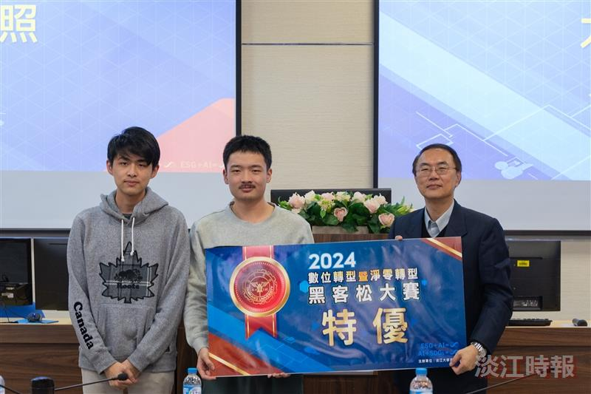
Executive Vice President Chun-Hung Lin (first from the right) presented the Extraordinary Excellence Award to Computer Science and Information Engineering seniors Yu-Cheng Chang and Yen-Chen Lin, along with Electrical and Computer Engineering freshman Cheng-Cheng Chuang, for their project “OCR Scholarship Application.”

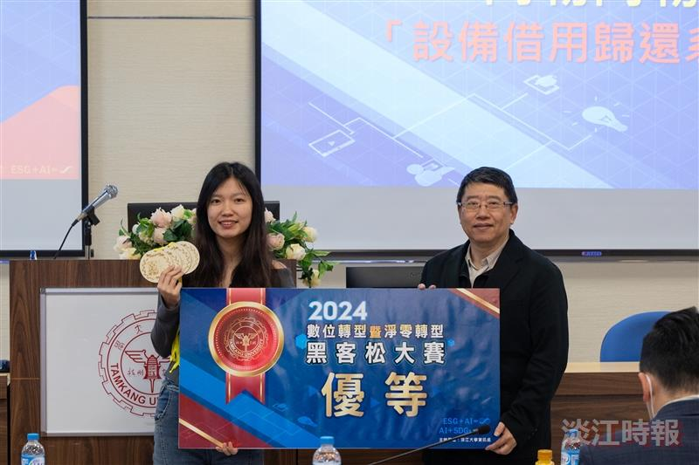
Chief Information Officer Kuei-Ping Shih (first from the right) presented the Excellence Award to Graduate Institute of Educational Technology students Ming-Ming Fan, Hsin-Yu Tseng, and Kai-Lun Lin for their project “Equipment Borrowing and Return System.”

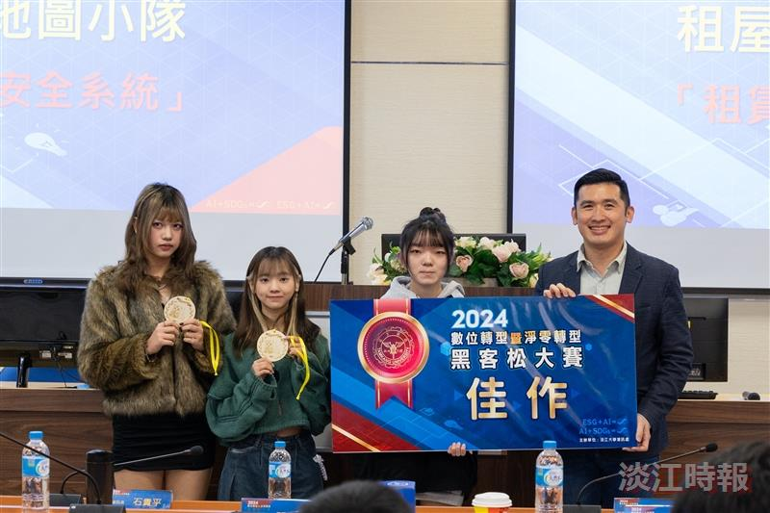
Senior Business Manager of Microsoft Taiwan Public Sector, Dennis Tu (first from the right), presented the Honorable Mention Award for the development of a Rental Safety System.

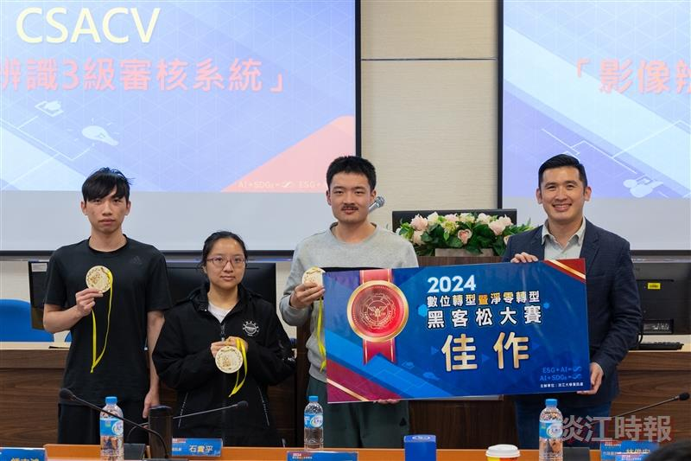
Yu-Cheng Chang (second from the right) received another Honorable Mention Award for developing a Three-Level Review System for Image Recognition.

