Tamkang Times No.1202
Tamkang TV Students Win 3 PeoPo Citizen Journalism Awards: Best Performance in History

The 2024 PeoPo Citizen Journalism Awards Ceremony, organized by the Public Television Service and the Foundation for Excellent Journalism Award, was held on December 21 at the International Conference Hall of National Chengchi University's College of Social Sciences. 7 senior students from Tamkang University’s Mass Communication Department, representing the Tamkang TV internship media, won 3 Excellence Awards in the Student Short Report category. The winning entries were "The Book Restorer: Picking Up the Past" (《拾起流年的書籍修復師》) by Yu-Wei Lin, Ming-Chih Chien, and Sung-Ya Yen; "Weaving the Name of Kavalan" (《編織出噶瑪蘭的名字》) by Yi-Ju Su and Yi-Jen Chiu; and "Endless Purity" (《永無止淨》) by Meng-Chu Hsu and Pin-Yu Chen. Professor Hui-Wen Liu presented the awards from NCCU’s Department of Journalism.

This year, the PeoPo Citizen Journalism Awards received a total of 217 entries, divided into Social and Student categories, and further categorized into Short Reports and News Features. Judging criteria included public interest, news value, technical quality, and other factors. Tamkang TV had 4 entries shortlisted in the Student Short Report category and won 3 awards, making it the school with the most nominations and awards, setting a record-breaking achievement for the department.

Tamkang TV advisor Yu-Feng Wan remarked: "This year, Tamkang TV students have set a new record for Tamkang University with the highest number of nominations and awards at the Citizen Journalism Awards. When teachers from other schools congratulated me, saying, ‘Tamkang is truly outstanding!’ I knew we had put Tamkang in the spotlight. However, records are meant to be broken, and the road ahead is long. Let’s get ready to move forward!"

"The Book Restorer: Picking Up the Past", previously won second place at the PeoPo Campus News Center Editors’ Conference in May, earned another accolade. Yu-Wei Lin, Ming-Chih Chien, and Sung-Ya Yen delicately depicted the craft of cultural book restoration, preserving historical memory. Reflecting on their production process, they shared: “Book restoration is such a niche profession, yet it embodies the spirit of craftsmanship. Their precision, dedication, pursuit of perfection, and passion breathe new life into historical treasures. We sincerely thank these unsung heroes!”

"Weaving the Name of Kavalan" by Yi-Ju Su and Yi-Jen Chiu explored the revival of the Indigenous Kavalan culture of banana fiber weaving. The craft gained international recognition when it was used for the shoe uppers of Taiwan’s Olympic team, symbolizing Taiwan on the global stage. Su and Chiu expressed:

"We never imagined we would win this award. We are deeply grateful to Professor Wan for refining our work and to the LaLa Ban Banana Fiber Workshop in Hualien’s Xinshe Village for allowing us to interview them. We are especially moved by 86-year-old Grandma Yu-Ying, whose dedication to preserving Kavalan culture is truly admirable.”

"Endless Purity" by Meng-Chu Hsu and Pin-Yu Chen focused on the marine waste crisis faced by Taiwan, an island surrounded by the sea. They highlighted the efforts of the RE-THINK organization in mobilizing beach cleanups and encouraged reflections on the connection between daily life and marine waste. The team commented: “It is an incredible honor to win at the Citizen Journalism Awards. We hope this report raises awareness about the marine waste problem and teaches people how to properly sort trash, starting with small actions in daily life to reduce the production of marine debris.”
2025/01/20

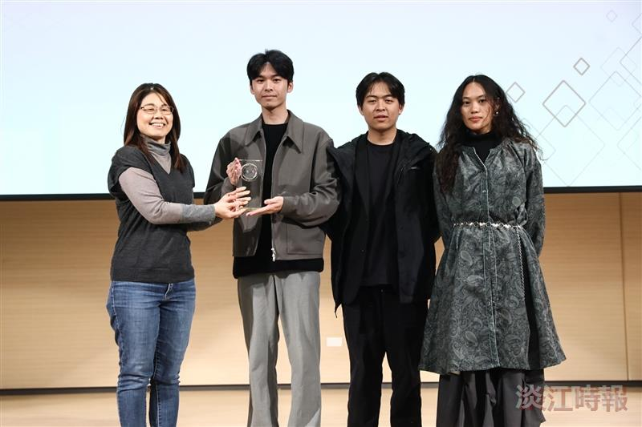
At the PeoPo Citizen Journalism Awards ceremony, the Tamkang TV production "The Book Restorer: Picking Up the Past" (《拾起流年的書籍修復師》), created by Mass Communication Department students Sung-Ya Yen (from right), Yu-Wei Lin, and Ming-Chih Chien, won the Excellence Award, presented by National Chengchi University Professor Hui-Wen Liu.

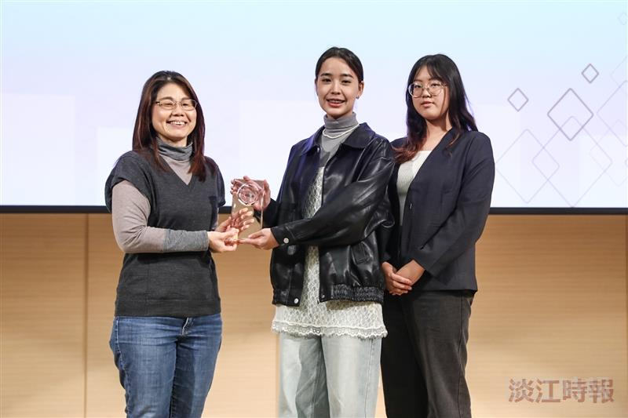
At the PeoPo Citizen Journalism Awards ceremony, the Tamkang TV production "Weaving the Name of Kavalan" (《編織出噶瑪蘭的名字》) created by Mass Communication Department students Yi-Jen Chiu (from right) and Yi-Ju Su, won the Excellence Award.

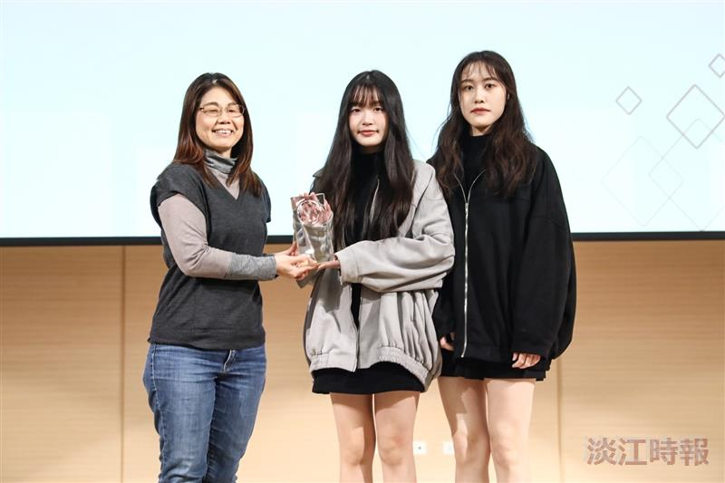
At the PeoPo Citizen Journalism Awards ceremony, the Tamkang TV production "Endless Purity" (《永無止淨》) created by Mass Communication Department students Meng-Chu Hsu (from right) and Pin-Yu Chen, won the Excellence Award.

