Tamkang Times No.1202
200th Administrative Meeting: Composing “Tamkang is the Best” with Smart e-Pen

The 200th Administrative Meeting was held on December 27 at 2 p.m. in the Yeo Lan Hall of the Hsu Shou-Chlien International Conference Center. Presided over by President Huan-Chao Keh, the meeting was attended by 3 vice presidents, first-level supervisors, academic department heads, and student representatives, with live streaming to the Taipei campus.

Before the meeting, a special ceremony was arranged. Secretary-General Yu-Pei Ma introduced the history of the administrative meetings, noting that the first one was held on December 12, 1980, after the university's official renaming. Over the past 40 years, Tamkang University has entered its 5th wave of development, emphasizing dual-track, digital, and net-zero transformations, achieving notable successes. Carrie Chang Fine Arts Center Director Ben-Hang Chang and Colleges of Engineering and Artificial Innovative Intelligence Dean Tzung-Hang Lee demonstrated the university's dual-track transformation using the distinctive "ePen Calligraphy" system. Chang showcased the system's "Shu Zuo Yu Cheng" (「書作玉成」) feature by inputting the poem “Tamkang is the Best” in semi-cursive script, displaying the verses and inscription. President Keh then wrote AI+SDGs=∞ and ESG+AI=∞ using the system, symbolizing the university's developmental goals and demonstrating its international writing capabilities.

In his remarks, President Keh reiterated the university’s vision of becoming "A University City with Glocalization, Intelligent Cloud, and A Sustainable Future." He highlighted Tamkang's impressive achievements over the past 2 years, particularly in 2023, and thanked faculty and staff for their dedication. He emphasized digital transformation as the foundation for all initiatives, announcing that starting in the 2025 academic year, the university will fully integrate AI into teaching. Relevant units will support faculty in effectively utilizing generative AI tools to enhance student learning outcomes.

Dean Cheng-Hao Pao of the College of International Affairs and Dean Kuo-Hua Chen of the College of Education presented reports on "Key Features and Innovative Transformations" in their respective units. Dean Cheng-Hao Pao: Focused on 4 areas—"Distinctive Features and Highlights," "Innovative Transformations in Key Disciplines," "Cultivating AI Application Skills," and "Preparing for Life and Work Competencies." He emphasized adapting to global changes by integrating innovative AI-based curricula to help students identify and actively pursue their development paths, aligning academic and practical expertise with international needs.

Dean Chen highlighted collaborations with the Dubai Future Forum, recognition as the third institution globally certified by the WFSF Program Accreditation Council for future education, and the Journal of Futures Studies, which researchers from 119 countries have cited. The College has also achieved 4 consecutive years of excellence in teaching practice research and plans to fully integrate AI into its curricula to cultivate interdisciplinary talent.

The meeting approved the following proposals: The 2025 Academic Year Ministry of Education Subsidy Program for Enhancing Student Affairs and Counseling, amendments to the Tamkang University Social Practice Service Excellence Incentive Guidelines, revisions to Article 6 of the Tamkang University Research and Development Office Establishment Guidelines, in the open discussion, Aerospace Engineering Department Chair Fu-Yuen Hsiao raised issues regarding noise from a suspected water pump near the Engineering Building, vehicle entry standards during peak hours, and campus speed limits. Physics Department Chair Cheng-Hao Chuang suggested adding rain shelters at campus bus stops. Relevant units were tasked with addressing these matters.

Before the meeting, President Keh presented several awards: National Science and Technology Council (NSTC) Research Creation Award to Assistant Professor Jun-Yi Wu (Physics) and student Shao-Hua Hu, Professor Fan-Hua Kung (Accounting) and student Chiao-Chi Tsai, and Assistant Professor Ting-Hui Hsiung (English) and student Xiang-En Wang received awards for outstanding and creative research. Students were awarded NT$20,000 and certificates, and faculty received medals; Social Practice Service Awards: Outstanding Teacher: Associate Professor Po-Ching Lee (Water Resources and Environmental Engineering) received NT$48,000 and a certificate. Excellent Teacher: Assistant Professor Yi-Nung Lin (Education and Technology) received NT$24,000 and a certificate. Teaching Practice Research Excellence Awards: Associate Professor Ying-Chang Yu (Architecture), Assistant Professor Ming-Hsiu Tsai (Civil Engineering), Professor Mei-Ling Wang (Business Administration), Associate Professor Kuei-Chieh Chang (Educational Psychology), and Assistant Professor Fu-Tzu Kuo (Physical Education Instruction and Activities) were recognized for their Ministry of Education-selected projects. Each received NT$60,000 and a certificate.
2025/01/20

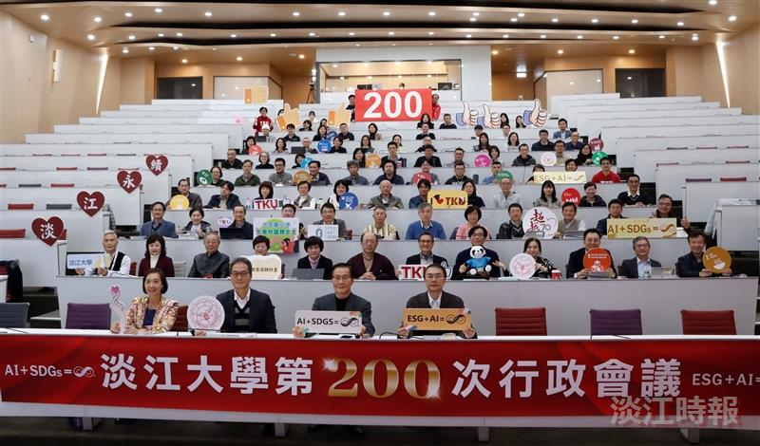
The 200th Administrative Meeting was held on a larger scale in the Yeo Lan Hall at the Hsu Shou-Chlien International Conference Center.

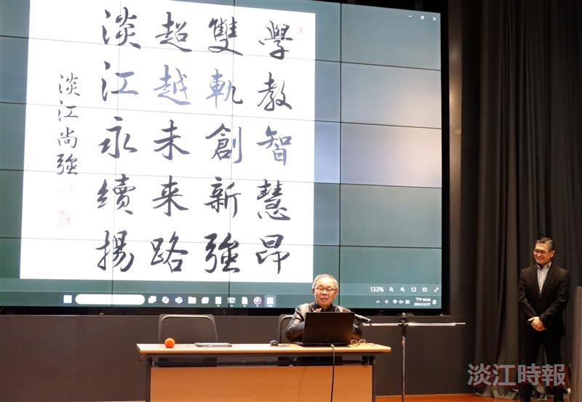
Ben-Hang Chang, Director of the Carrie Chang Fine Arts Center, demonstrated the poem "Tamkang is the Best" using the "Shu Zuo Yu Cheng" (「書作玉成」) system with the Smart ePen.

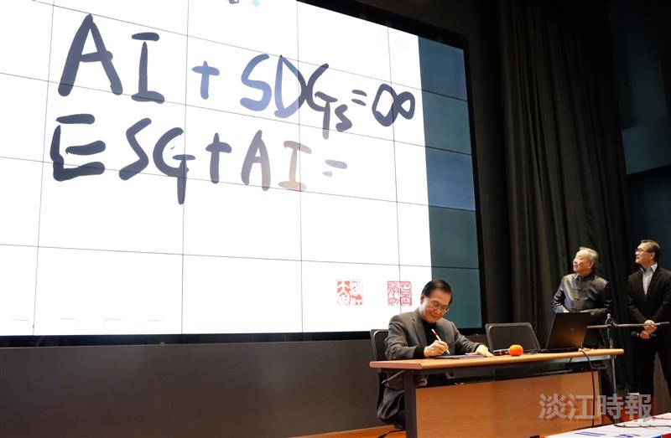
President Huan-Chao Keh used the ePen to write "AI+SDGs=∞" and "ESG+AI=∞."

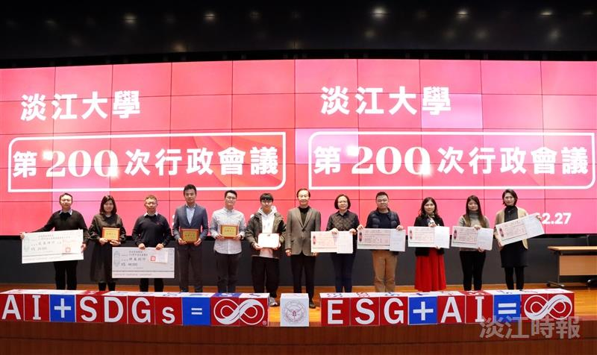
During the administrative meeting, an award ceremony was held, and President Keh (7th from left) posed for a group photo with the award recipients.

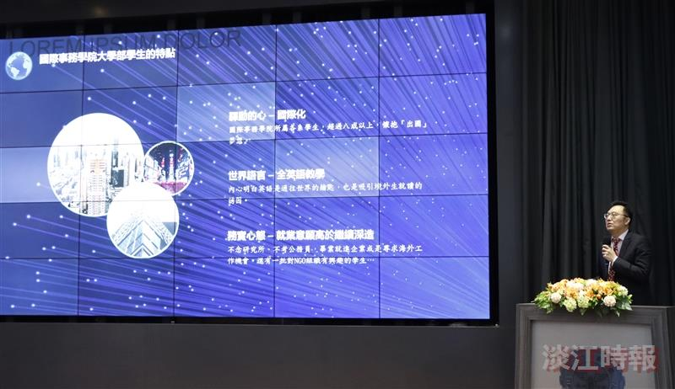
The Dean of the College of International Affairs, Professor Cheng-Hao Pao, delivered a special report.

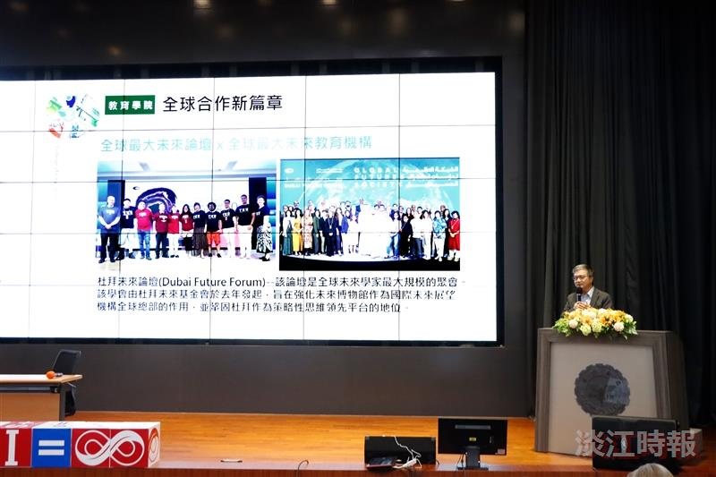
Dean of the College of Education, Professor Kuo-Hua Chen, delivered a special report.

