Tamkang Times No.1202
Women's Association Second-Hand Clothing Sale: Sustainable, Chic and Educational Supportive

The Women Faculty and Staff Association is dedicated to promoting an eco-friendly lifestyle centered on cherishing and reusing items. From December 16 to 20, the association hosted the "Second-Hand Clothing Sale – My Old Love, Your New Treasure" event at the Black Swan Exhibition Hall. Faculty members and alumni donated clothing and luxury items, raising a record-breaking NT$311,023 from the charity sale, with proceeds designated for student scholarships at Tamkang University.

The highlight of the event was a fashion show held on December 16 at 11 a.m. Chairperson Flora Chia-I Chang, Women Faculty and Staff Association Chairperson and Vice President for International Affairs Hsiao-Chuan Chen, along with faculty, local students, and 6 international students, participated as models. They confidently showcased second-hand clothing, accessories, and handbags, receiving enthusiastic applause and cheers from the audience, creating a lively atmosphere.

Hsiao-Chuan Chen noted that the second-hand sale is one of the Women’s Association’s most important annual events. This year’s theme, "Sustainable Fashion, Net Zero Carbon" (「時尚永續，淨零碳排」), aimed to promote extending the life of clothing to reduce carbon footprints and encouraged active participation in the auction. Chairperson Chang highly praised the event, commending its successful integration of multiple Sustainable Development Goals (SDGs) and its demonstration of the blend between fashion and sustainability. She expressed hope that the event would achieve new fundraising records to support more students. To motivate participants, the top 3 auction bidders were awarded sustainable bags co-designed by Chairperson Chang and her friends.

The luxury auction on December 19 at noon drew significant attention, with spirited bidding and cheers accompanying the sale of various premium items. The top 3 bidders were Hsiao-Chuan Chen, Cadence Wang from the International Affairs Office, and Professor Shi-Feng Chuang from the Department of Economics, all receiving special prizes prepared by Chairperson Chang. A standout item was an SUV offered by Registration Center Director XingChen C.C. Lin with a starting bid of NT$350,000. It was ultimately purchased by Chiung-Ju Chang from the Admission Strategies Center for NT$366,000, with 10% of the sale included in the event’s total proceeds. The event concluded with a joyful group photo of all participants. Everyone expressed their excitement to return next year, continuing the theme of love and sustainability while promoting an environmentally friendly lifestyle.
2025/01/20

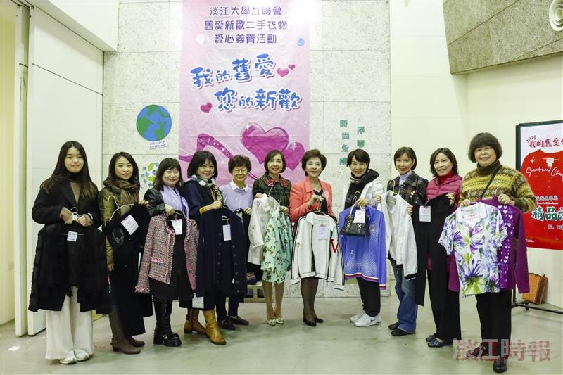
The Women's Faculty and Staff Association organized a second-hand clothing charity sale, with Chairperson Flora Chia-I Chang (5th from right) posing for a photo with colleagues who left with their purchases.

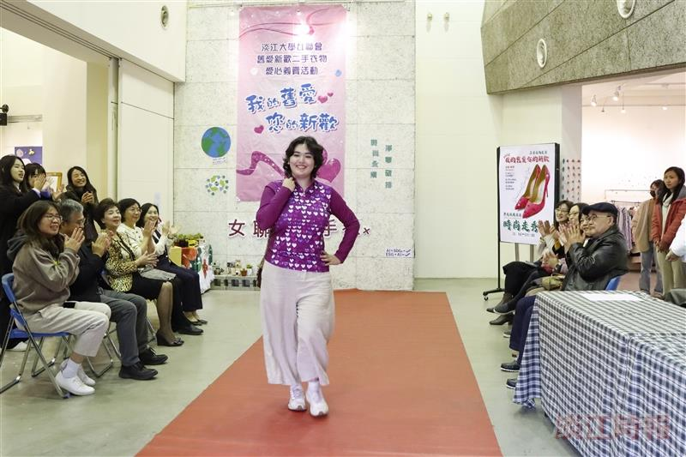
The Women's Faculty and Staff Association invited international students to participate in a fashion show, where they confidently showcased the exquisite clothing they wore.

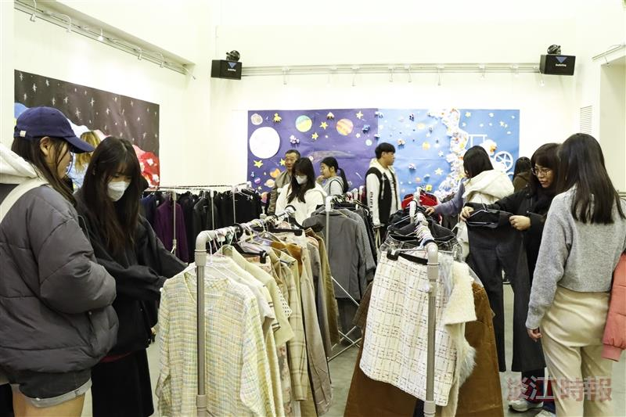
Many faculty and students visited the Black Swan Exhibition Hall to shop for second-hand clothing and accessories on sale.

