Tamkang Times No.1202
Scholarship Award Ceremony for International Students: Vice President Hsiao-Chuan Chen Encourages Focus on Academics

The Office of International and Cross-Strait Affairs held the "2024 Academic Year International Student Admission Scholarship Award Ceremony" at 10:10 a.m. on December 16 in the Ching-Sheng International Conference Hall. The event aimed to encourage outstanding students from around the world to pursue academic excellence. The ceremony was attended by the Vice President for International Affairs, Professor Hsiao-Chuan Chen, deans and department chairs of the award recipients’ respective colleges, and other relevant officials.

In her speech, Prof. Chen expressed gratitude to the international students for choosing Tamkang University. She emphasized that, at Tamkang, students not only gain valuable knowledge but also build lasting friendships with peers from around the world, broadening their horizons. She acknowledged the financial challenges many international students face and highlighted the various scholarships offered by Tamkang to support their academic focus. These scholarships, she noted, are not just financial aid but also recognition of students' potential and achievements, as well as encouragement for their future development and contributions to society. She wished all award recipients continued success in their endeavors.

The scholarships presented included awards for outstanding international students, graduate and doctoral foreign students, and students from Malaysia, Thailand, Indonesia, overseas alliance high schools, and Hong Kong and Macau. Prof. Chen and other first-level supervisors presented scholarships to 54 international students.

Representing the recipients, Penubarthi Guru Varun, a first-year doctoral student in Mechanical and Electro-Mechanical Engineering, expressed gratitude to Tamkang University and the scholarship committee for their recognition and support. He described the scholarship as an honor that inspires him to strive for academic excellence and meaningful contributions. He pledged to uphold Tamkang University's values and reputation, make the most of this opportunity, and give his utmost effort.
2025/01/20

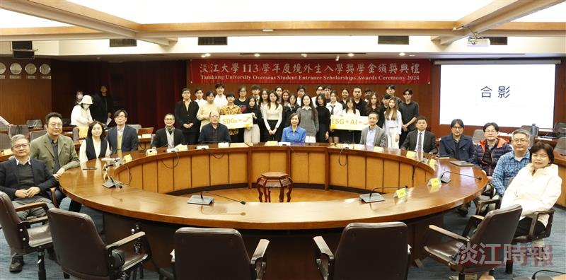
The Office of International and Cross-Strait Affairs held the "2024 Academic Year International Student Admission Scholarship Award Ceremony" at the Ching-Sheng International Conference Hall.

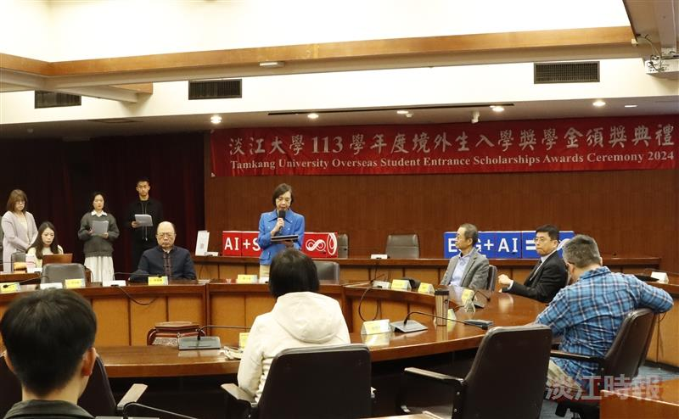
Vice President for International Affairs, Prof. Hsiao-Chuan Chen, delivered a speech encouraging international students at Tamkang University to focus on their studies and broaden their horizons.

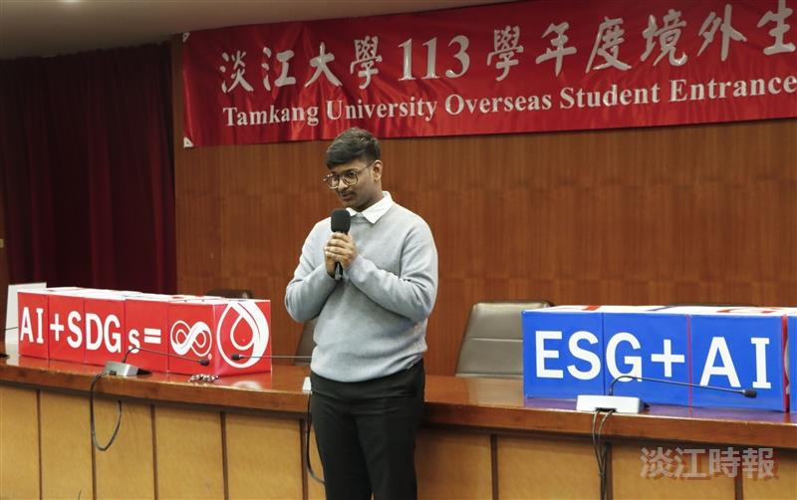
Penubarthi Guru Varun, a first-year graduate student in Mechanical and Electro-Mechanical Engineering, delivered a speech on behalf of the scholarship recipients.

