Tamkang Times No.1200
Tamkang Sustainability Together with Yeo Lan: Hsu Hang-Chien Continues with Generous NT$20 Million Scholarship Donation

On December 11, 2024, at 1:00 PM, the Guidance Section under the Office of Student Affairs held the "2024 Academic Year Chang Yeo Lan Scholarship Award Ceremony" in the Yeo-Lan Hall of the Hsu Shou-Chlien International Conference Center. With the theme "Tamkang Sustainability Together with Chang Yeo Lan," the ceremony was hosted by President Huan-Chao Keh. Over 300 attendees, including Vice President for Academic Affairs Hui-Huang Hsu, Vice President for Administrative Affairs Chun-Hung Lin, Vice President for International Affairs Hsiao-Chueh Chen, faculty, staff, scholarship recipients, and their families, witnessed alumnus Hang-Chien Hsu’s generous contribution to benefit future Tamkang students.

The Chang Yeo Lan Scholarship, the largest single scholarship fund among universities in Taiwan, was established in 2020 with an NT$120 million donation by Hang-Chien Hsu in honor of his mother. The scholarship aims to encourage outstanding and research-potential students to study at Tamkang University while supporting international students in their academic pursuits. Since September 2021, the scholarship has benefited new students annually with a total of NT$20 million awarded each year. Over the past 3 years, 592 students have received scholarships ranging from NT$20,000 to NT$200,000. This year marks the fourth round of awards, with 50 new bachelor's, master's, and doctoral students receiving NT$200,000 each; 7 new international master's and doctoral students receiving NT$100,000 each; and 136 new international undergraduate students receiving NT$25,000 to NT$50,000 each.

During his speech, President Keh expressed gratitude to Hang-Chien Hsu for his generosity in giving back to his alma mater. He praised Hsu not only for benefiting current students but also for inspiring a strong sense of alumni community, embodying Tamkang’s motto of "Simplicity, Truthfulness, Firmness, and Perseverance." He encouraged the scholarship recipients to strive for self-improvement, surpass their competitors, and become exemplary individuals with the core competencies emphasized by the university’s "Three Circles and Five Disciplines" educational philosophy and its AI+SDGs=∞ initiative. President Keh urged students to use the scholarship wisely, make the most of it, and contribute back to the school and society in the future.

Kang-Wei Chu, a first-year master's student from the Graduate Institute of Senior Health Management, expressed pride in being a scholarship recipient. He sincerely thanked Hang-Chien Hsu for his broad-minded generosity, which not only funded the construction of the Hsu Shou-Chlien International Conference Center but also established the "Chang Yeo Lan Scholarship." Chu shared that the scholarship provided crucial support, enabling him to focus on his studies and research at the Lanyang campus without financial concerns. He pledged to cherish this support, work hard, and give back to society in the future by applying his expertise in senior care to meet the needs of the aging population in Yilan. "I hope to follow in the footsteps of alumnus Hsu, generously practicing good deeds and passing on this selfless love and support to benefit more students."

Gabriella Gwennie Nethania, an international student from Indonesia and a first-year Economics student, shared in English that university life is a brand-new experience with a different learning environment, new opportunities, new responsibilities, and new challenges. She thanked Tamkang University for providing an excellent academic environment and resources that have made her feel at home during her nearly 4 months in Taiwan. She described the Chang Yeo Lan Scholarship as a guiding light, offering financial support and reminding her to move forward with positivity and determination. On behalf of all the recipients, she extended heartfelt thanks to Hang-Chien Hsu, believing that his support would inspire more people to pursue their dreams and create hopeful futures.

Additionally, the parent of AI freshman Yao-Yu Tsai, also a Tamkang alumnus, expressed appreciation for the university’s positive development and dedication to education. They also thanked Hang-Chien Hsu for his generous scholarship donations and support for future generations, expressing pride in their child’s achievement. "I hope Yao-Yu will stay true to his aspirations, make the best use of this scholarship, and strive toward his professional goals. We will fully support him."

The ceremony concluded with a group photo featuring Tamkang’s digital mascot, "TKU Copilot," leading attendees to make gestures symbolizing "thumbs-up," "love," and "Tamkang Sustainability: Journeying Together with Lotus Spirit," marking a perfect ending to the event.
2025/01/07

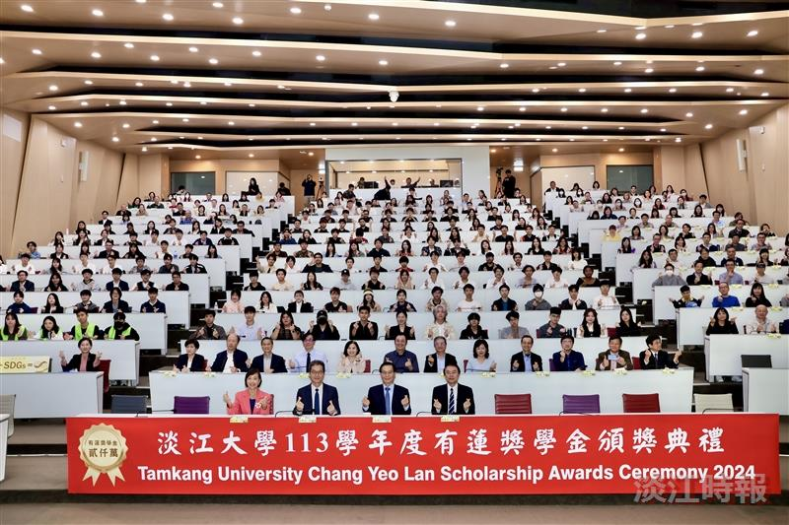
Group photo of participants at the 2024 Academic Year Chang Yeo Lan Scholarship Award Ceremony.

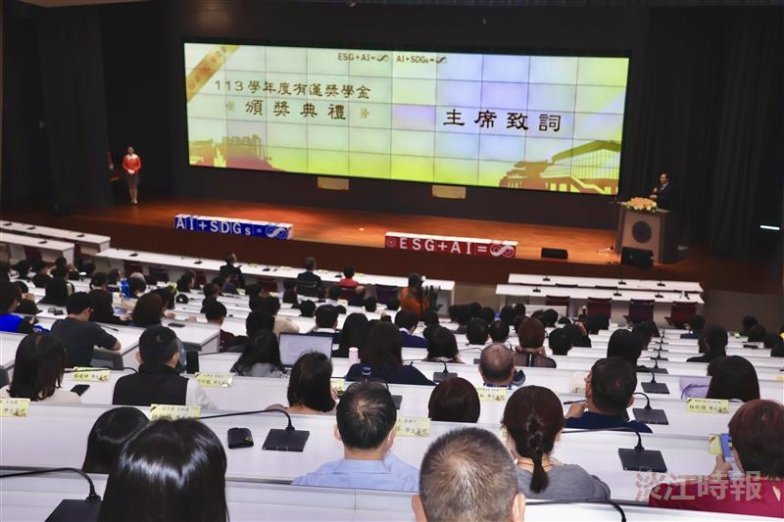
The 2024 Academic Year Chang Yeo Lan Scholarship Award Ceremony was held on December 11 at 1:00 PM in the Yeo Lan Hall of the Hsu Shou-Chlien International Conference Center.

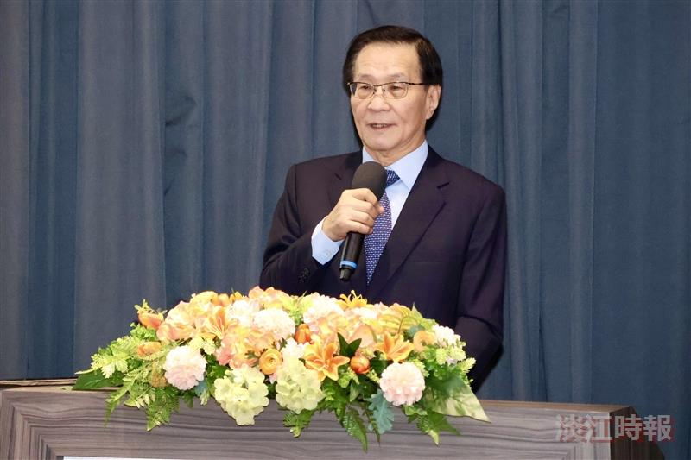
At the 2024 Academic Year Chang Yeo Lan Scholarship Award Ceremony, President Huan-Chao Keh encouraged the scholarship recipients to pursue their studies with enthusiasm.

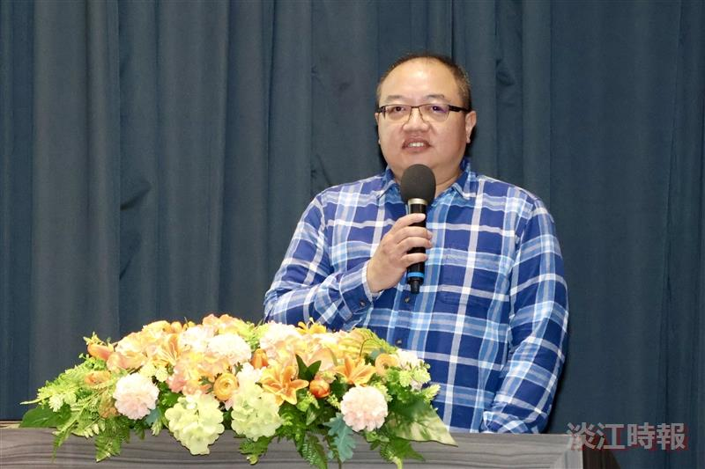
At the 2024 Academic Year Chang Yeo Lan Scholarship Award Ceremony, Kang-Wei Chu, a first-year master's student from the Graduate Institute of Senior Health Management, delivered a speech of gratitude on behalf of the recipients.

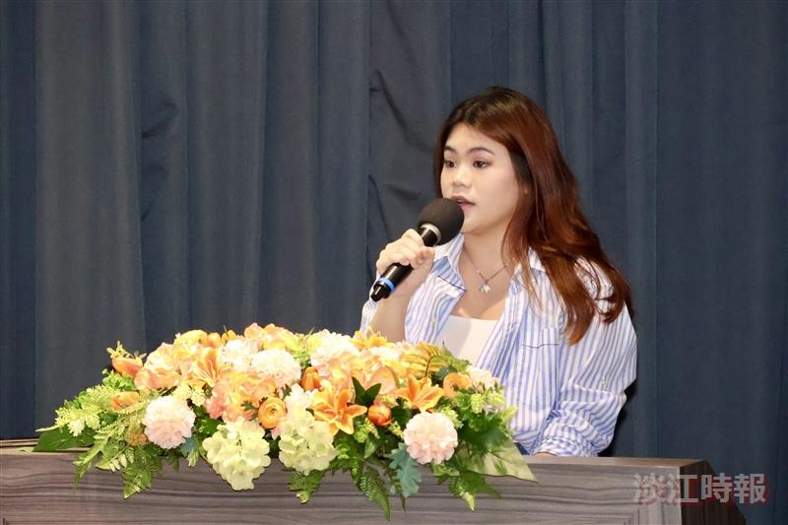
At the 2024 Academic Year Chang Yeo Lan Scholarship Award Ceremony, international student Gabriella Gwennie Nethania, a first-year student in Economics, delivered a speech of gratitude on behalf of the recipients.

