Tamkang Times No.1198
Education and Futures Design Department Faculty and Students Visit Japan for Aging Society Exchange with Mejiro University

7 students from the Department of Education and Futures Design, led by Assistant Professor June S. Chen, visited Tokyo, Japan, from November 7 to 9 for an exchange with Mejiro University's Department of Human Welfare to jointly explore issues related to aging societies. The participating students, ranging from freshmen to juniors, signed up for this valuable opportunity despite the self-funded trip and limited Japanese proficiency, eager to experience cross-cultural exchange.

The seminar, themed “Issues and Responses to Aging Societies in Taiwan and Japan,” began with both sides sharing the current state of aging populations in their respective countries, followed by group discussions. Tamkang students joined various discussion groups and overcame language barriers using translation software. Chih-Chieh Lin, a sophomore, noted that while elderly people in both Taiwan and Japan enjoy binge-watching TV shows, Japan places greater emphasis on cultivating hobbies. He also observed that Japanese families rarely hire foreign caregivers, which differs from the situation in Taiwan.

June Chen believed the exchange not only allowed students to understand different educational systems but also enhanced their intercultural interaction skills. She encouraged future participants to seize opportunities to engage with local students actively. Lin shared that cross-cultural exchange helped him discover the similarities and differences between Taiwanese and Japanese cultures. Despite language challenges, maintaining confidence and openness enabled him to gain valuable experiences and friendships.

After the seminar, students spent the following day with their new Japanese friends, enjoying activities such as karaoke, yakiniku restaurants, Ueno Zoo, and bowling, fostering strong bonds. Lin mentioned that while translation software occasionally missed context, such as omitting subjects, his basic self-taught Japanese skills helped bridge gaps and facilitate team communication. At the end of the trip, the 7 students did not return to Taiwan together; instead, each planned their own itineraries to make the most of their time in Japan.

The faculty and students expressed gratitude for the warm hospitality provided by Mejiro University's Chair of Human Welfare, Prof. Makiko Inoue, and Taiwanese professor Li-Ting Chen. June Chen also praised Mejiro University's flexible learning environment, such as discussion spaces scattered throughout the campus and adjustable classroom desks and chairs, which provide an optimal learning environment for students.

Yi-Ying Chen, a junior, shared her thoughts, stating that international exchange is a valuable learning opportunity to experience local life on a deeper level, unlike typical sightseeing trips. She suggested that younger peers prepare an introduction to their department in advance or organize workshop-style activities to help foreign students understand what they are studying. This approach not only breaks the ice quickly but also promotes meaningful interactions with international peers.
2024/12/18

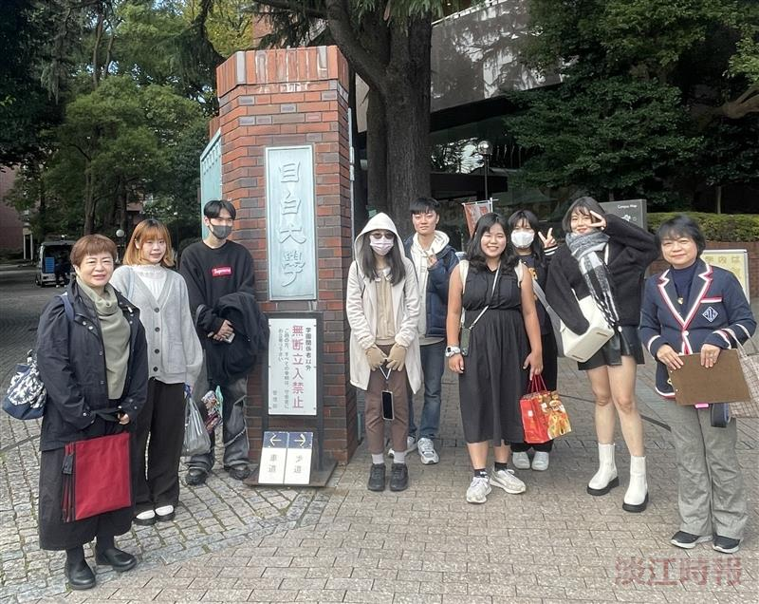
Faculty and students from the Department of Education and Futures Design took a group photo at the entrance of Mejiro University, with Li-Ting Chen (first from the right), a faculty member of Mejiro University's Department of Human Welfare.

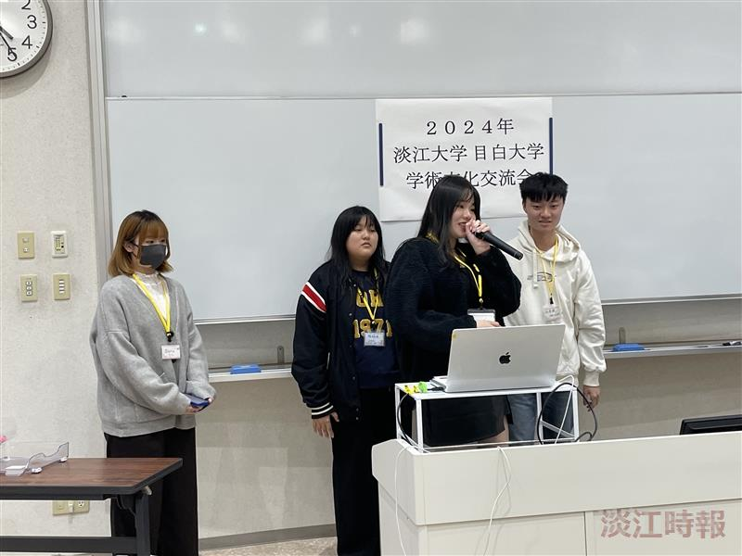
Students from the Department of Education and Futures Design presented a report titled "Taiwan 2025: Moving Toward a Super-Aged Society" at the seminar.

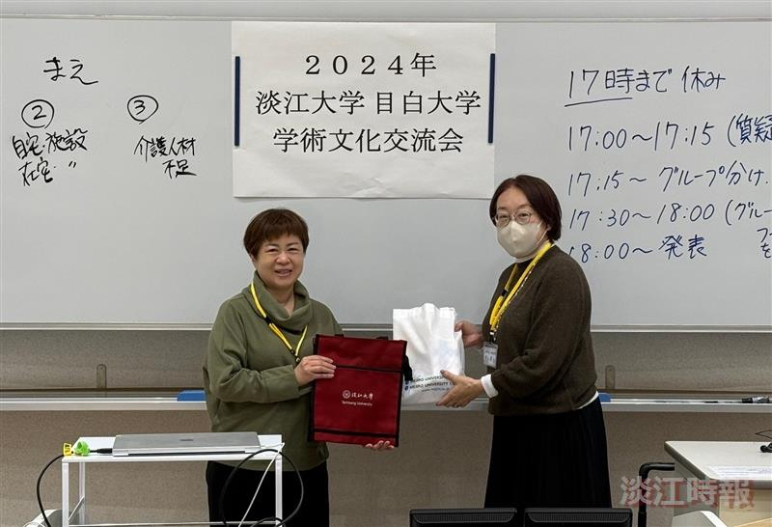
Assistant Professor June S. Chen (left) from the Department of Education and Futures Design and Professor Makiko Inoue, Chair of the Department of Human Welfare, exchanged gifts between the two departments.

